BANK OF ISRAEL
Office of the Spokesperson and Economic Information

April 12, 2026

Press Release:

Foreign Exchange Reserves at the Bank of Israel, March 2026

Israel’s foreign exchange reserves at the end of March 2026 stood at $228,271 million, a decrease of $6,274 million from their level at the end of the previous month. The level of the reserves relative to GDP was 37.2 percent (Figure 1).

The decrease was mainly the result of a revaluation that decreased the reserves by approximately $8,936 million. This decrease was partly offset by the government’s foreign exchange activities totaling approximately $2,681 million.

Israel's Foreign Exchange Reserves ($ million)

Date | Reserves excluding IMF | Reserves at the IMF | Total Foreign Exchange Reserves
March 2026 | 223,697 | 4,574 | 228,271
February 2026 | 229,909 ^{c} | 4,636 | 234,545^{c}
January 2026 | 228,360^{c} | 4,682 | 233,042^{c}
December 2025 | 224,834^{c} | 4,674^{c} | 229,508^{c}
November 2025 | 226,794 | 4,631 | 231,425
October 2025 | 227,295 | 4,659 | 231,954
September 2025 | 227,246 | 4,634 | 231,880
August 2025 | 225,694^{c} | 4,626 | 230,320^{c}
July 2025 | 222,157 | 4,611 | 226,768
June 2025 | 223,651 | 4,599 | 228,250
May 2025 | 219,086^{c} | 4,553 | 223,639^{c}
April 2025 | 217,489 | 4,546 | 222,035
March 2025 | 214,394^{c} | 4,416 | 218,810^{c}

Figure 1
Level of foreign exchange reserves, and their ratio to GDP, 2008–2026

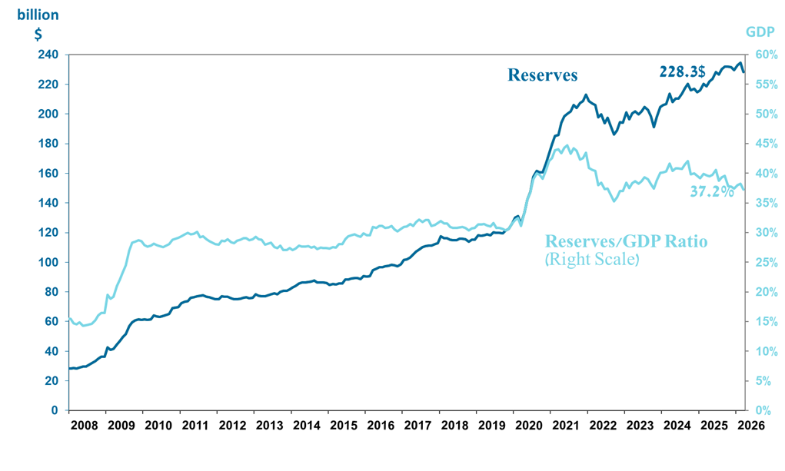

a Includes Bank of Israel payments and receipts in foreign currency.
^{b} This column includes Special Drawing Rights (SDRs), the balance of NAB loans, and the balance of Israel's reserve tranche at the IMF. c Updated after the original date of publication.

