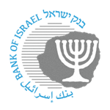

BANK OF ISRAEL
Office of the Spokesperson and Economic Information

February 5, 2026

Press Release:

Foreign Exchange Reserves at the Bank of Israel, January 2026

Israel’s foreign exchange reserves at the end of January 2026 stood at $233,044 million, an increase of $3,539 million from their level at the end of the previous month. The level of the reserves relative to GDP was 39.9 percent (Figure 1).

The increase was mainly the result of:
- A revaluation that increased the reserves by approximately $3,068 million.
- The government’s foreign exchange activities totaling approximately $465 million.

Israel's Foreign Exchange Reserves ($ million)

Date | Reserves excluding IMF (including reserves bought under the natural gas purchase program) | Reserves at the IMF | Total Foreign Exchange Reserves
January 2026 | 228,362 | 4,682 | 233,044
December 2025 | 224,831^{c} | 4,674^{c} | 229,505^{c}
November 2025 | 226,794 | 4,631 | 231,425
October 2025 | 227,295 | 4,659 | 231,954
September 2025 | 227,246 | 4,634 | 231,880
August 2025 | 225,694^{c} | 4,626 | 230,320^{c}
July 2025 | 222,157 | 4,611 | 226,768
June 2025 | 223,651 | 4,599 | 228,250
May 2025 | 219,086^{c} | 4,553 | 223,639^{c}
April 2025 | 217,489 | 4,546 | 222,035
March 2025 | 214,394^{c} | 4,416 | 218,810^{c}
February 2025 | 215,898^{c} | 4,356 | 220,254^{c}
January 2025 | 211,710^{c} | 4,358 | 216,068^{c}

Figure 1
Level of foreign exchange reserves, and their ratio to GDP, 2008–2026

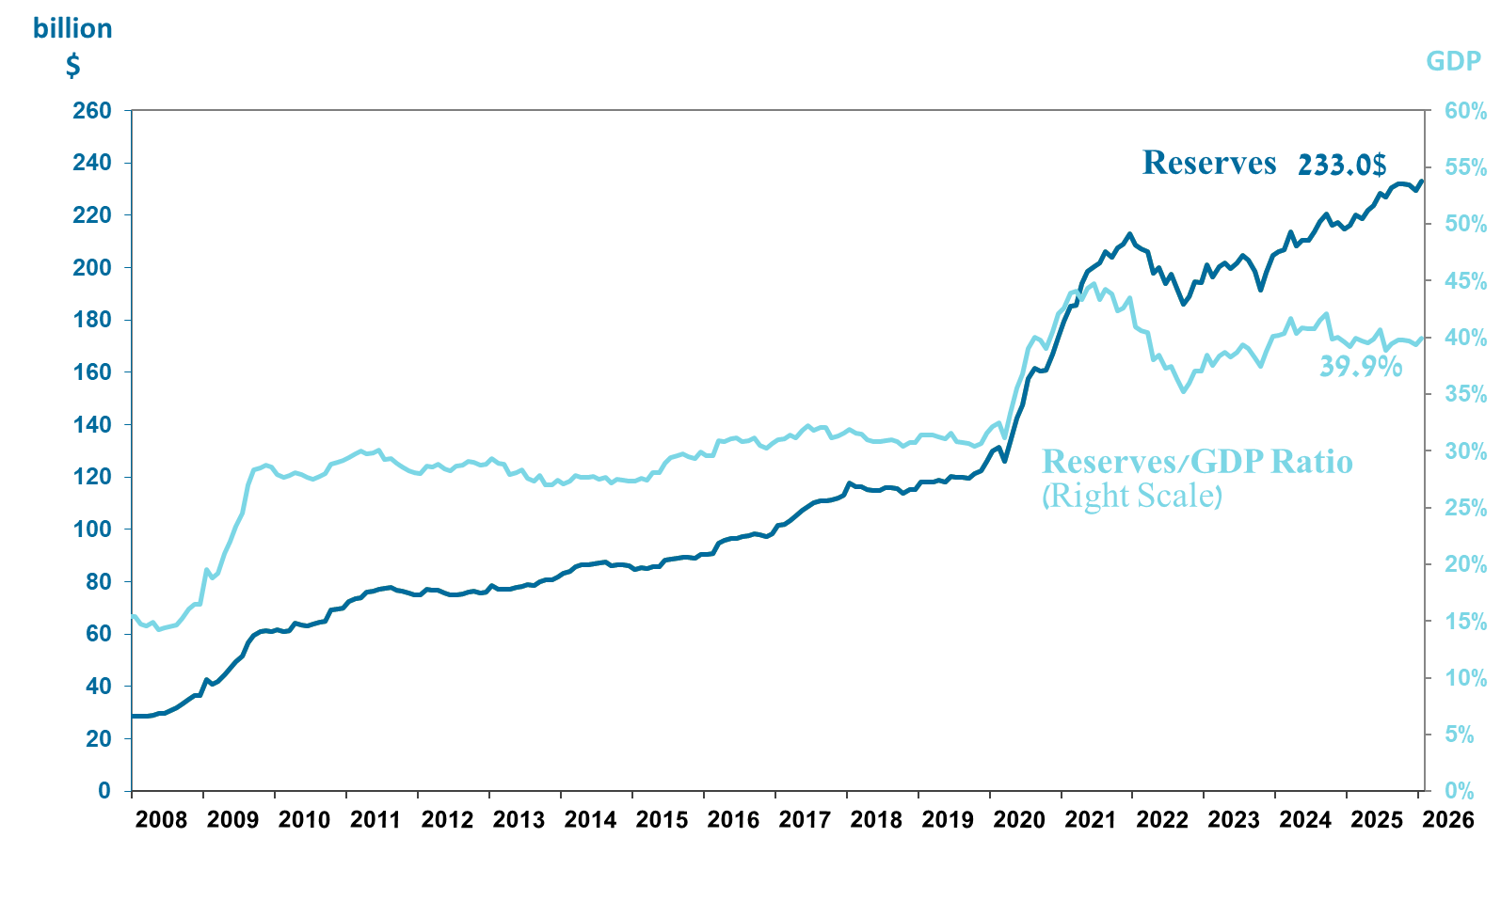

a Includes Bank of Israel payments and receipts in foreign currency.
^{b} This column includes Special Drawing Rights (SDRs), the balance of NAB loans, and the balance of Israel's reserve tranche at the IMF. c Updated after the original date of publication.

