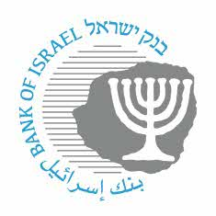

BANK OF ISRAEL
Office of the Spokesperson and Economic Information

September 28, 2022

Press Release:

Another step in opening the payment systems to nonbank entities

The Bank of Israel and the Capital Market, Insurance and Savings Authority have agreed on a framework in which financial service providers that are supervised by the CMISA will be able to connect to the payment systems.

This is another step that enables nonbank entities to enter the Israeli payments array, thereby increasing innovation and competition in this field.

The framework will apply to financial asset service providers and credit and deposit unions supervised by the CMISA. In addition to meeting the license conditions, these entities will also have to fulfill relevant requirements regarding their operations in the payment services field, which will be formulated by the CMISA. If relevant, this process will also apply to other entities supervised by the CMISA.

Dr. Moshe Bareket, Head of the Capital Market, Insurance and Savings Authority, said: “I am pleased with the cooperation with the Bank of Israel on this matter. This is an important step that will enable participants in the nonbank market to operate more effectively in the payments system, which will lead to an increase in competition in financial services provided to the Israeli consumer.”

Oded Salomy, Director of the Bank of Israel Payment and Settlement Systems Department, said: “Many domestic and international participants are interested in operating in the domestic market, but are waiting for a license that will enable them to connect to the payment systems. Unfortunately, the legislation for regulating payment service operations is being delayed. We have therefore found a solution that will make it possible for nonbank participants to offer advanced payment solutions and value-added offerings to the Israeli public, while maintaining the stability of the payment systems, similar to the most advanced countries in the payment field. This step will enable consumers and merchants to benefit from additional innovative and efficient services that will begin operating in Israel.”

