November 5, 2026
Press Release:

Foreign Exchange Reserves at the Bank of Israel, October 2026

Israel’s foreign exchange reserves at the end of October 2026 stood at $237,773 million, an increase of $775 million from their level at the end of the previous month. The level of the reserves relative to GDP was 34.3 percent (Figure 1).

The increase was mainly the result of a revaluation of the reserves totaling approximately $1,755 million.
This increase was partly offset by the government’s foreign exchange activities totaling about $965 million.

Israel's Foreign Exchange Reserves ($ million)

Date | Reserves excluding IMF | Reserves at the IMF | Total Foreign Exchange Reserves
October 2026 | 233,226 | 4,547 | 237,773
September 2026 | 232,436 | 4,562 | 236,998
August 2026 | 237,040 | 4,601 | 241,641
July 2026 | 234,219 | 4,572^{c} | 238,791^{c}
June 2026 | 234,199 | 4,500 | 238,699
May 2026 | 234,098 | 4,583 | 238,681
April 2026 | 231,113^{c} | 4,615 | 235,728^{c}
March 2026 | 224,832^{c} | 4,574 | 229,406^{c}
February 2026 | 229,896^{c} | 4,636 | 234,532^{c}
January 2026 | 228,346^{c} | 4,682 | 233,028^{c}
December 2025 | 224,834^{c} | 4,674^{c} | 229,508^{c}
November 2025 | 226,794 | 4,631 | 231,425
October 2025 | 227,295 | 4,659 | 231,954

Figure 1
Level of foreign exchange reserves, and their ratio to GDP, 2008–2026

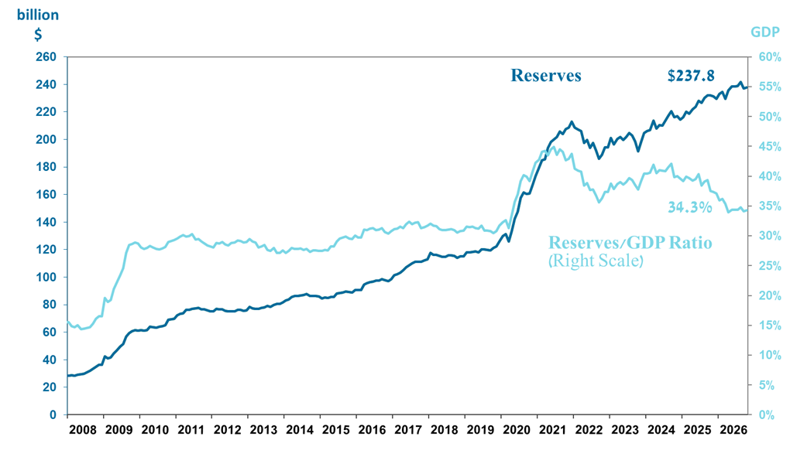

a Includes Bank of Israel payments and receipts in foreign currency.
^{b} This column includes Special Drawing Rights (SDRs), the balance of NAB loans, and the balance of Israel's reserve tranche at the IMF. c Updated after the original date of publication.

