

BANK OF ISRAEL
Office of the Spokesperson and Economic Information

December 20, 2023

Press Release:

Israel’s International Investment Position (IIP),
third quarter (July–September) of 2023

- In the third quarter of 2023, the balance of assets held abroad by Israeli residents declined by approximately $8.9 billion (about 1.3 percent), to about $662 billion at the end of September. The decline was mainly due to a decline in the prices of foreign securities held by Israelis, which was partly offset by net investments abroad by Israeli residents.
- Outstanding liabilities to abroad increased by approximately $0.8 billion (about 0.2 percent) in the third quarter, to about $480 billion at the end of the quarter. The increase was primarily due to net direct investments.
- Israel’s surplus of assets over liabilities vis-à-vis abroad declined by approximately $9.7 billion (5.1 percent) in the third quarter, to about $182 billion at the end of the quarter.
- The surplus of assets over liabilities vis-à-vis abroad in debt instruments alone (negative net external debt) declined by about $3.4 billion (1.5 percent) during the third quarter, to approximately $220 billion at the end of September.
- The ratio of gross external debt to GDP increased by about 0.1 percentage points in the third quarter, to about 30.2 percent at the end of September.

Table 1: Asset and liability balances, and changes in them

- The balance of Israel’s assets abroad
In the third quarter of 2023, the value of the assets held abroad by Israeli residents declined by about $8.9 billion (about 1.3 percent) to approximately $662 billion at the end of September.

- The value of direct investments increased by about $2.6 billion (approximately 2.5 percent) in the third quarter, mainly as a result of reinvested earnings.
- The value of the securities portfolio declined by about $5.1 billion (about 2.3 percent) during the third quarter, mainly as a result of price declines on foreign securities held by Israeli residents.
During the third quarter, there were negligible net realizations in the securities portfolio abroad. Institutional investors realized investments in foreign securities totaling about $1.3 billion, which were fully offset by investments from other sectors (Figure 1).

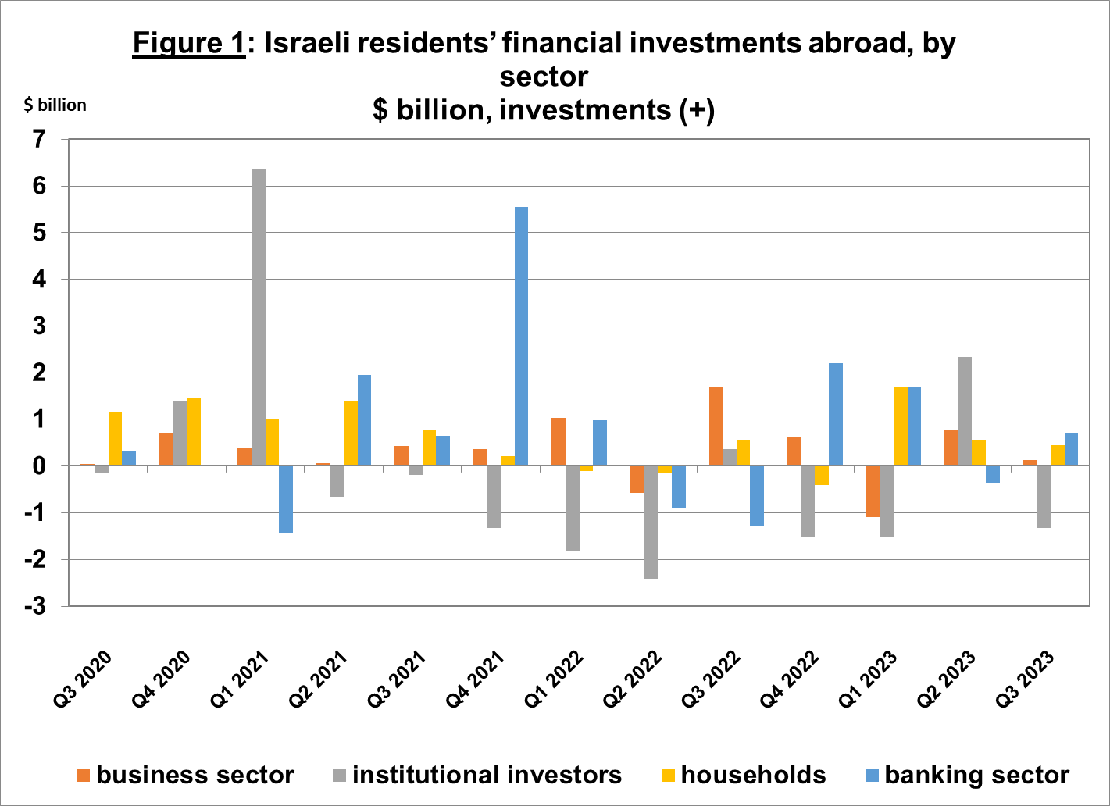
Source: Bank of Israel data and processing¹.

- The value of other investments abroad increased by about $0.3 billion (about 0.2 percent) in the third quarter. The increase derived mainly from deposits abroad by Israelis (including banks) totaling about $1.6 billion, and from investments in other assets totaling about $1.5 billion, mainly by institutional investors in foreign investment funds. These investments were fully offset by a decline in customer credit.
- The value of reserve assets declined by about $3.3 billion (about 1.6 percent) during the third quarter, to about $199 billion at the end of September. The decline derived mainly from price declines totaling about $2.3 billion.
- The composition of Israelis’ securities portfolio abroad: During the course of the third quarter, the share of equity instruments in Israeli residents’ portfolio abroad remained unchanged, and was 43 percent at the end of September. Accordingly, the share of debt instruments remained at 57 percent at the end of the quarter.

- Israel’s liabilities to abroad

The balance of Israel's liabilities to abroad increased by about $0.8 billion (about 0.2 percent) during the second quarter, to approximately $480 billion at the end of the quarter. The increase was mainly due to net investments, particularly direct investments.

- The value of direct investments in the economy increased by about $3.2 billion (about 1.4 percent) during the third quarter, mainly due to net direct investments in share capital totaling about $4.2 billion, of which about $1.8 billion was in respect of reinvested earnings. The rest of the investments were spread out over a large number of companies.
- The value of the securities portfolio declined by about $1.6 billion (about 0.8 percent) in the third quarter, as a result of the shekel’s depreciation against the US dollar during the quarter, which reduced the dollar value of the investment portfolio by about $2.5 billion. This decline was partly offset by nonresidents’ net investments of about $1.2 billion, mainly in bonds.
- The value of nonresidents' financial portfolio on the Tel Aviv Stock Exchange, which makes up a part of nonresidents’ investments in Israel, increased by about $1.6 billion in the third quarter, to about $82.4 billion at the end of September. The increase in the portfolio value derived mainly from nonresidents’ investments in Makam, which were partly offset by the depreciation of the shekel vs. the dollar. (Figure 2 and Figure 3).
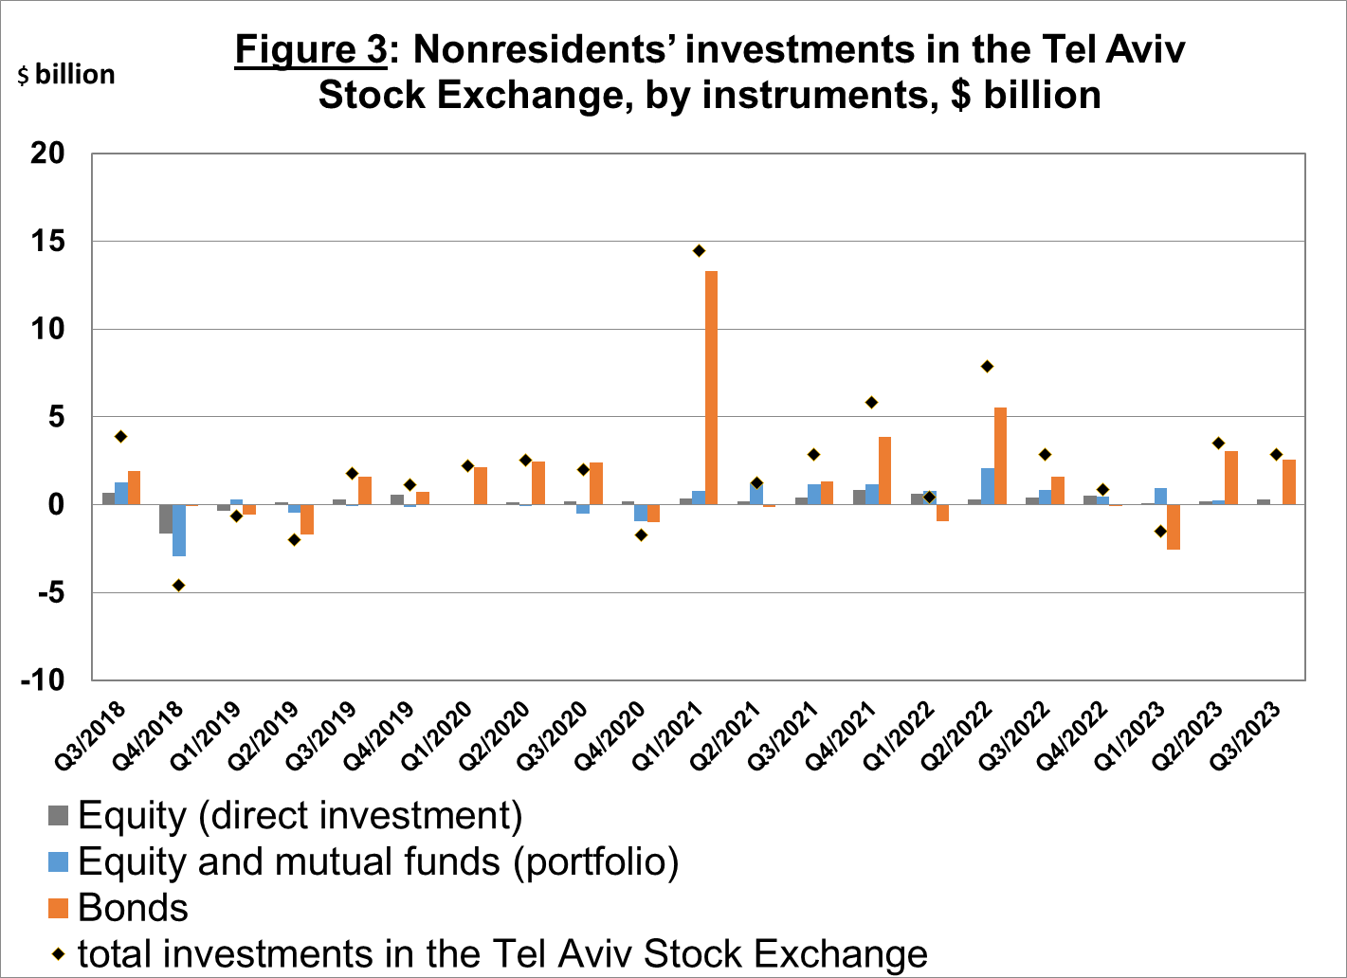
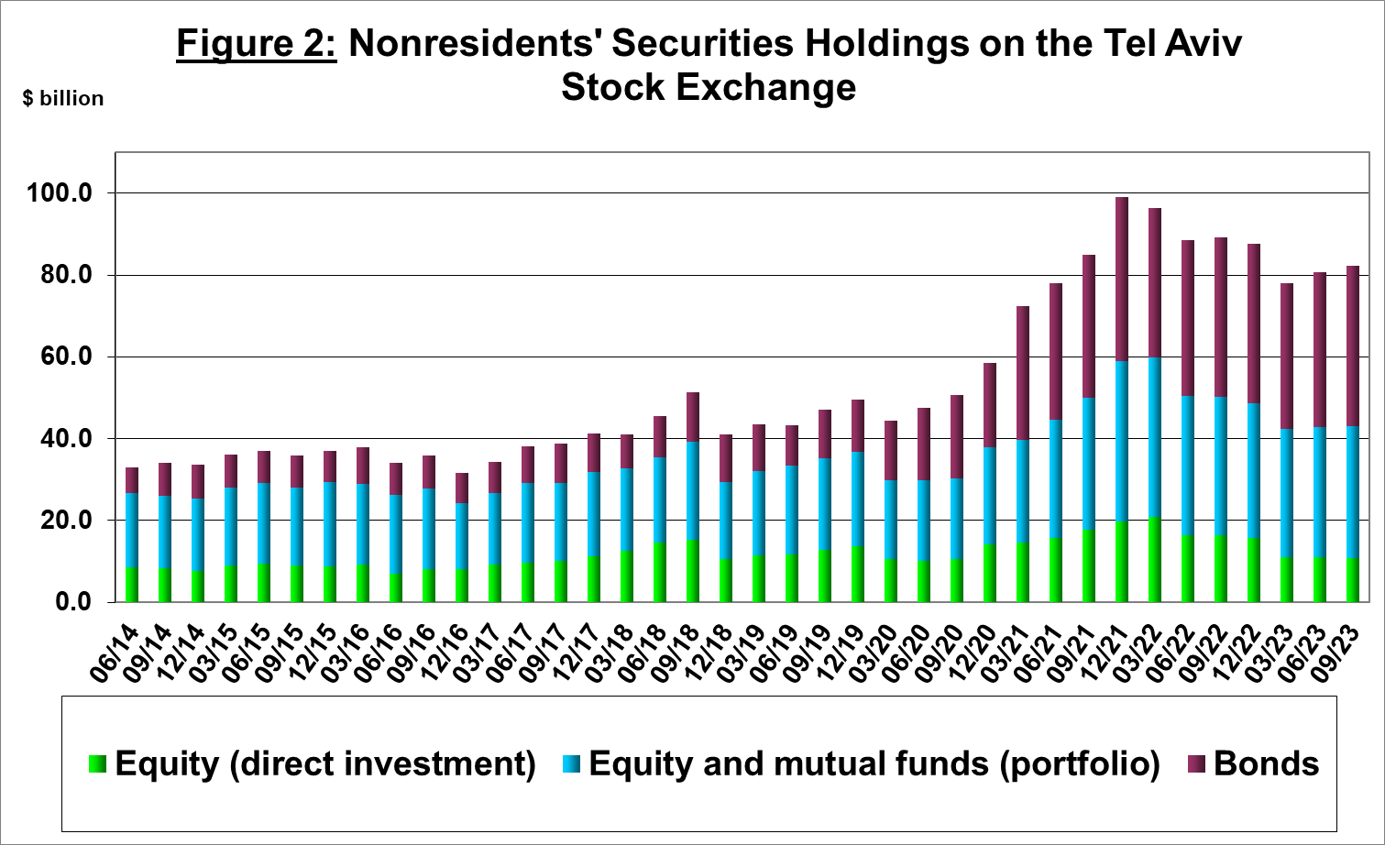

Source: Israel Securities Authority, and Bank of Israel data and processing¹.

The value of other investments in the economy declined by about $0.9 billion (about 1.5 percent) in the third quarter, to about $59.5 billion. The decrease was mainly due to a decline of about $1.9 billion in suppliers’ credit received by Israelis. This decline was partly offset by nonresidents’ net deposits of about $1.7 billion in Israeli banks.

The balance of liabilities in debt instruments alone, which makes up Israel's gross external debt, declined by about $0.9 billion (0.6 percent) in the third quarter, to about $155 billion.

The ratio of gross external debt to GDP increased by about 0.1 percentage points in the third quarter, to about 30.2 percent at the end of September (Figure 4).
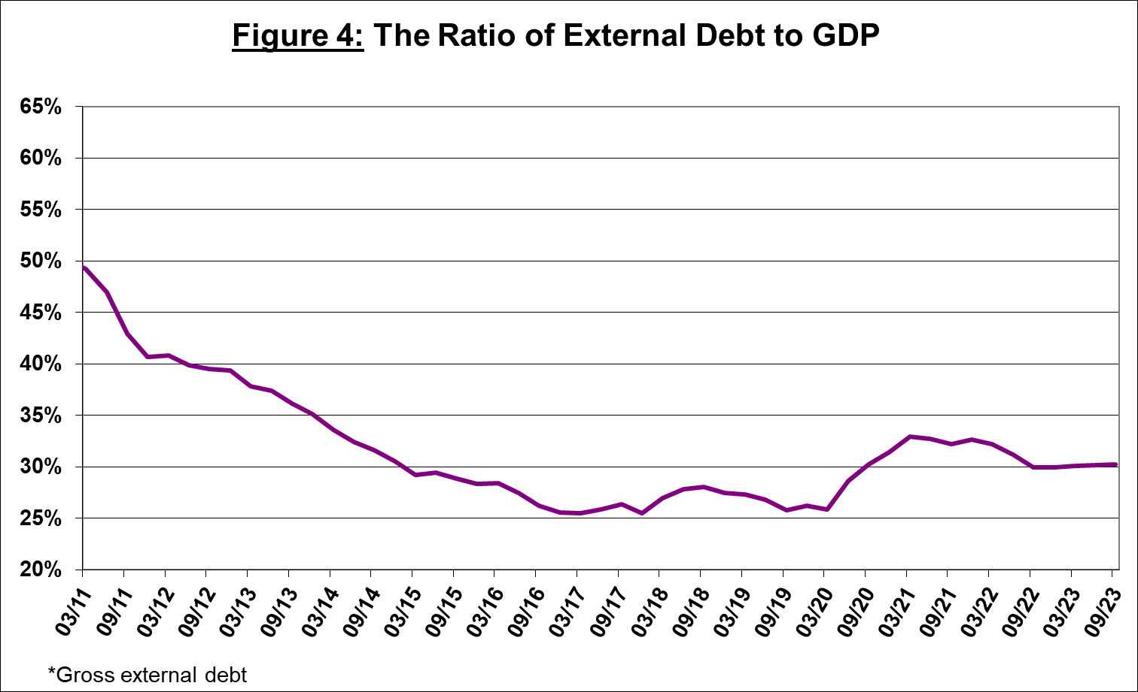

Source: Israel’s Ministry of Finance, Israel’s Central Bureau of Statistics, and Bank of Israel data and processing¹.

- Israel’s surplus assets over liabilities vis-à-vis abroad

The decline in the balance of assets compared with the increase in the balance of liabilities led to a decline of about $9.7 billion (5.1 percent) in the surplus of assets over liabilities vis-à-vis abroad, which totaled about $182 billion at the end of September (Figure 5).

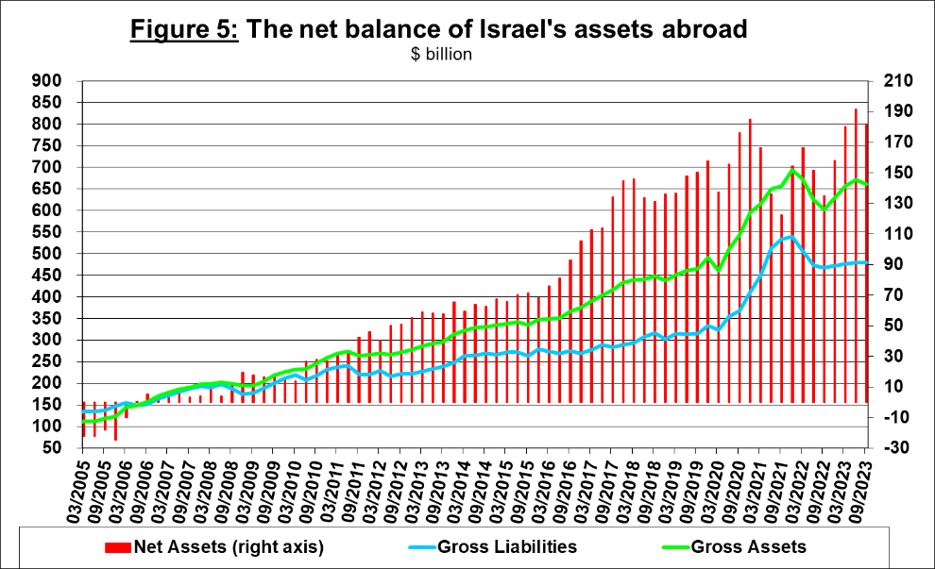

Source: Bank of Israel data and processing¹.

- Net external debt

The surplus of assets over liabilities vis-à-vis abroad in debt instruments alone (negative net external debt) declined by approximately $3.4 billion (about 1.5 percent) in the third quarter, to about $220 billion at the end of September (Figure 6).

The balance of assets in debt instruments declined by about $4.3 billion in the third quarter, to about $376 billion at the end of the quarter, of which about $199 billion is the Bank of Israel's foreign exchange reserves. This balance reflects a coverage ratio of 2.4 times the gross external debt.
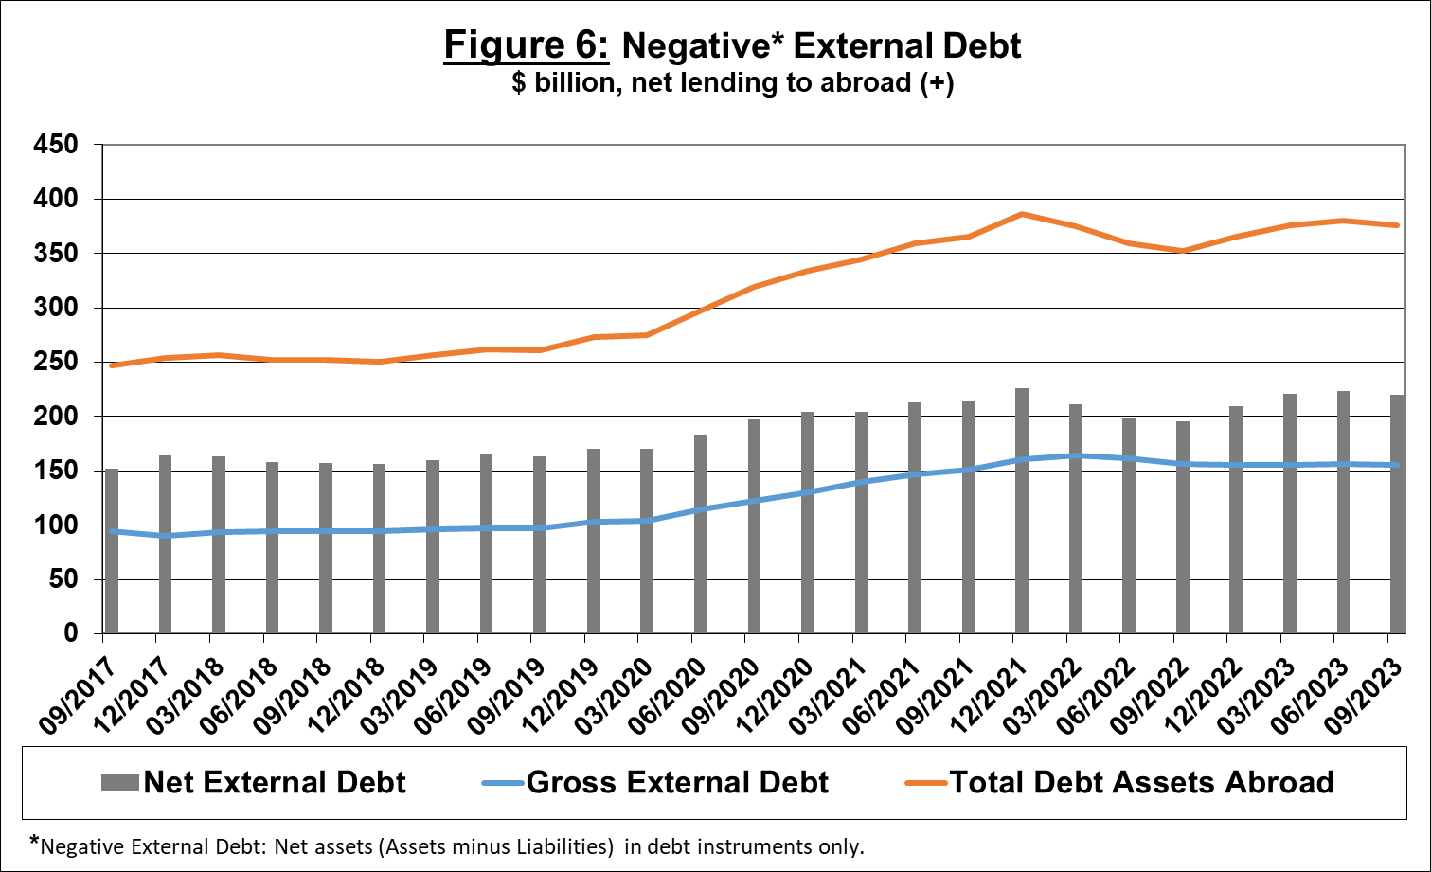

Source: Israel’s Ministry of Finance, and Bank of Israel data and processing.

For the complete data file, click here.

Bank of Israel data and processing: The Bank of Israel’s Information and Statistics Department collects data from numerous varied sources. Most of the data on the economy’s activity vis-à-vis abroad are received by force of a Bank of Israel Order, from direct reports by corporations and individuals to the Bank of Israel. (See: “Information Regarding Foreign Exchange Market Developments in Israel”, 5770–2010). Additional data used for measuring economic activity vis-à-vis abroad are received by reports from the Bank of Israel’s Accounting Division, the Ministry of Finance, the Central Bureau of Statistics, the Israel Securities Authority, domestic banks and other financial intermediaries, and institutional investors. The Department carries out estimations and processing on data received from the various sources.

