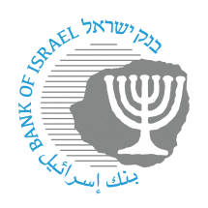

BANK OF ISRAEL

Office of the Spokesperson and Economic Information

Press release

October 14, 2024

**Allocation of an identification code to a nonbank payment services provider – Approval of the allocation of an identification code for UPay Settlement Ltd.**

Participants in the Israeli financial system are identified by an identification code that is unique to each participant (also known as a “bank code”), which is comprised of two characters. The Bank of Israel announces the allocation of a new identification code to a fintech firm that is in the process of connecting to the payment systems in Israel.

This step is consistent with the other measures advanced by the Bank of Israel to open access for nonbank participants and to advance competition in the payments market, such that fintech firms will be able to operate directly and independently in the supervised payment systems in Israel, which will reduce the dependence on banks. The identification code enables fintech firms to allocate payment account numbers to their customers, and enables other participants in the payment systems to identify them in a unique manner.

Oded Salomy, Director of the Payment and Settlement Systems Department, said: “The new entities that are expected to participate in the payment systems will contribute to increased competition, reduce concentration in the financial market, develop innovative advanced payment solutions, streamline processes and business services, and lower costs for consumers and merchants in Israel.”

The identification code allocated to **UPay Settlement Ltd.** is **85**.