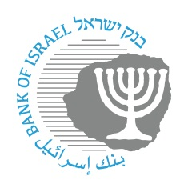

BANK OF ISRAEL
Office of the Spokesperson and Economic Information

March 23, 2022

Press Release:

The public's financial assets portfolio in the fourth quarter of 2021

[For an analysis of developments in the assets portfolio in 2021 overall, see “The public's financial assets portfolio” in Part A of Statistical Bulletin for 2021 (translation forthcoming).]

- In the fourth quarter of 2021, the balance of the public’s financial assets portfolio increased by approximately NIS 222 billion (4.6 percent), and for the year overall it increased by abut 14.6 percent, to about NIS 5 trillion, further to the trend of increase in recent years.
- The increase in the fourth quarter derived mainly from an increase in the balance of equities in Israel (12.5 percent), and tradable corporate bonds (6.5 percent), and cash and deposits (5.2 percent).
- The balance of the asset portfolio managed by institutional investors increased in the fourth quarter by approximately NIS 120 billion (5.3 percent), to about NIS 2.4 trillion at the end of the quarter. For the year overall, the balance increased by approximately 17 percent.
- Institutional investors’ rate of exposure to assets abroad increased by about 0.9 percentage points during the quarter, while their exposure to foreign currency decreased by about 0.4 percentage points.
- The value of the portfolio managed by mutual funds in Israel increased by about NIS 20 billion (5.4 percent) in the fourth quarter, to about NIS 397 billion.

1. The total assets portfolio
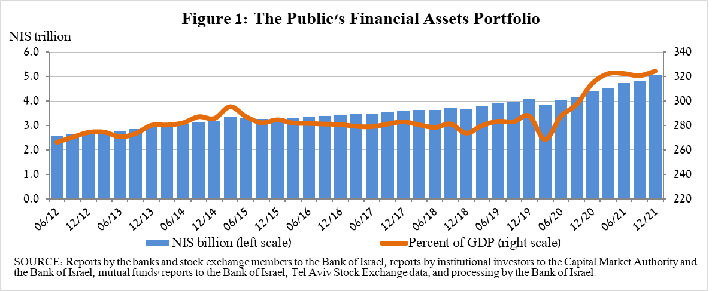
In the fourth quarter of 2021, the balance of the public’s financial assets portfolio continued to increase, rising by about NIS 222 billion (4.6 percent) to about NIS 5 trillion (Figure 1). It thus increased by about 14 percent for the year overall. The share of the public’s financial assets portfolio relative to GDP increased by about 3.7 percentage points, to about 325 percent at the end of the quarter, as a result of a slightly greater increase in the balance of the portfolio than in the increase in GDP.

2. Analysis of the changes in the overall portfolio
Over the course of the fourth quarter, the public’s holdings increased in most components, other than the balance of investments abroad (0.7 percent). Prominent among these were increases in the domestic equities component (12.5 percent), tradable corporate bonds (6.5 percent), and in cash and deposits (5.2 percent).
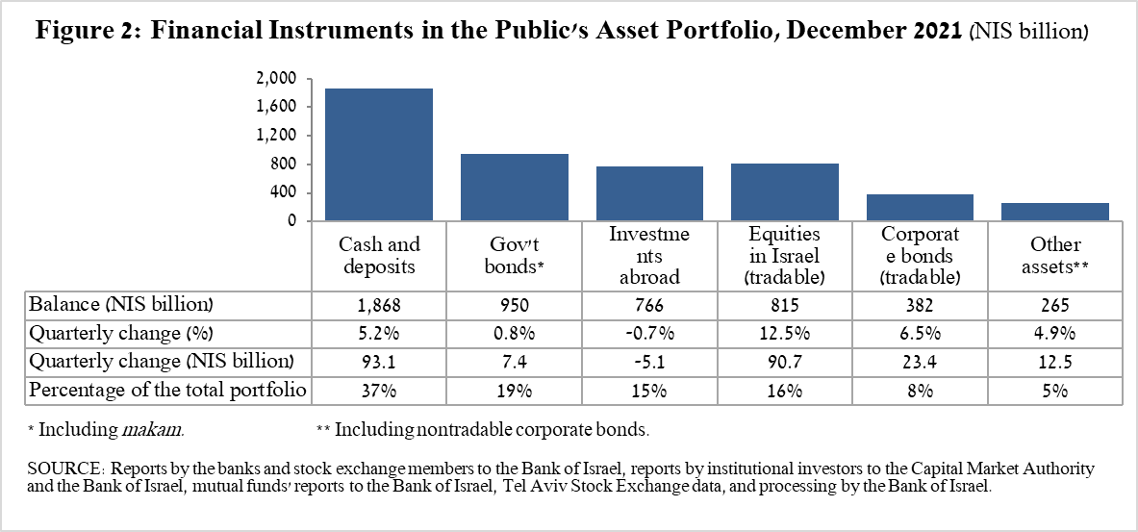

- The balance of holdings of equities in Israel increased by about NIS 90.7 billion (12.5 percent) during the quarter, primarily as a result of price increases on the equity indices, which were partially offset by net realizations. For the year overall, the balance of equities in Israel increased by about 33 percent, to about NIS 815 billion at year end.
- The balance of cash and deposits increased during the fourth quarter by about NIS 93 billion (5.2 percent) to about NIS 1.9 trillion, further to the marked increase in this component that began in 2020.
- The balance of tradable corporate bonds traded in Israel increased by about NIS 23.4 billion during the quarter, to about NIS 382 billion at the end of the quarter, mainly due to net investments, in view of net issuances during the quarter.
- The balance of government bonds (tradable and nontradable) and makam increased during the quarter by about NIS 7.4 billion (0.8 percent), to about NIS 950 billion at the end of the quarter.
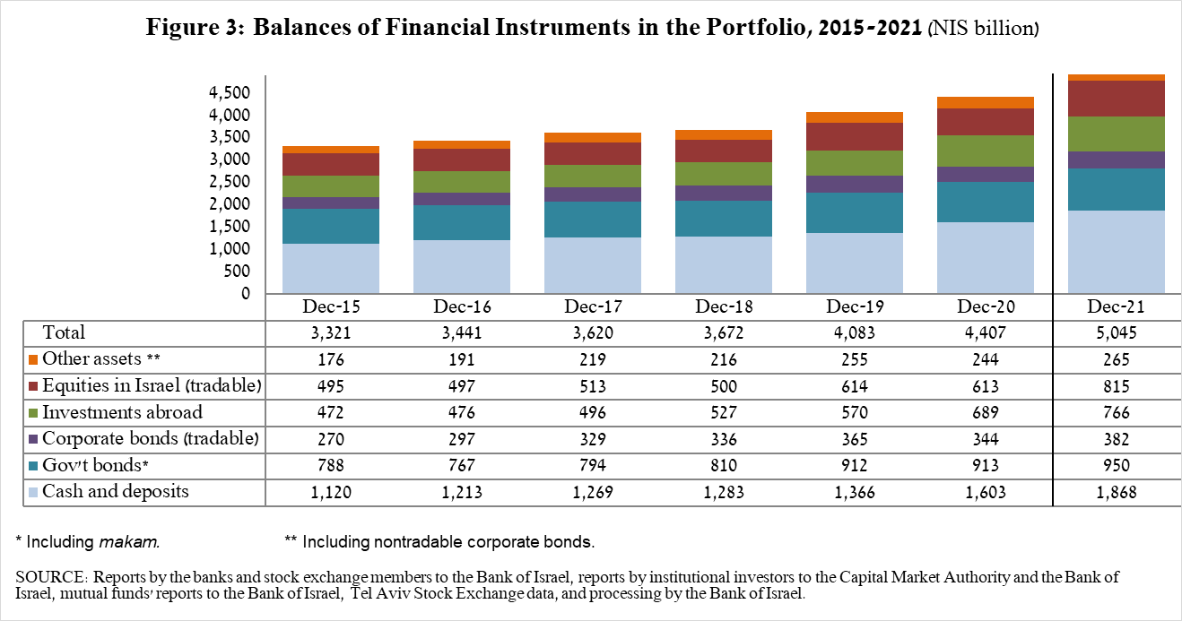

The balance of investments abroad declined by about NIS 5.1 billion (0.7 percent) during the quarter, to about NIS 766 billion, constituting about 15 percent of the total asset portfolio. The decline derived from the following 2 components:

- The balance of tradable (corporate and government) bonds abroad declined by about NIS 2.6 billion (1.5 percent) during the quarter, despite net investments of about NIS 10 billion. This was due to the appreciation of the shekel against the dollar (3.7 percent) and price declines, to about NIS 166 billion at the end of the quarter.
- The balance of equities held abroad declined by about NIS 2.5 billion (0.4 percent), to about NIS 599 billion at the end of the quarter. Despite the increases in equity indices, the balance declined as a result of net realizations of about NIS 1.7 billion and from the shekel’s appreciation against the dollar (3.7 percent).

As a result of developments during the quarter, there was a decline of about 0.8 percentage points (from 16 percent to 15.2 percent) in the share of foreign assets, and a decline of about 0.7 percentage points (from 23.1 percent to 22.4 percent) in the share of foreign exchange assets.

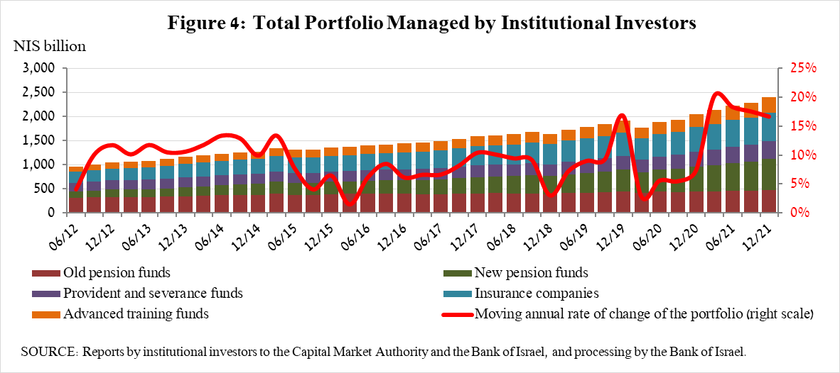
3. The portfolio managed by institutional investors

- The balance of the asset portfolio managed by all institutional investors increased in the fourth quarter by about NIS 120 billion (5.3 percent), to about NIS 2.4 trillion at the end of the quarter (about 48 percent of the public’s total financial assets portfolio). The increase in the balance encompassed all institutional investors and was notable mainly in the new pension funds (an increase of about NIS 39 billion). The increase in the balance of the managed portfolio during the quarter derived mainly from changes in the following investment components: equities in Israel—an increase of about NIS 34 billion (15.5 percent), mainly due to price increases; government bonds and makam—an increase of about NIS 22 billion (2.6 percent); equities abroad—a decline of about NIS 30 billion (15.4 percent), mainly due to net sales.

- Exposure of the portfolio managed by institutional investors to assets abroad and to foreign currency

In the fourth quarter of 2021, the share of institutional investors’ exposure to assets abroad increased by about 0.9 percentage points, to about 37.5 percent of total assets. This was a result of a larger increase in institutional investors’ balance of exposure to assets abroad than the rate of increase in total assets of institutional investors. Provident funds and advanced training funds were notable for their increase in exposure to abroad up to a level of 44.5 percent.
Most of the increase in the balance of exposure to assets abroad (about $29.7 billion) derived from an increase in exposure to equity indices abroad through futures contracts and options (about $17.6 billion).

Exposure to foreign currency—During the fourth quarter of 2021, institutional investors made net sales of foreign currency assets totaling about $3.3 billion, purchases totaling about $3.9 billion in assets denominated in and linked to foreign currency (mainly in deposits and in foreign currency-denominated current accounts in Israel) were offset by the net sale of foreign exchange through derivative financial instruments totaling about $7.2 billion, meaning an increase in futures transactions for the sale of foreign exchange.

As a result of these developments, institutional investors’ rate of exposure to foreign exchange (including shekel/forex derivatives) declined by about 0.4 percentage points to about 17.3 percent.

The decline in the rate of exposure to foreign exchange encompassed all institutional investors. Prominent among these were new pension funds, which, which lowered their rates of exposure to foreign exchange by about 0.9 percentage points to 17.9 percent.
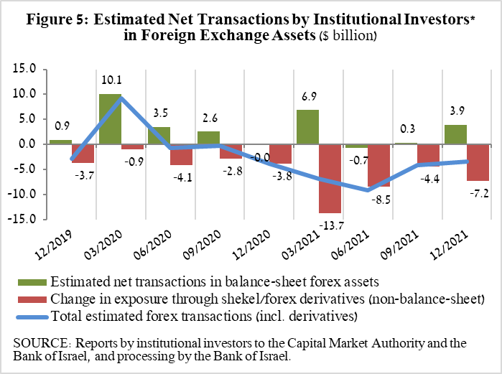
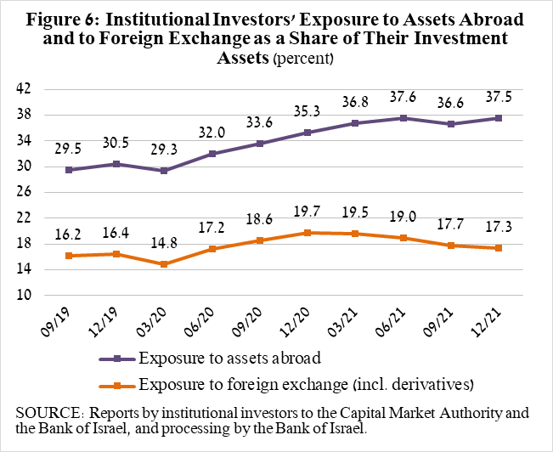

4. The portfolio managed by mutual funds

The value of the portfolio managed by Israeli mutual funds increased in the fourth quarter by about NIS 20 billion (5.4 percent), to about NIS 397 billion, constituting about 7.9 percent of the public’s total asset portfolio.

The increase in the fourth quarter was mainly due to a combination of price increases in the capital market and net new investment in the funds, totaling about NIS 5.6 billion. Most of the net new investments were in funds specializing in general domestic bonds, totaling about NIS 3.5 billion, and in funds specializing in equities in Israel, totaling about NIS 2.3 billion, while in contrast, there were negative net new investments in funds specializing in equities abroad, totaling about NIS 1.2 billion.

Further information and details:

Long-term tables on the asset portfolio are available here.

Long-term tables on institutional investors’ exposure to foreign exchange and to foreign assets are available here.

Long-term tables on mutual funds are available here.

Due to the receipt of new data, the data on the Public’s Assets Portfolio was scrubbed, beginning from January 2020.
For an explanation of the terms, see the indicators table on the Bank of Israel website at https://www.boi.org.il/en/DataAndStatistics/Pages/MainPage.aspx?Level=3&Sid=47&SubjectType=2
Excluding mutual funds.
Estimates of members’ exposure (rather than exposure of the institutional investors themselves) to various risks in the portfolio managed for them by the institutional investors (excluding insurance policies with a guaranteed yield, where the risk is taken on by the institutional investors). For additional details on definitions, terms, and explanations, see “Measuring the Exposures of Institutional Investors to Foreign Currency and to Foreign Assets” in the Bank’s Statistical Bulletin for 2016.

