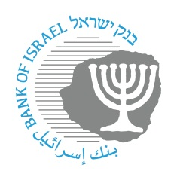
BANK OF ISRAEL
Office of the Spokesperson and Economic Information

October 22, 2023

Press Release:

Regulatory easings in view of the Swords of Iron War—The Banking Supervision Department adopts regulatory easings with the goal of assisting during the Swords of Iron War

The Banking Supervision Department today—October 22, 2023—published a temporary directive to the banking system to enable banks and credit card companies the business flexibility required at this time, with the goal of making things easier for customers who have been adversely impacted by the war situation and to permit consistency in providing the services. The temporary directive will be updated occasionally as needed.

The war situation in which we find ourselves requires providing a rapid response and aid to customers. To that end, the Banking Supervision Department is taking various steps. These include formulating a temporary directive that contains adjustments and leniencies that will assist in providing a response to customers of the banking system and support in dealing with the challenges of the situation. The Banking Supervision Department will continue to assist customers who have been adversely impacted by the war situation in ways that are available to it. Among other things it will examine granting additional regulatory easings, as needed.

LINK to the Directive (in Hebrew). The Directive in English is forthcoming.

The public enquiries unit: 02-655-2680 or *9086

