

BANK OF ISRAEL
Office of the Spokesperson and Economic Information

December 23, 2024
Press Release:

Israel’s International Investment Position (IIP),
third quarter of 2024

- In the third quarter of 2024, the balance of assets held abroad by Israeli residents increased by approximately $37.5 billion (about 5.1 percent), to about $770 billion at the end of September. The increase was mainly due to net investments abroad by Israeli residents and an increase in the prices of foreign securities held by Israeli residents.
- Outstanding liabilities to abroad increased by approximately $24.6 billion (about 5 percent) in the third quarter, to about $528 billion at the end of the quarter. The increase was primarily due to a combination of an increase in the prices of Israeli securities held by nonresidents and the flow of net investments in Israel by nonresidents. In the third quarter, nonresidents resumed net investments in Israeli securities, in contrast with the realizations of the past two years.
- Israel’s surplus of assets over liabilities vis-à-vis abroad increased by approximately $13 billion (5.6 percent) in the third quarter, to about $242 billion at the end of the quarter.
- The surplus of assets over liabilities vis-à-vis abroad in debt instruments alone (negative net external debt) increased by about $15.6 billion (5.9 percent) during the third quarter, to approximately $282 billion at the end of September.
- The ratio of gross external debt to GDP increased by about 0.7 percentage points in the third quarter, to about 28 percent at the end of September.

Table 1: Asset and liability balances, and changes in them

- The balance of Israelis’ assets abroad
In the third quarter of 2024, the value of the assets held abroad by Israeli residents increased by about $37.5 billion (about 5.1 percent), to approximately $770 billion at the end of September.

- The value of direct investments increased by about $3 billion (approximately 2.7 percent) in the third quarter, mainly as a result of reinvested earnings.
- The value of the securities portfolio increased by about $12.8 billion (about 4.9 percent) during the third quarter, mainly as a result of price increases totaling approximately $6.9 billion on foreign securities held by Israeli residents, and net investment in foreign securities by Israeli residents totaling about $5.8 billion. (Figure 1).
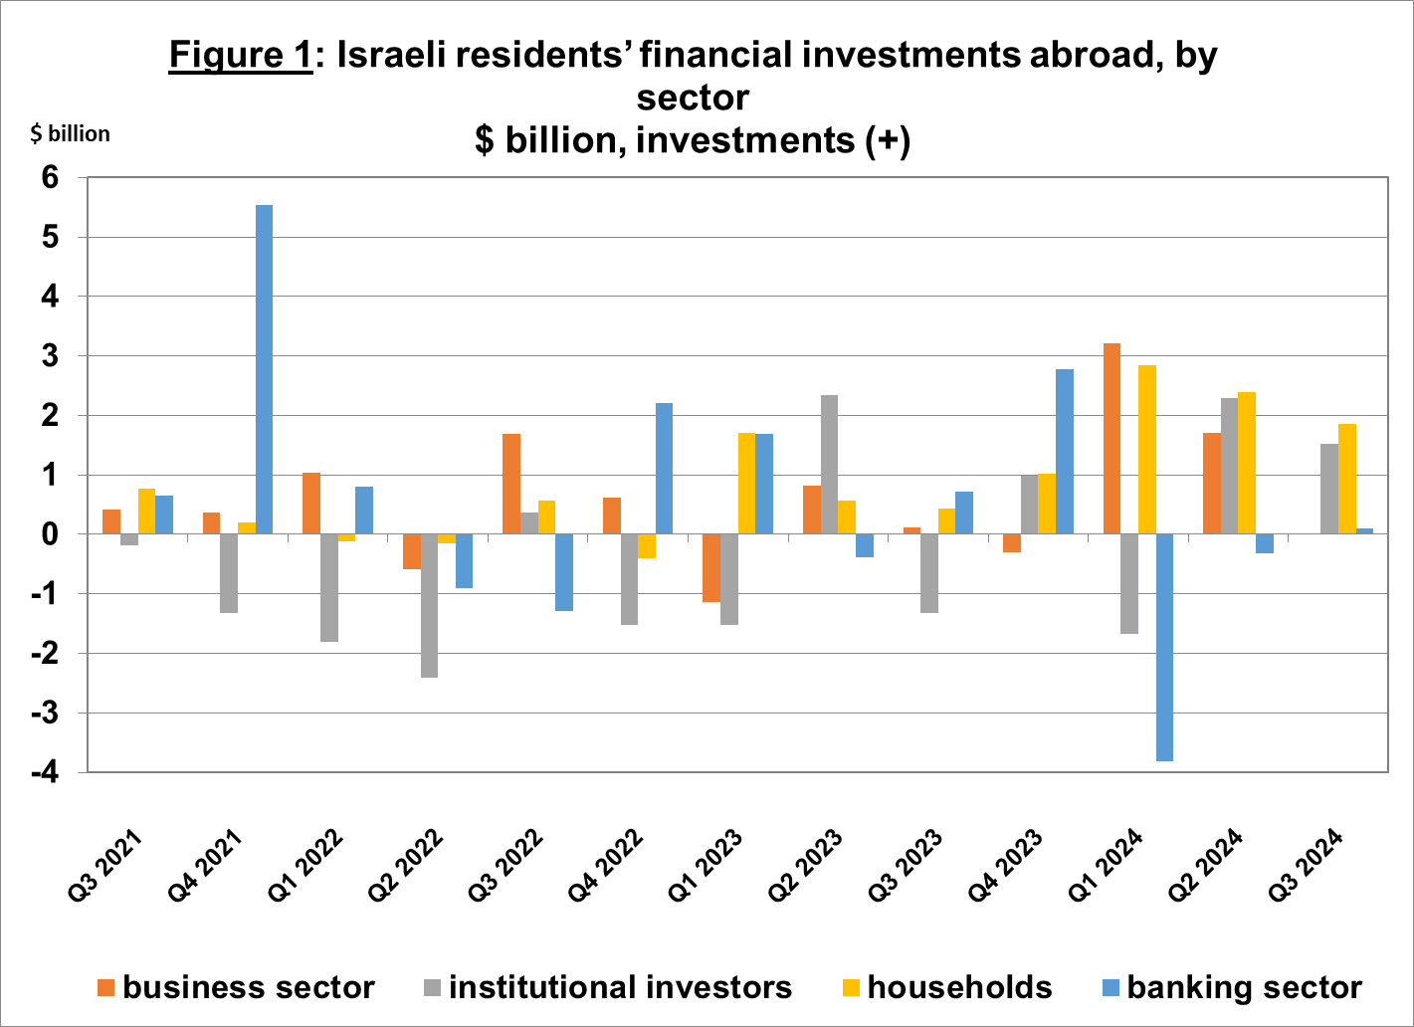
Source: Bank of Israel data and processing¹.
- The value of other investments abroad increased by about $9.6 billion (about 6.3 percent) in the third quarter. The increase derived mainly from net deposits abroad by Israelis (including banks) totaling about $4.2 billion, the provision of loans to nonresidents totaling about $1 billion, and net investments in other assets totaling about $0.7 billion.
- The value of the reserve assets increased by about $10 billion (about 4.8 percent) during the third quarter, to about $220 billion at the end of September. The increase was mainly due to price increases totaling about $5.5 billion. In addition, the weakening of the dollar against other currencies contributed an increase of about $4.3 billion in the value of the reserve assets.
- The composition of Israelis’ securities portfolio abroad: During the third quarter, the share of equity instruments in Israeli residents’ portfolio abroad remained unchanged, and was 44 percent at the end of September. Accordingly, the share of debt instruments was 56 percent at the end of the quarter.

- Israel’s liabilities to abroad

The balance of Israel's liabilities to abroad increased by about $24.6 billion (about 4.9 percent) during the third quarter, to approximately $528 billion at the end of the quarter. The increase was mainly due to an increase in prices of Israeli securities held by nonresidents, and net investments in Israel by nonresidents (mainly direct investments).

- The value of direct investments in the economy increased by about $7.1 billion (about 2.9 percent) during the third quarter, mainly due to an increase in net investments by nonresidents totaling about $5.6 billion (half of which was reinvested earnings), and an increase in the prices of Israel shares held by nonresident parties at interest. In the first three quarters of 2024, the volume of net direct investments was similar to the volume in the same period in the previous year (Figure 2).
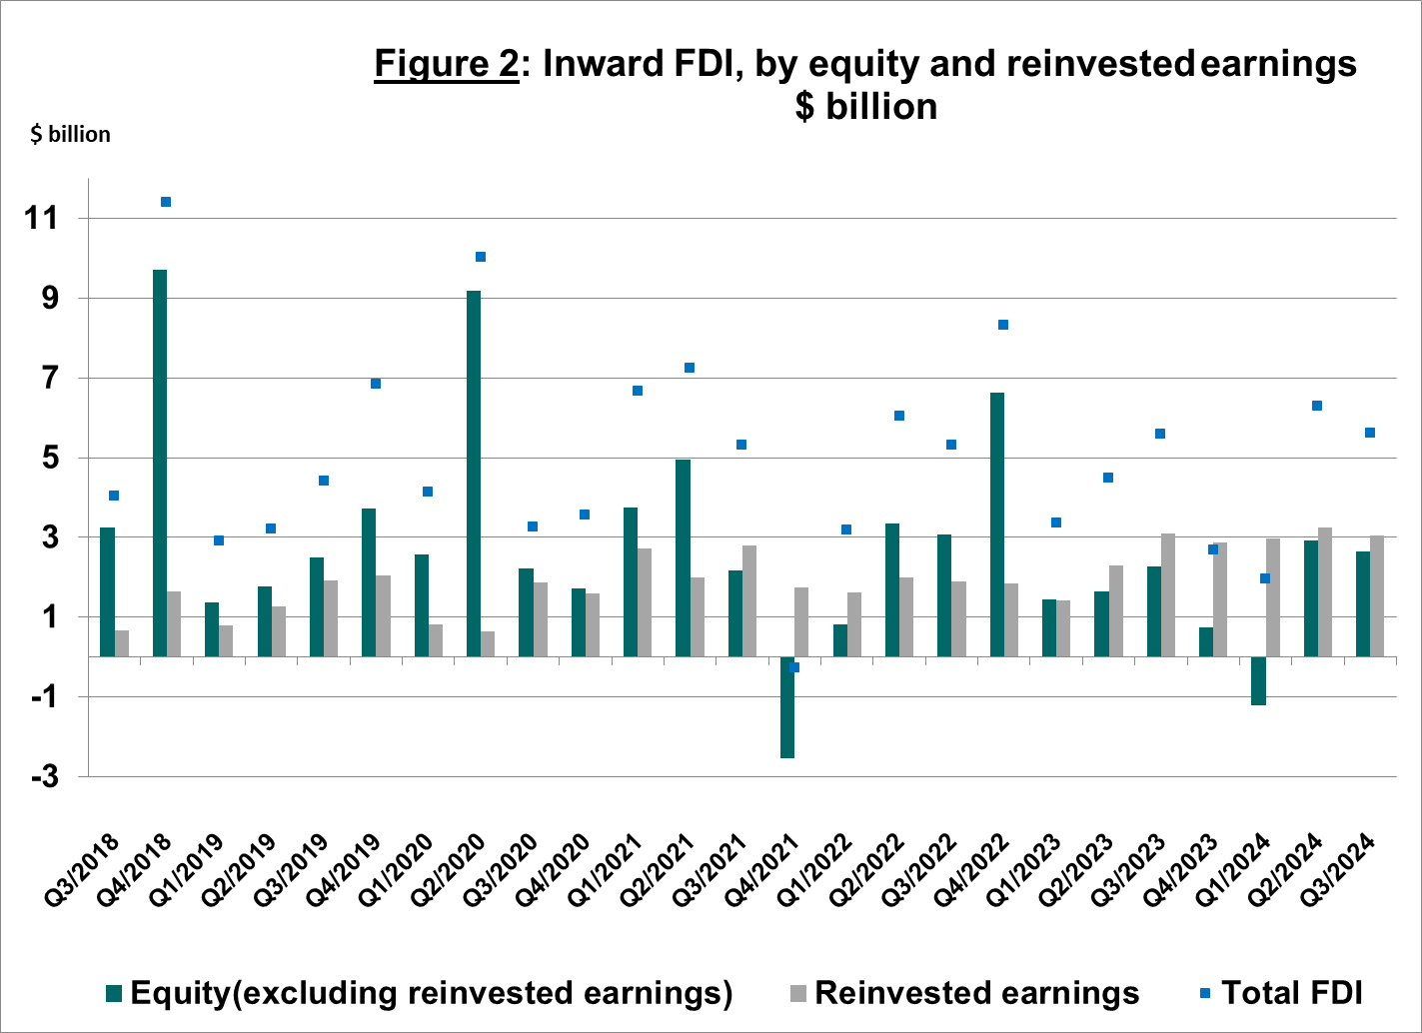

Source: Bank of Israel data and processing¹.

- The value of the securities portfolio increased by about $14.1 billion (about 7.4 percent) in the third quarter, mainly due to an increase of about $9.8 billion in the prices of Israeli securities, and nonresidents’ net investments totaling about $3 billion. Nonresidents made investments in Israeli shares traded in Tel Aviv, and realized investments in Israeli shares traded abroad. In the third quarter, nonresidents resumed making net investments in Israeli securities, in contrast with the realizations of the previous two years.

- The value of nonresidents' financial portfolio on the Tel Aviv Stock Exchange, which makes up a part of nonresidents’ investments in Israel, increased by about $10 billion in the third quarter, to about $67.3 billion at the end of September. Nonresidents invested about $3.2 billion in government bonds (including Makam), and purchased shares of Israeli companies totaling about $1.5 billion. (Figure 3 and Figure 4).
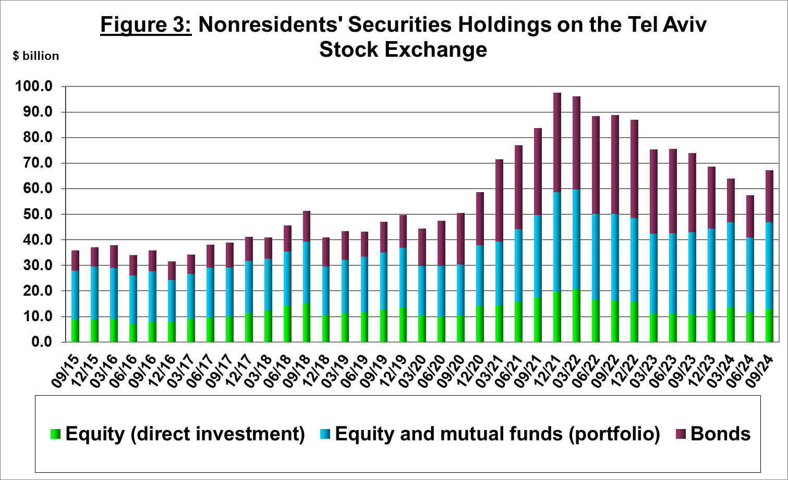
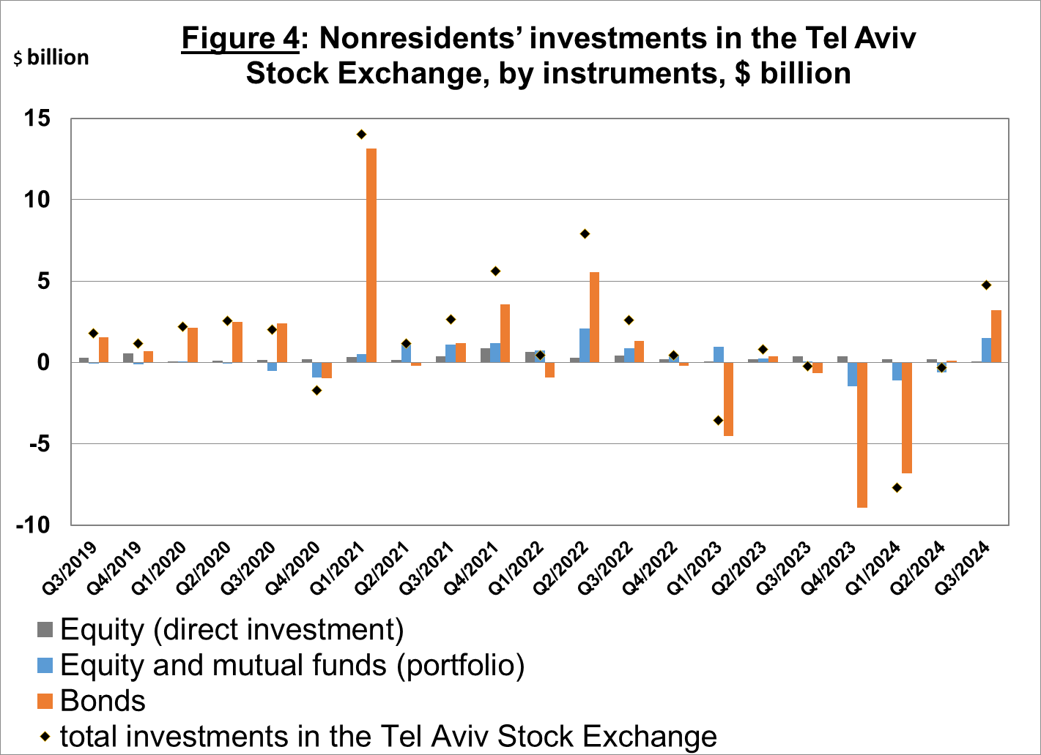

Source: Israel Securities Authority, and Bank of Israel data and processing¹.

The value of other investments in the economy increased by about $3.3 billion (about 5.2 percent) in the third quarter, to about $67 billion. The increase was mainly due to net deposits by nonresidents (including banks) of about $1.9 billion in deposits at Israeli banks, the provision of loans totaling about $0.5 billion by nonresidents, and an increase of a similar amount in suppliers’ credit.

The balance of liabilities in debt instruments alone, which makes up Israel's gross external debt, increased by about $5.8 billion (4.1 percent) in the third quarter, to about $147 billion.

The ratio of gross external debt to GDP increased by about 0.7 percentage points in the third quarter, to about 27.9 percent at the end of September (Figure 5).

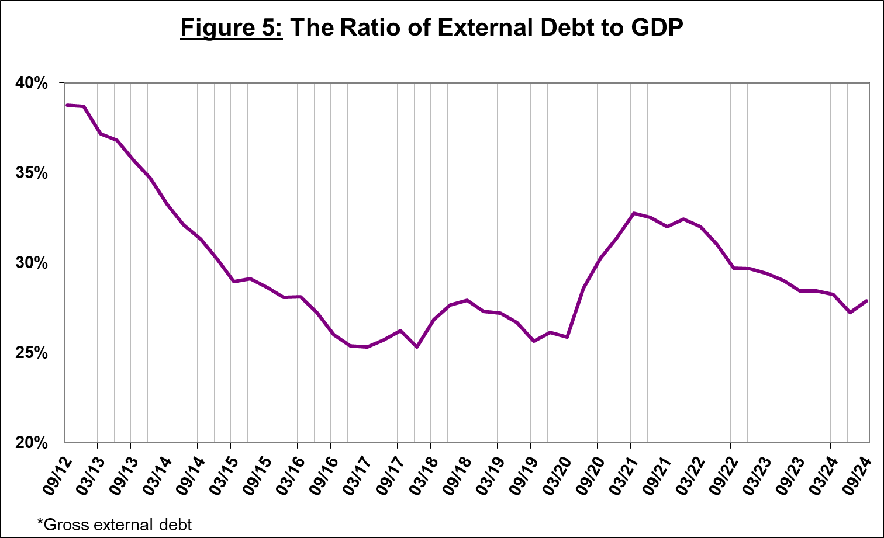

Source: Israel’s Ministry of Finance, Israel’s Central Bureau of Statistics, and Bank of Israel data and processing.¹

- Israel’s surplus assets over liabilities vis-à-vis abroad

The increase in the balance of assets was greater than the increase in the balance of liabilities, which led to an increase of about $13 billion (5.9 percent) in the surplus of assets over liabilities vis-à-vis abroad, which totaled about $242 billion at the end of September (Figure 6).
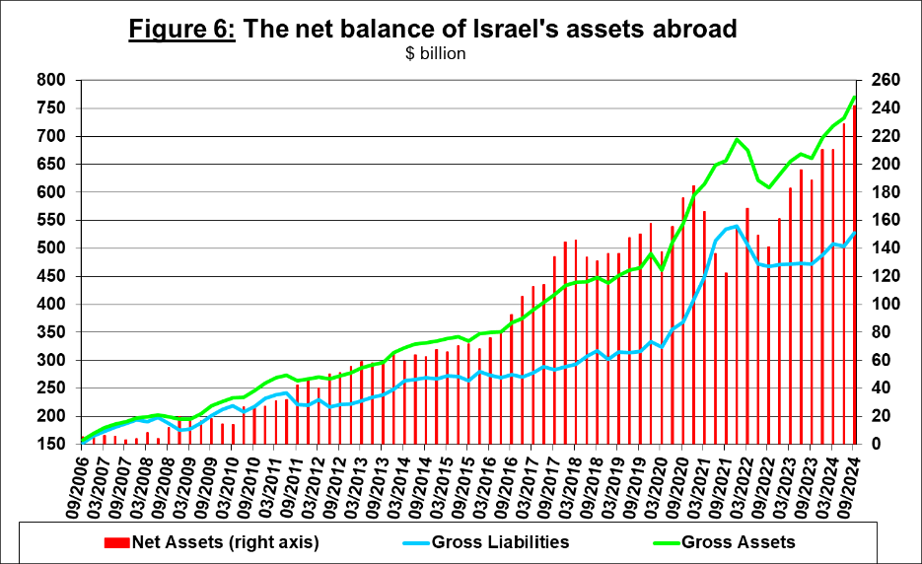

Source: Bank of Israel data and processing¹.

- Net external debt

The surplus of assets over liabilities vis-à-vis abroad in debt instruments alone (negative net external debt) increased by approximately $15.6 billion (about 5.9 percent) in the third quarter, to about $282 billion at the end of September (Figure 7).

The balance of assets in debt instruments increased by about $21.5 billion in the third quarter, to about $429 billion at the end of the quarter, of which about $220 billion is the Bank of Israel's foreign exchange reserves. This balance reflects a coverage ratio of 2.9 times the gross external debt.

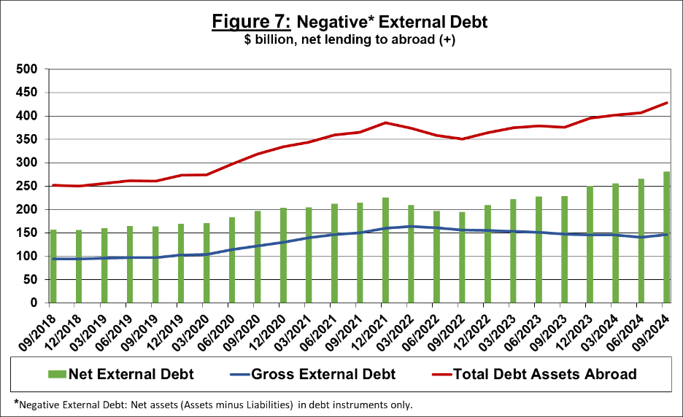

Source: Israel’s Ministry of Finance, and Bank of Israel data and processing.

For the complete data file, click here.

