
BANK OF ISRAEL
Office of the Spokesperson and Economic Information

Press release

January 25, 2023

Dr. Eyal Argov has been appointed Head of the Macroeconomics and Policy Division in the Bank of Israel’s Research Department

Following a tenders process conducted by the Bank of Israel, Dr. Eyal Argov has been chosen for the position of Head of the Macroeconomics and Policy Division in the Research Department.

Dr. Argov began working at the Bank of Israel about 20 years ago, as an economist in the Monetary Division and in the Research Department, developing models to support monetary policy decision-making. Over the past 11 years, he has managed the macroeconomics and economic activity field in the Research Department. As part of his work, he has advanced research studies in the areas of long-term growth and labor productivity. This work has led to a number of reports that were written by the Bank, with significant policy recommendations to the government. In addition, Eyal and his staff have dealt with the formulation of the Research Department’s staff forecast and assessments of the state of macroeconomic activity for the purpose of making monetary policy decisions. This work has included the development of new analysis tools and data sources, including during the COVID-19 crisis. Eyal holds Bachelor’s, Master’s, and doctorate degrees in Economics from the Hebrew University of Jerusalem, as well as a Master’s degree in Political Science from the University of Haifa. He is also a graduate of the National Security College.

The Macroeconomics and Policy Division in the Research Department plays a significant role in formulating the picture of the real economy as part of the analysis of economic activity in Israel within the Bank of Israel’s policy discussions. In addition, the Division deals with analyses and studies of economic policy in Israel, and provides insights and recommendations that help formulate the government’s economic policy in a variety of fields.

Research Department Director Dr. Adi Brender said, “The Macroeconomics and Policy Division plays a central role in analyzing the economic picture in Israel and in presenting economic insights to the Governor and the Monetary Committee of the Bank of Israel. The Division also makes important contributions to the design of the government’s economic policy through research studies, policy analyses, and recommendations formulated by the Division’s researchers, whether on their own or in cooperation with government ministries. I have no doubt that Eyal’s wealth of experience and his high level of ability will make it possible to continue and expand the Division’s contributes in these important areas. Based on my work together with Eyal, I am also convinced that his interpersonal skills will help him drive the Division’s researchers and, together with them, generate insights and high-quality research that will contribute to the Israeli economy.”

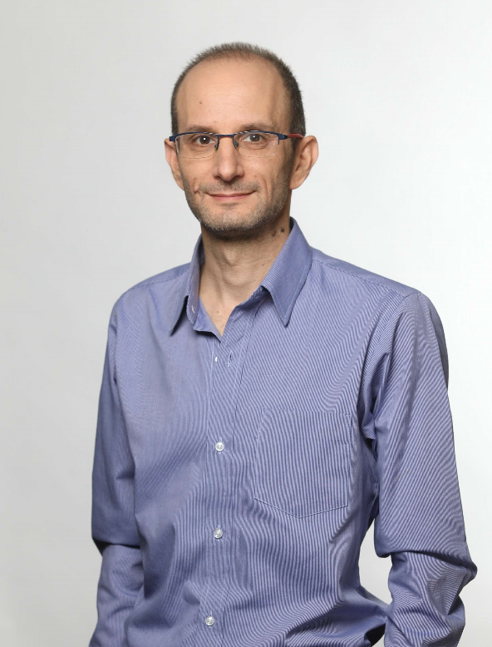

Credit: Eyal Twaeg

