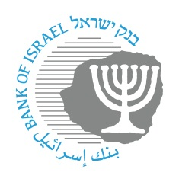

BANK OF ISRAEL
Office of the Spokesperson and Economic Information

Press Release
October 16, 2025

The Bank of Israel welcomes the decisions by the Capital Market Authority and the Israel Securities Authority to begin regulating the exposure of institutional investors and mutual funds to foreign currency through derivatives

A Bank of Israel analysis of the insights from the COVID-19 crisis shows that institutional investors’ exposure to equity indices abroad through derivatives may have an impact on the stability of the Israeli financial markets. In view of this, the Bank of Israel initiated the establishment of a joint working group with the Israel Securities Authority and the Capital Market, Insurance and Savings Authority to examine this issue in depth.
The conclusions of the joint team have led to the formulation of a new regulatory framework governing the exposure of institutional investors and mutual funds to foreign currency through derivatives. As part of this framework, a foreign currency liquidity threshold will be set at 10% of the total exposure to foreign currency derivatives.
In recent years, there has been a significant increase in the exposure of institutional investors and mutual funds to foreign equity indices through derivatives. Under certain market conditions, such exposure may trigger substantial margin calls in foreign currency within a short timeframe. This could result in insufficient foreign currency liquidity among investors, thereby amplifying volatility in Israel’s capital and foreign exchange markets.
The recommendation was discussed by the Financial Stability Committee and received its full support. It constitutes an important step toward strengthening the stability of Israel’s capital market, foreign exchange market, and the financial system as a whole.
Bank of Israel Governor Professor Amir Yaron, stated: “The exposure of institutional investors and mutual funds to foreign equity indices through derivatives, which has increased significantly in recent years, may under certain circumstances create considerable risks to the capital market and, in particular, to the foreign exchange market. The introduction of a foreign currency liquidity threshold is a highly important measure that will contribute to the strength of Israel’s financial system. I welcome its advancement.”

