
BANK OF ISRAEL
Office of the Spokesperson and Economic Information

Press release

March 18, 2026

Israel’s International Investment Position (IIP),
fourth quarter of 2025

- The economy’s outstanding liabilities to abroad increased by approximately $28 billion (about 4.5 percent) in the fourth quarter, to about $652 billion at the end of the quarter. During the quarter, nonresidents’ direct investments in Israel increased, including in share capital, relative to the previous 4 quarters. At the same time, the prices of Israeli securities held by nonresidents increased.
- In the fourth quarter of 2025, the balance of assets held abroad by Israeli residents increased by approximately $29 billion (about 3.2 percent), to about $915 billion at the end of December. The increase in the balance was mainly due to net investments abroad by Israeli residents and an increase in prices of foreign securities held by Israeli residents.
- The surplus of assets over liabilities vis-à-vis abroad increased during the fourth quarter of 2025 by $1 billion (0.3 percent), to about $263 billion at the end of the quarter.
- The surplus of assets over liabilities vis-à-vis abroad in debt instruments alone (negative net external debt) increased by about $9 billion (2.8 percent) during the fourth quarter, to approximately $331 billion at the end of December.
- The ratio of gross external debt to GDP (in dollar terms) declined by 0.2 percentage points in the fourth quarter, to about 26.6 percent at the end of December.

Full year summary of 2025:
- In 2025, there was an increase in net investments in the economy by nonresidents. The scope of net investments was $39 billion, compared to $25 billion in 2024.
- The increase in scope of net investments by nonresidents in the economy derived mainly from the increase in direct investments (mainly reinvested earnings).
- The scope of net investments abroad by Israel residents in 2025 was larger than its scope in 2024, totaling $56 billion.

Table 1: Asset and liability balances, and changes in them

1. Balance of Israeli residents’ assets abroad
The balance of Israeli residents’ assets abroad increased in the fourth quarter of 2025 by about $29 billion (approximately 3.2 percent) to $915 billion at the end of December.
- The value of direct investments increased in the fourth quarter by $2.5 billion (about 2 percent) as a result of net investments by Israeli residents.
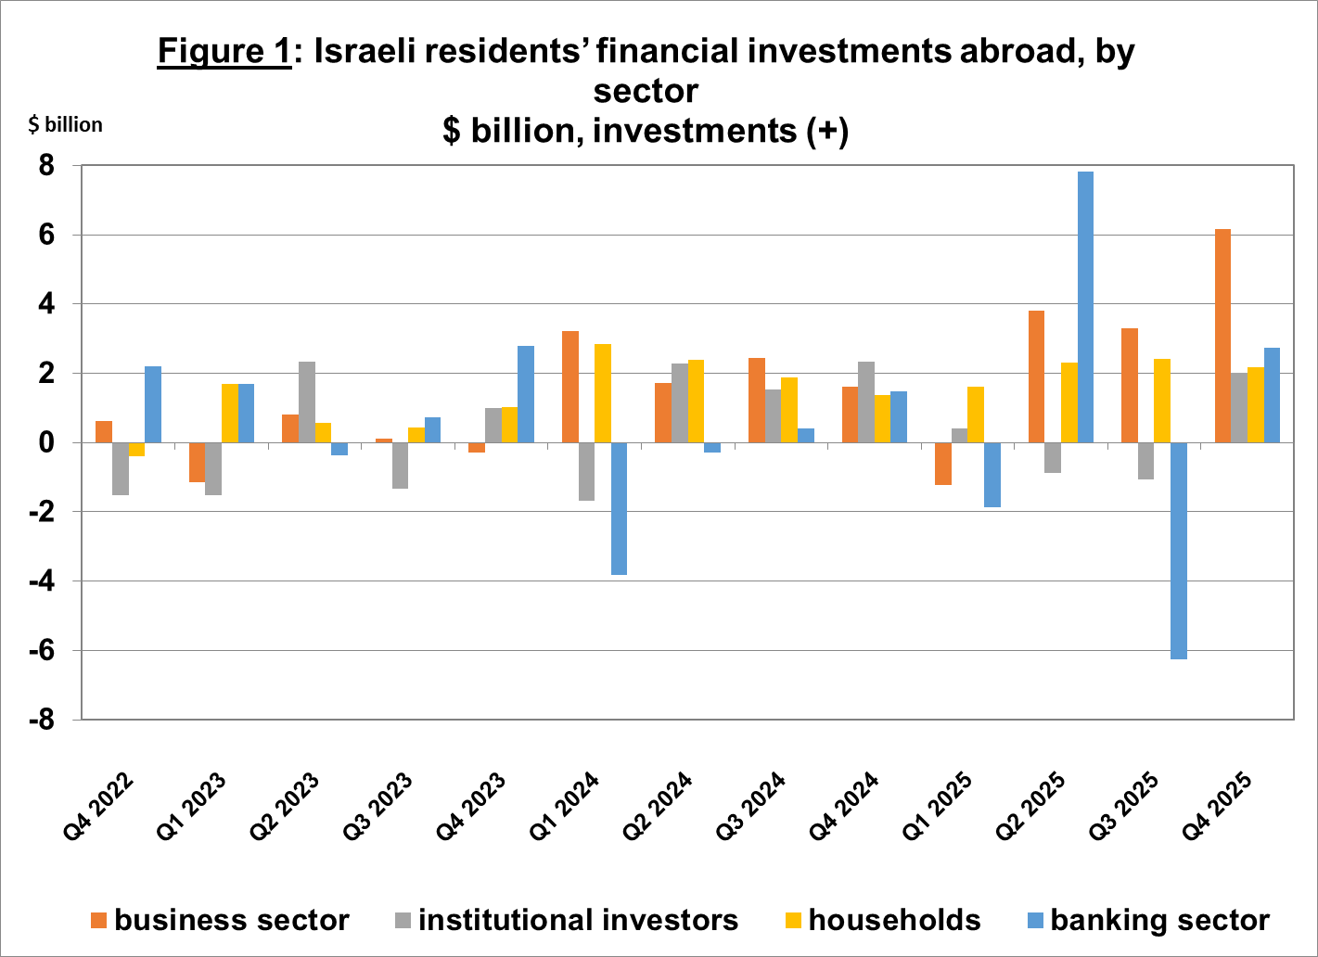
- The value of the securities portfolio increased during the fourth quarter by about $19.4 billion (about 5.8 percent), the result mainly of net investments of $13 billion by Israeli investments in foreign securities, and by an increase in the prices of foreign securities held by Israeli residents, totaling approximately $5 billion. The business sector invested about $6.2 billion and the remaining sectors invested a similar amount (Figure 1).

- The value of other investments abroad increased in the fourth quarter by about $11.5 billion (about 6 percent). Israeli residents issued loans to nonresidents totaling approximately $2.5 billion. In parallel, Israeli residents (including banks) deposited a net of about $2 billion in deposits abroad. In addition, there was a sharp increase in customer credit, totaling about $5.8 billion.
- The reserve assets value declined in the fourth quarter by approximately $2.4 billion (about 1 percent), and reached a level of about $230 billion at the end of December. The decline in the balance derived mainly from government activity.
- The composition of the portfolio abroad: During the fourth quarter, the share of capital instruments in the assets portfolio of Israeli residents’ abroad remained unchanged, and was 46 percent at the end of December. Accordingly, the share of debt instruments at the end of the quarter was 54 percent.

2. The balance of the economy’s liabilities to abroad
In the fourth quarter of 2025, the value of the economy’s liabilities to abroad increased by about $28 billion (about 4.5 percent), to approximately $652 billion at the end of the quarter. The increase in the balance derived mainly from direct investments by nonresidents in Israel and from an increase in Israeli securities prices held by nonresidents.
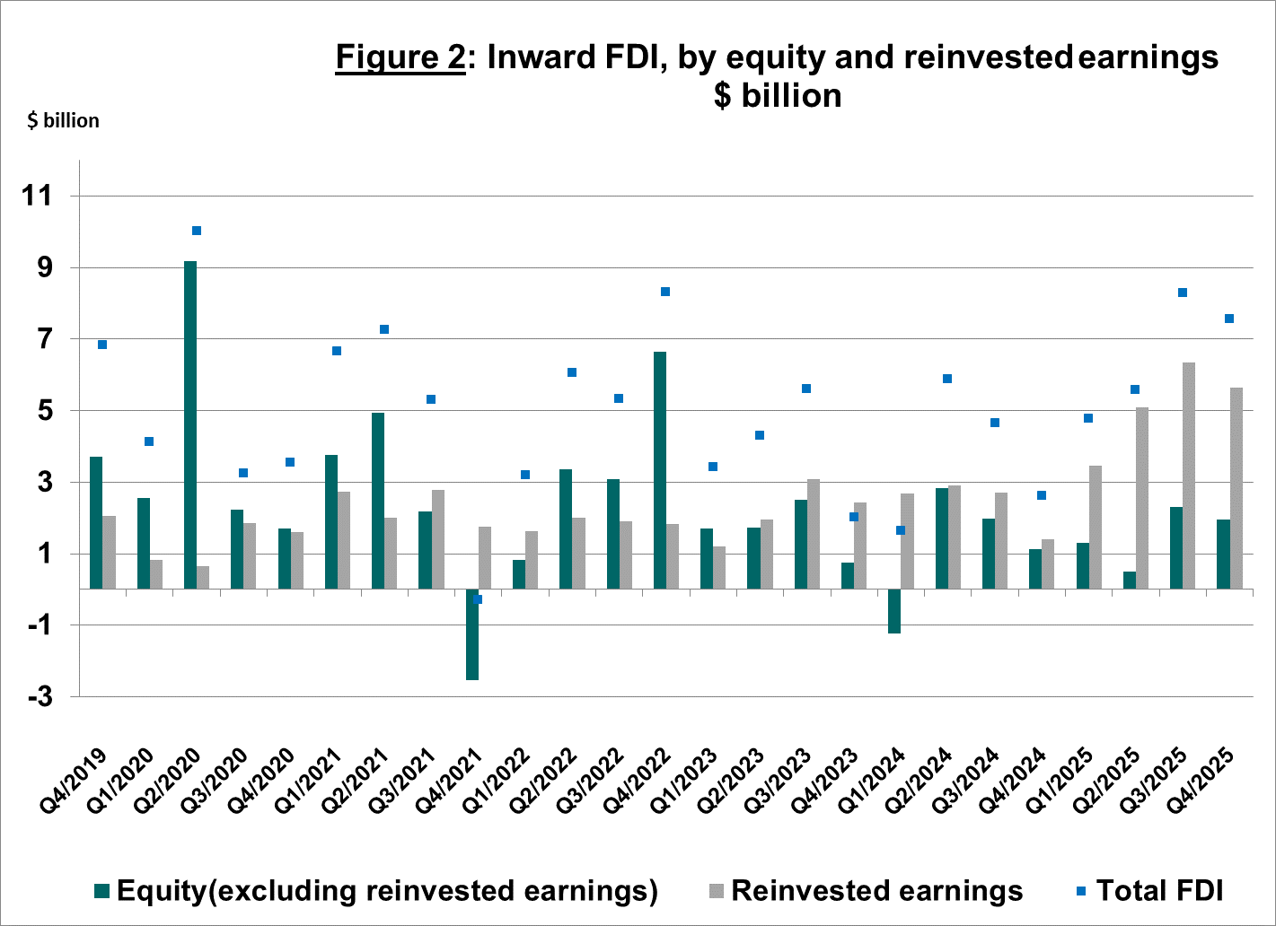
- The value of direct investments in the economy increased by about $11 billion (approximately 3.8 percent) in the fourth quarter, a result of net investments of $8 billion by nonresidents (mainly reinvested earnings) and by an increase in Israeli equity prices held by nonresident parties at interest (Figure 2).
Source: Bank of Israel data and processing¹.

- The value of the securities portfolio increased during the fourth quarter by about $15 billion (about 15.7 percent). The increase derived mainly from an increase in prices of Israeli securities held by nonresidents, totaling about $8 billion. Nonresidents invested a net of $0.4 billion in Israeli equities, with net investments in Israeli bonds totaling $2.6 billion.
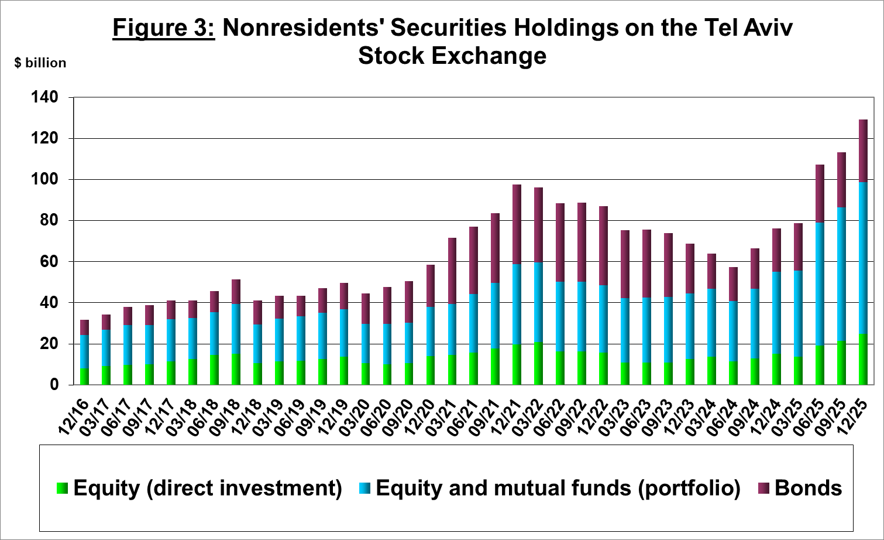
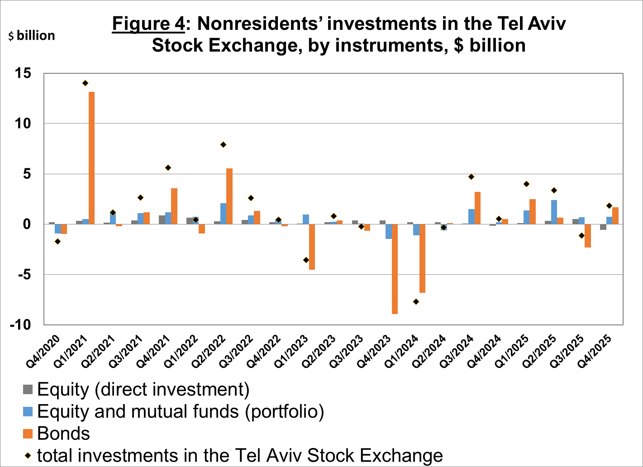
- The portfolio value of nonresidents on the Tel Aviv Stock Exchange (which makes up part of the balance of nonresidents’ investments in the economy), increased in the fourth quarter by about $6.2 billion and was $113 billion at the end of December (Figure 3 and Figure 4).
Source: Israel Securities Authority, and Bank of Israel data and processing¹.

- The value of other investments in the economy increased during the fourth quarter by about $2 billion (about 2.7 percent), to $76 billion. The increase derived mainly from an increase of $2.4 billion in suppliers credit. In contrast, nonresidents (including banks) withdrew $1 billion from Israeli bank deposits.
- The balance of liabilities in debt instruments alone making up the gross external debt of the economy increased during the fourth quarter by about $6 billion (3.7 percent) to a level of $165 billion.
- The ratio of gross external debt to GDP in the fourth quarter declined by 0.2 percentage points, totaling 27 percent at the end of December. The decline in the ratio of gross external debt to GDP reflected a decline in the balance of gross external debt and an increase in GDP in dollar terms. (Figure 5)
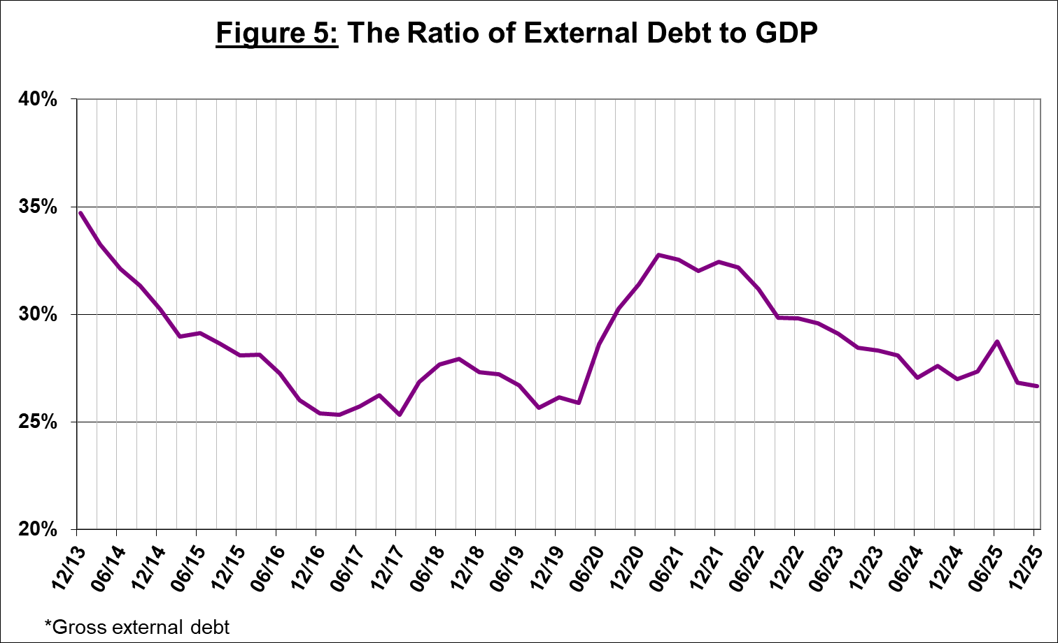
Source: Israel’s Ministry of Finance, Israel’s Central Bureau of Statistics, and Bank of Israel data and processing.¹

3. Surplus of assets over liabilities in the economy vis-à-vis abroad

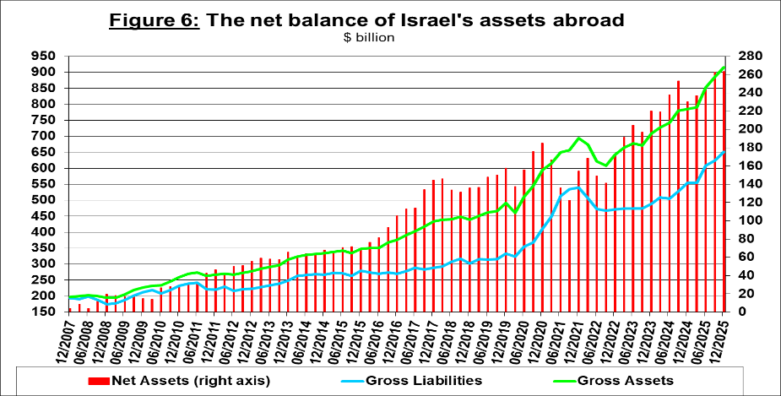
The increase in the balance of assets that was larger than the increase in the balance of liabilities led to an increase of about $1 billion (0.3 percent) in the surplus of assets over liabilities of the economy vis-à-vis abroad, which was $263 billion at the end of December (Figure 6).
Source: Bank of Israel data and processing¹.

4. Israel’s surplus assets over liabilities vis-à-vis abroad in debt instruments alone
The surplus of assets over liabilities in debt instruments alone (net external debt) increased during the fourth quarter by about $9 billion (2.8 percent) to $331 billion (Figure 7).

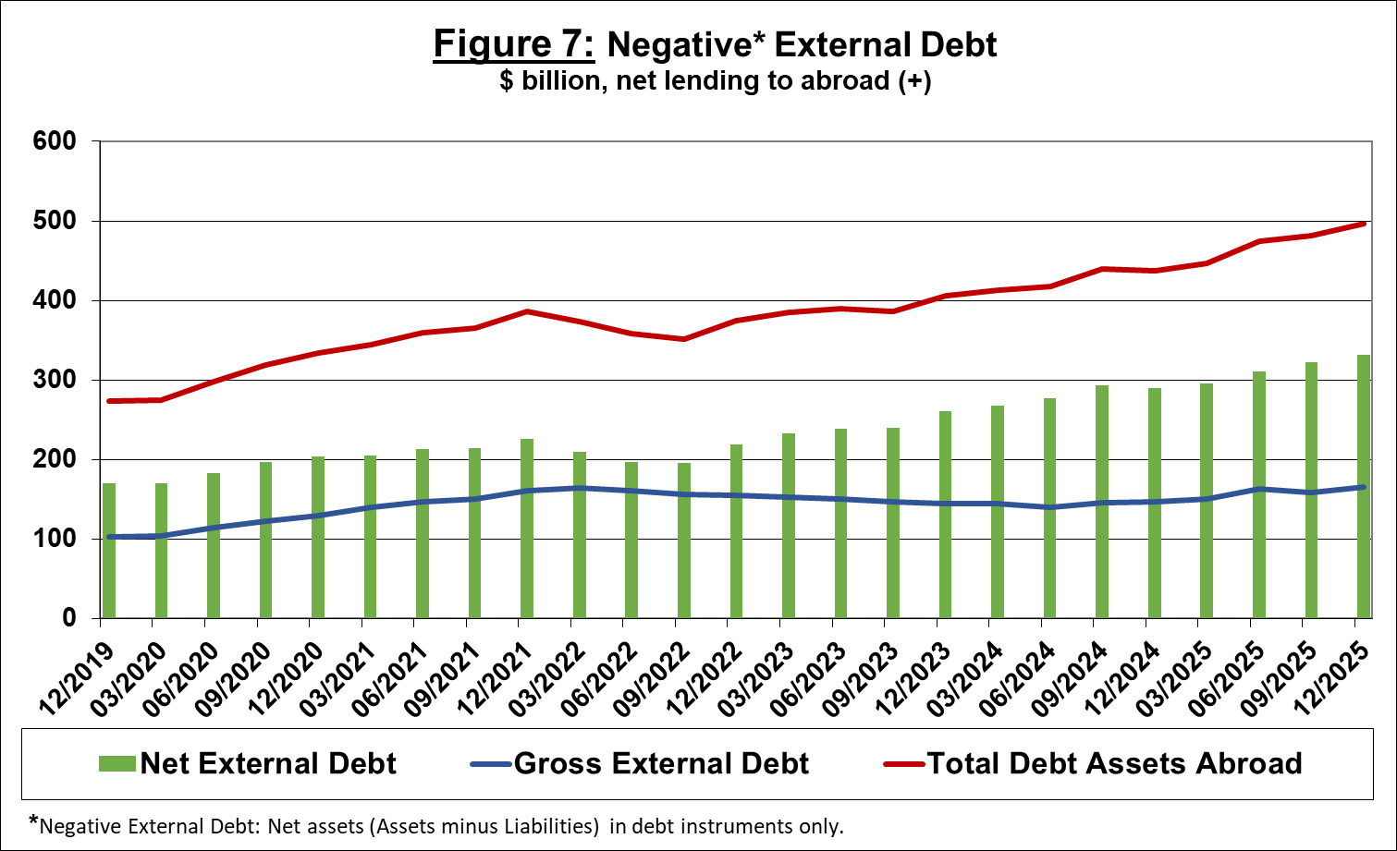
The balance of assets in debt instruments increased in the fourth quarter by $15 billion to around $496 billion, of which $230 billion are the Bank of Israel’s foreign exchange reserves. This balance reflects a coverage ratio of 3 times the gross external debt.

Source: Israel’s Ministry of Finance, and Bank of Israel data and processing.

For the complete data file, click here.

Bank of Israel data and processing: The Bank of Israel’s Information and Statistics Department collects data from numerous varied sources. Most of the data on the economy’s activity vis-à-vis abroad are received by force of a Bank of Israel Order, from direct reports by corporations and individuals to the Bank of Israel. (See: Information Regarding Foreign Exchange Market Developments in Israel, 5770–2010). Additional data used for measuring economic activity vis-à-vis abroad are received by reports from the Bank of Israel’s Accounting Division, the Ministry of Finance, the Central Bureau of Statistics, the Israel Securities Authority, domestic banks and other financial intermediaries, and institutional investors. The Department carries out estimations and processing on data received from the various sources.

