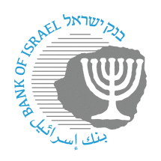
BANK OF ISRAEL
Office of the Spokesperson and Economic Information

Press release

May 1, 2023

The International Monetary Fund delegation begins its discussions on the Israeli economy

The annual International Monetary Fund (IMF) delegation began its discussions on developments in the Israeli economy this morning.

Upon the completion of the meetings, the delegation will submit an initial report to the Minister of Finance and the Bank of Israel Governor on May 11. Following that, a detailed annual report will be written in Washington, and will be submitted to the IMF Executive Council, as is customary regarding every IMF member country.

The delegation is headed by Miguel Segoviano, and includes three other economists: Shakill Hassan, Pablo Druck, and Luca Mazzone.

As in every year, the delegation will hold consultations with leaders of the public sector and of the private sector. Among others, the delegation will meet with senior officials of the Bank of Israel and the Ministry of Finance, and with senior officials of other government ministries, banks, the Industrialists’ Association, the Histadrut, and more.

