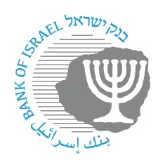

BANK OF ISRAEL
Office of the Spokesperson and Economic Information

Press Release
September 15, 2026

The Bank of Israel held a national emergency drill this week to examine the currency system’s preparedness for an earthquake scenario

The Bank of Israel held a national emergency drill this week to examine the currency system’s preparedness to maintain the cash supply and essential banking services during a crisis. The results of the drill indicated that the system’s participants have a high level of preparedness.
Limor Goldstein, Head of the Currency Department, said: “The national emergency drill to examine preparedness for an earthquake scenario, led by the Bank of Israel and the Currency Department, is another layer in increasing the system’s readiness for dealing with crises. Maintaining cash as a strategic national infrastructure is essential for increasing civilian resilience and maintaining a sense of personal security during both routine and emergency times. The drill is intended to ensure that we are professionally trained and ready when necessary.”

