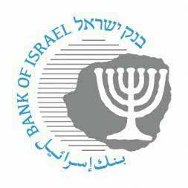

BANK OF ISRAEL
Office of the Spokesperson and Economic Information
July 13, 2023

Press Release:

The Bank of Israel Monetary Committee meets with financial forecasters

Governor of the Bank of Israel Prof. Amir Yaron and members of the Bank of Israel Monetary Committee today held their quarterly meeting with the group of forecasters that regularly provides the Bank of Israel with forecasts for inflation, the interest rate, and the exchange rate. The meeting provides an opportunity for exchanging opinions and assessments between the Bank of Israel and leading financial institutions in the economy.

The meeting began with reference to the various economic developments, after which Inon Gamrasni, an economist in the Research Department, presented and explained the Research Department’s assessment as published on July 10, 2023, in parallel with the recent interest rate announcement.

The forecasters responded and conveyed their assessments of developments.

