
BANK OF ISRAEL
Office of the Spokesperson and Economic Information

Press release

September 17, 2026

Israel’s International Investment Position (IIP),
Second quarter of 2026

- In the second quarter of 2026, the balance of assets held abroad by Israeli residents increased by approximately $92 billion (about 10 percent), to about $1,013 billion at the end of June. The increase in the balance was mainly due to price increases and net investments in foreign securities by Israeli residents.
- The economy’s outstanding liabilities to abroad increased by approximately $39 billion (about 6 percent) in the second quarter, to about $697 billion at the end of the quarter. The increase was mainly due to net investments by nonresidents. At the same time, the prices of Israeli securities held by nonresidents increased.
- The volume of direct investments (mainly undistributed profits) remained high during the second quarter, similar to the volume during the first quarter of the year.
- The surplus of assets over liabilities vis-à-vis abroad increased by about $53 billion (20 percent) during the second quarter of 2026, to about $316 billion at the end of the quarter.
- The surplus of assets over liabilities vis-à-vis abroad in debt instruments alone (negative net external debt) increased by about $11 billion (3.1 percent) during the second quarter, to approximately $350 billion at the end of June.
- The ratio of gross external debt to GDP (in dollar terms) increased by 0.2 percentage points in the second quarter, to about 27 percent at the end of June.

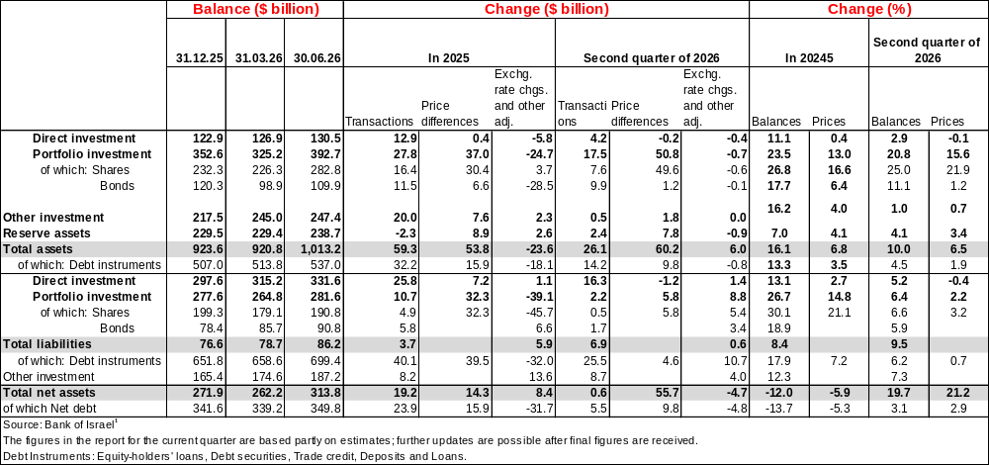
Table 1: Asset and liability balances, and changes in them
1. Balance of Israeli residents’ assets abroad
The balance of Israeli residents’ assets abroad increased by about $92 billion (approximately 10 percent) in the second quarter of 2026 to $1,013 billion at the end of June.
- The value of direct investments increased by $4 billion (about 3 percent) in the second quarter.
- The value of the securities portfolio increased by about $68 billion (about 20 percent) during the second quarter, mainly the result of increases in the prices of foreign securities held by Israeli residents totaling about $51 billion, and net investments in foreign securities by Israeli residents totaling about $17 billion. The banking sector invested about $10 billion, and the other sectors invested about $7 billion combined (Figure 1).
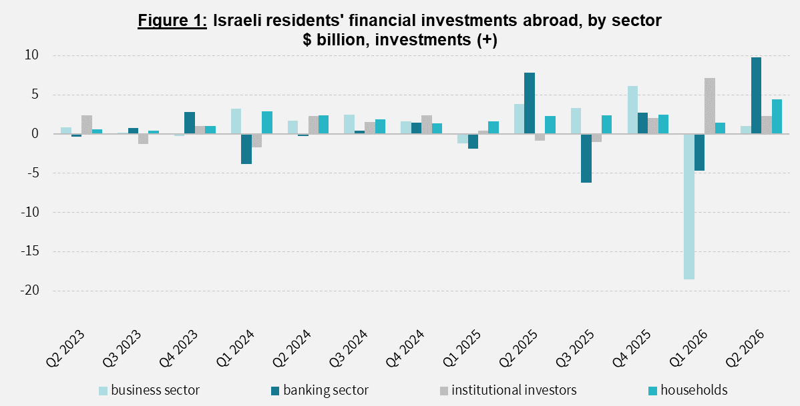

- The value of other investments abroad increased by about $2 billion (about 1 percent) in the second quarter. Israeli residents (including banks) made net withdrawals of about $6 billion from deposits abroad. At the same time, in view of the recovery in economic activity, there was an increase of about $4.9 billion in customer credit.
- The value of reserve assets increased by about $9 billion in the second quarter, to about $239 billion at the end of June, mainly due to an increase in the prices of foreign securities totaling about $8 billion. In addition, foreign exchange purchases by the Bank of Israel contributed about $2 billion to the increase.
- The composition of the portfolio abroad: The share of capital instruments in Israeli residents’ asset portfolio abroad was 47 percent at the end of the second quarter, virtually unchanged from the end of the previous quarter. Accordingly, the share of debt instruments at the end of the quarter was 53 percent.

2. The balance of the economy’s liabilities to abroad
In the second quarter of 2026, the value of the economy’s liabilities to abroad increased by about $39 billion (about 6.2 percent), to approximately $697 billion. The increase in the balance was mainly derived from nonresidents’ direct investments in Israel and from the strengthening of the shekel against the US dollar during the quarter.
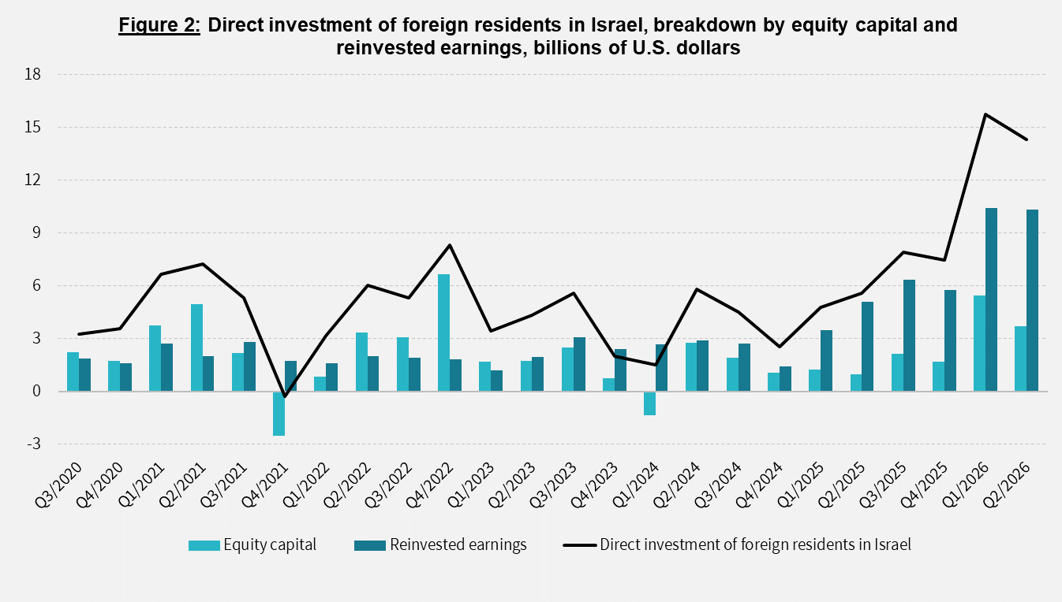
- The value of direct investments in the economy increased by about $14 billion (approximately 4.6 percent) in the second quarter, a result of net investments of $14 billion by nonresidents (mainly undistributed profits). During the first half of 2026, there was a sharp increase in the volume of undistributed profits relative to previous years (Figure 2).

- The value of the securities portfolio increased by about $17 billion (about 6.4 percent) during the second quarter, a result of the strengthening of the shekel against the US dollar and of an increase in the prices of Israeli securities held by nonresidents.
- The value of nonresidents’ portfolio on the Tel Aviv Stock Exchange (which makes up part of the balance of nonresidents’ investments in the economy), increased by about $9 billion in the second quarter, to about $154 billion at the end of June (Figure 3 and Figure 4).
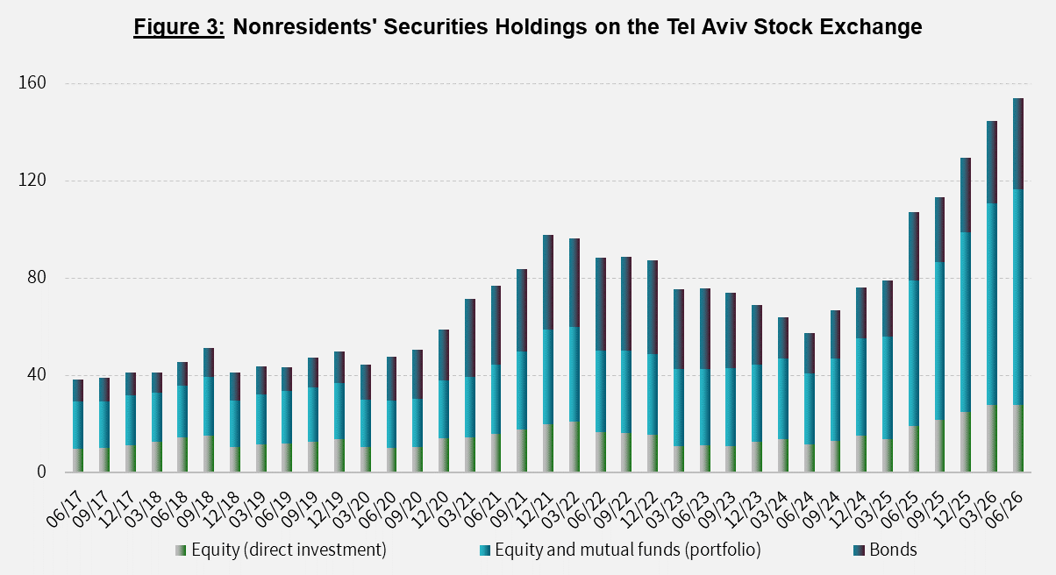
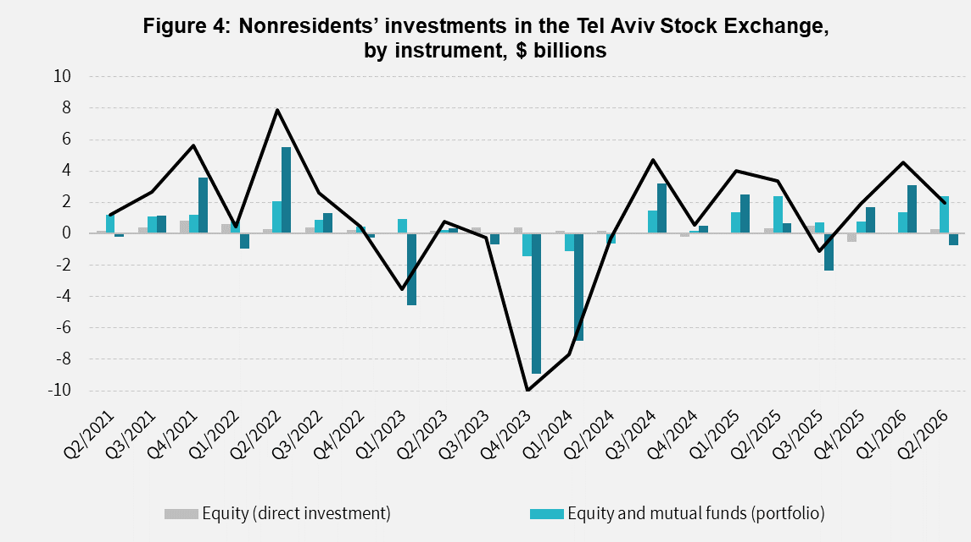
Source: Bank of Israel data and processing¹.

- The value of other investments in the economy increased by about $8 billion (about 9.5 percent) during the second quarter, to $86 billion. The increase derived mainly from net deposits by nonresidents (including banks) in Israeli bank deposits, totaling about $4 billion. At the same time, there was an increase in supplier’s credit totaling about $3 billion.
- The balance of liabilities in debt instruments alone, making up the economy’s gross external debt, increased by about $13 billion (7.3 percent) during the second quarter, to about $187 billion.
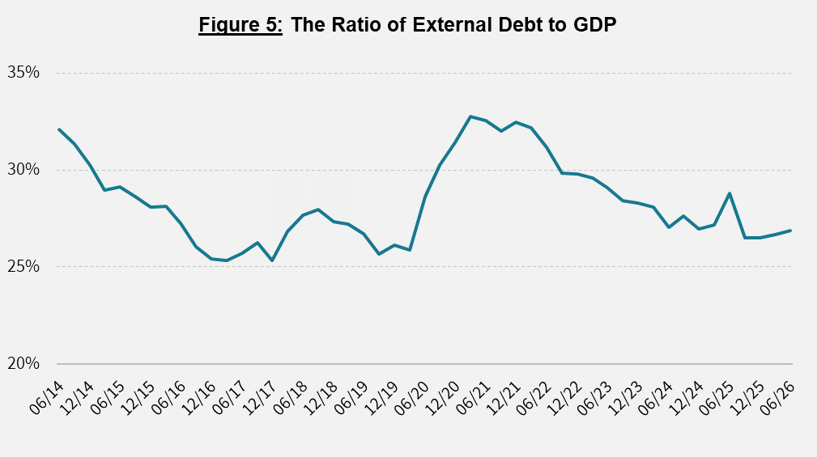
- The ratio of gross external debt to GDP increased by 0.2 percentage points during the second quarter, to about 27 percent at the end of June. The increase in the ratio of gross external debt to GDP reflected an increase in the balance of gross external debt that was greater than the increase in GDP in dollar terms. (Figure 5)
3. The economy’s surplus of assets over liabilities vis-à-vis abroad
The greater increase in the balance of assets than in the balance of liabilities led to an increase of about $53 billion (20 percent) in the economy’s surplus of assets over liabilities vis-à-vis abroad, which was $316 billion at the end of June (Figure 6).
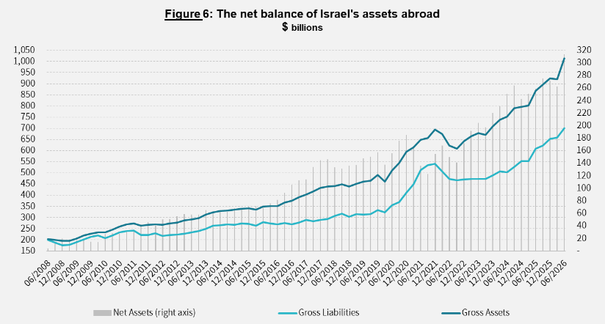

Source: Bank of Israel data and processing¹.

4. Israel’s surplus of assets over liabilities vis-à-vis abroad in debt instruments alone
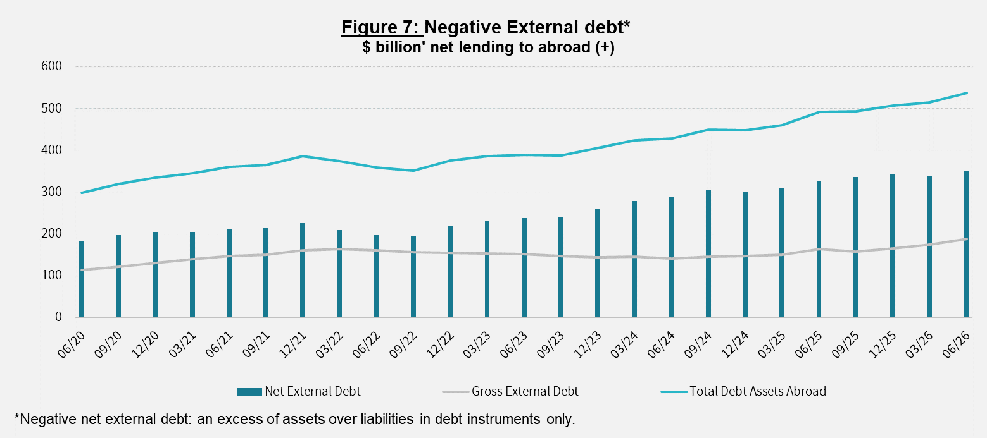
The surplus of assets over liabilities in debt instruments alone (negative net external debt) increased by about $11 billion (3,1 percent) during the second quarter, to $350 billion at the end of June (Figure 7).

The balance of assets in debt instruments increased by about $23 billion in the second quarter, to around $537 billion, of which about $239 billion are the Bank of Israel’s foreign exchange reserves. This balance reflects a coverage ratio of 3 times the gross external debt.

Source: Israel’s Ministry of Finance, and Bank of Israel data and processing.
For the complete data file, click here.

Bank of Israel data and processing: The Bank of Israel’s Information and Statistics Department collects data from numerous varied sources. Most of the data on the economy’s activity vis-à-vis abroad are received by force of a Bank of Israel Order, from direct reports by corporations and individuals to the Bank of Israel. (See: Information Regarding Foreign Exchange Market Developments in Israel, 5770–2010). Additional data used for measuring economic activity vis-à-vis abroad are received by reports from the Bank of Israel’s Accounting Division, the Ministry of Finance, the Central Bureau of Statistics, the Israel Securities Authority, domestic banks and other financial intermediaries, and institutional investors. The Department carries out estimations and processing on data received from the various sources.

