
BANK OF ISRAEL
Office of the Spokesperson and Economic Information

Press release

May 20, 2026

The monthly Index of Economic Activity declined by 0.2 percent in April

The monthly Index of Economic Activity declined by 0.2 percent in April. The Index this month reflects the average monthly growth estimate for the three months from February to April. The Index was adversely impacted by data on credit card expenditures and labor market data regarding the number of employees and job vacancies in February and March, service industries revenue in February, and retail trade data in February and March. In addition, data on actual GDP in the first quarter of 2026 contributed negatively to the Index. In contrast, data on goods exports and the imports of consumer goods and manufacturing inputs in April, and financial data on the Tel Aviv Stock Exchange General Shares Index in recent months, and the Nasdaq index in April, moderated the Index’s decline (Tables 1 and 2).
The pace of increase of the index is under the long-term growth trend (about 0.3 percent).
The Index for the past three months was revised downward with the completion of data that were previously missing and with the additional downward revision in growth data for the fourth quarter of 2025.
Figure 1 presents the Index data over the past two years. Table 1 presents the contributions of the Index’s components to the overall estimate and the revisions to the Index, and Table 2 presents the monthly rate of change in the Index’s components.

FIGURE 1: The Monthly Index of Economic Activity
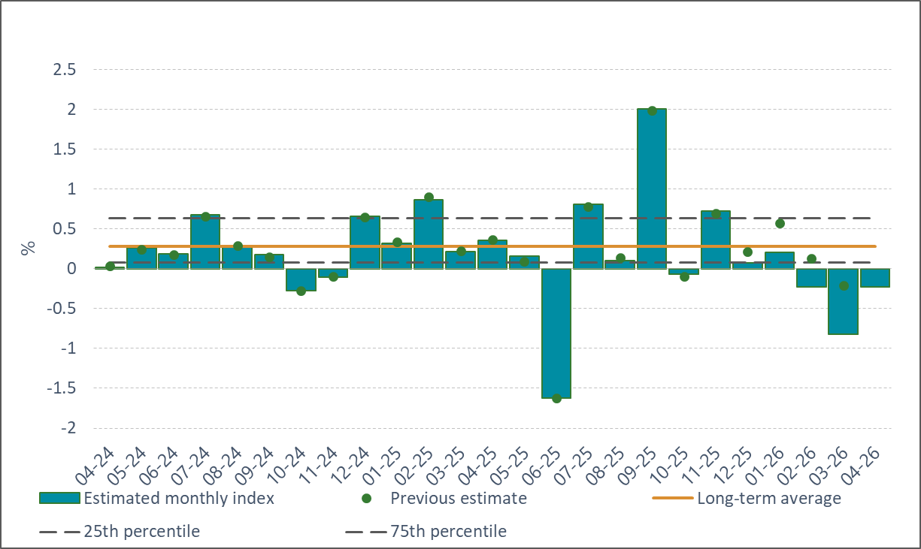

* The table presents the contribution of each group of components in the monthly index, such that the monthly estimate constitutes the sum of the contributions of each of the components detailed in the table. Some of the raw data influence the monthly estimate with a lag or influence the estimates of several months.

The monthly Index of Economic Activity reflects the three-month average of the estimated monthly growth of GDP. The estimate is based on a model developed at the Bank of Israel (Ginker and Suhoy, 2021).

