

BANK OF ISRAEL
Office of the Spokesperson and Economic Information

Press release

December 16, 2025

Israel’s International Investment Position (IIP),
Third quarter of 2025

- The economy’s outstanding liabilities to abroad increased by approximately $16 billion (about 2.7 percent) in the third quarter, to about $625 billion at the end of the quarter. Nonresidents’ direct investments in Israel increased, including in share capital, relative to the previous 4 quarters. At the same time, the prices of Israeli securities held by nonresidents increased.
- In the third quarter of 2025, the balance of assets held abroad by Israeli residents increased by approximately $33 billion (about 3.8 percent), to about $885 billion at the end of September. The increase was mainly due to an increase in the prices of foreign securities held by Israeli residents and net investments abroad by Israeli residents.
- The surplus of assets over liabilities vis-à-vis abroad increased during the third quarter of 2025 by $16 billion (6.7 percent), to about $260 billion at the end of the quarter.
- The surplus of assets over liabilities vis-à-vis abroad in debt instruments alone (negative net external debt) increased by about $6 billion (2.1 percent) during the third quarter, to approximately $318 billion at the end of September.
- The ratio of gross external debt to GDP (in dollar terms) declined by about 1.6 percentage points in the third quarter, to about 27.2 percent at the end of September.

Table 1: Asset and liability balances, and changes in them

- The balance of Israelis’ assets abroad
In the third quarter of 2025, the value of the assets held abroad by Israeli residents increased by about $33 billion (about 3.8 percent), to approximately $885 billion at the end of September.
- The value of direct investments increased by about $4.8 billion (approximately 4.1 percent) in the third quarter, mainly as a result of net investments by Israeli residents.
- The value of the securities portfolio increased during the third quarter by about $25.7 billion (about 8.3 percent), mainly as a result of an increase in prices of foreign securities held by Israeli residents totaling about $25 billion. Net investments by Israeli residents in foreign securities totaled approximately $1.5 billion, and were made by the business sector and households. In contrast, the banking sector and institutional investors realized investments in the securities portfolio. (Figure 1).
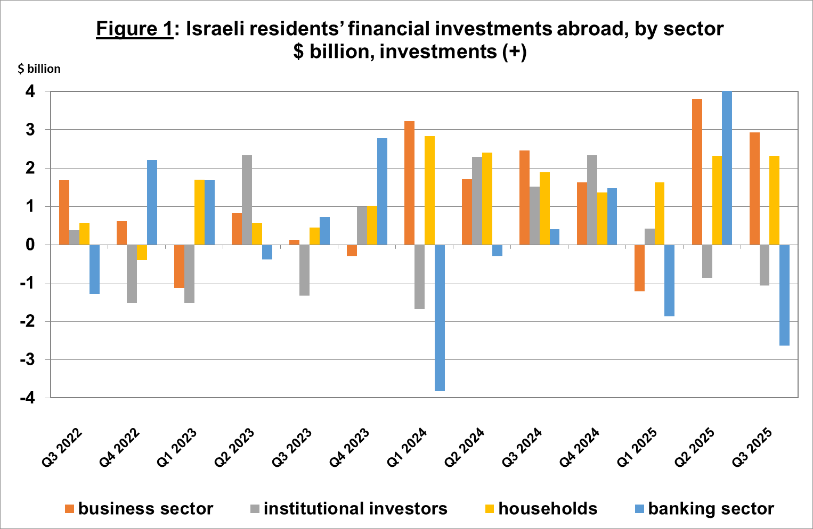

Source: Bank of Israel data and processing¹.

- The value of other investments abroad increased during the third quarter by about $1.5 billion (about 0.8 percent). Israeli residents issued loans totaling about $1.1 billion to nonresidents, and made investments in other assets. In parallel, there was an increase of about $0.6 billion in customer credit to nonresidents. In contrast, Israeli residents (including banks) made net withdrawals totaling about $2.4 billion from deposits abroad.
- The value of the reserve assets increased by about $3.6 billion (about 1.6 percent) during the third quarter, to about $232 billion at the end of September. The increase in the balance was mainly due to an increase in the price of foreign securities.
- The composition of Israelis’ securities portfolio abroad: During the third quarter, the share of equity instruments in Israeli residents’ portfolio abroad remained unchanged, and at the end of September it was 46 percent. Accordingly, the share of debt instruments was 54 percent at the end of the quarter.

- Israel’s liabilities to abroad

The balance of Israel's liabilities to abroad increased by about $16.3 billion (about 2.7 percent) during the third quarter, to approximately $625 billion at the end of the quarter. The increase was mainly due to increases in prices of Israeli securities held by nonresidents, and nonresidents’ direct investments in Israel.
- The value of direct investments in the economy increased by about $10 billion (about 3.7 percent) during the third quarter, due to net investments (mainly undistributed profits) by nonresidents totaling about $8 billion, and an increase in the prices of Israeli equities held by nonresident parties at interest (Figure 2). It should be noted that in the third quarter, there was also an increase in investments in share capital, following a downward trend in this component since the second half of 2024.

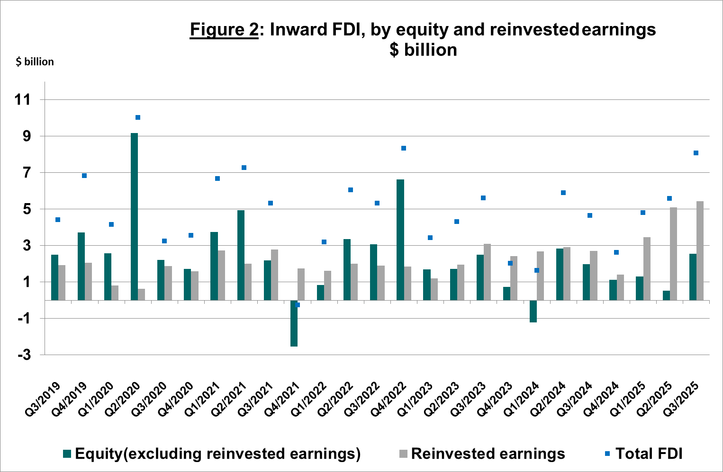

Source: Bank of Israel data and processing¹.

- The value of the securities portfolio increased by about $6.4 billion (about 2.5 percent) in the third quarter. The increase in the balance was mainly due to an increase in the prices of Israeli securities held by nonresidents, totaling about 46.4 billion. Nonresidents made net investments of about $1 billion in Israeli equities, and made net realizations of about $2.5 billion in Israeli bonds.
- The value of nonresidents' financial portfolio on the Tel Aviv Stock Exchange, (which makes up a part of nonresidents’ investments in Israel) increased by about $6.2 billion in the third quarter of 2025, to about $113 billion at the end of September. (Figure 3 and Figure 4).

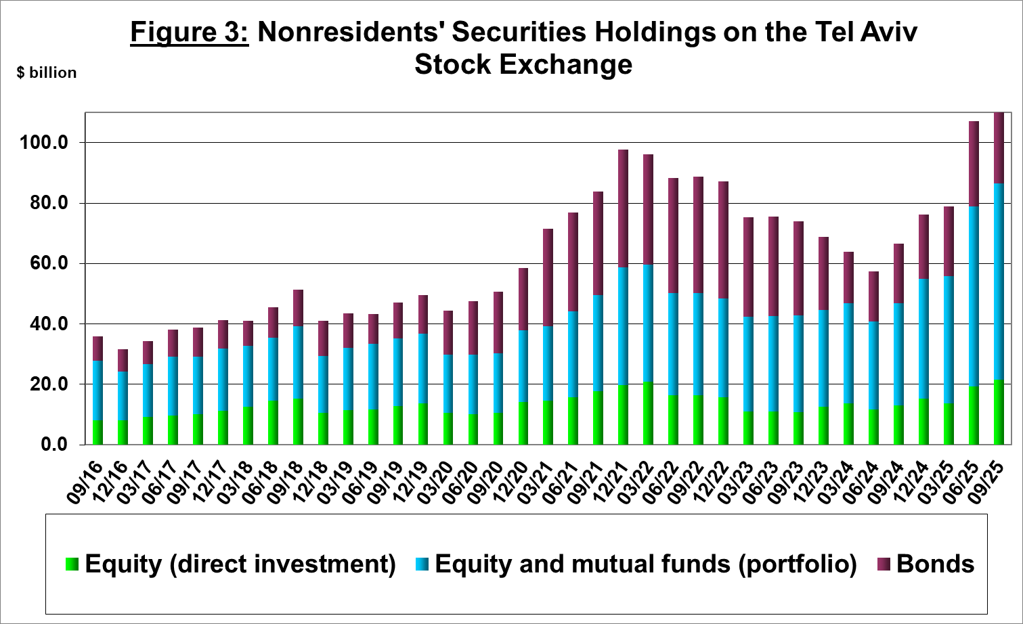
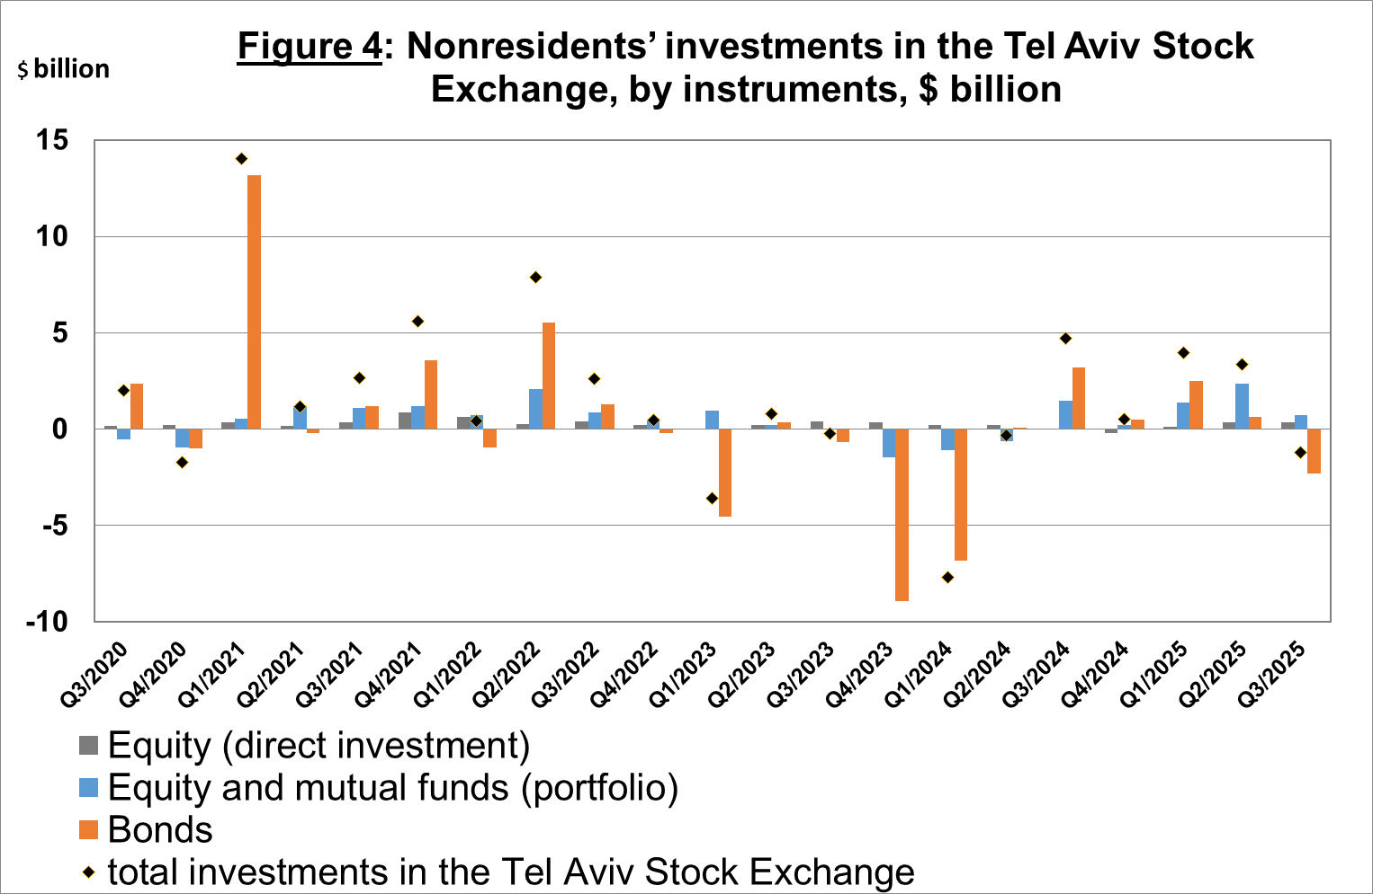

Source: Israel Securities Authority, and Bank of Israel data and processing¹.

The value of other investments in the economy declined by about $0.4 billion (about 0.5 percent) in the third quarter, to about $75 billion. The decline was mainly due to net withdrawals by nonresidents (including banks) from deposits with Israeli banks totaling about $2.8 billion. In contrast, there was an increase in suppliers’ credit totaling about $2.4 billion.

The balance of liabilities in debt instruments alone, which makes up Israel's gross external debt, declined by about $2.7 billion (1.6 percent) in the third quarter, to about $160 billion.

The ratio of gross external debt to GDP declined by about 1.6 percentage points in the third quarter, to about 27 percent at the end of September. The decrease in the external debt to GDP ratio reflected a decline in the balance of gross external debt and an increase in GDP in dollar terms (Figure 5).
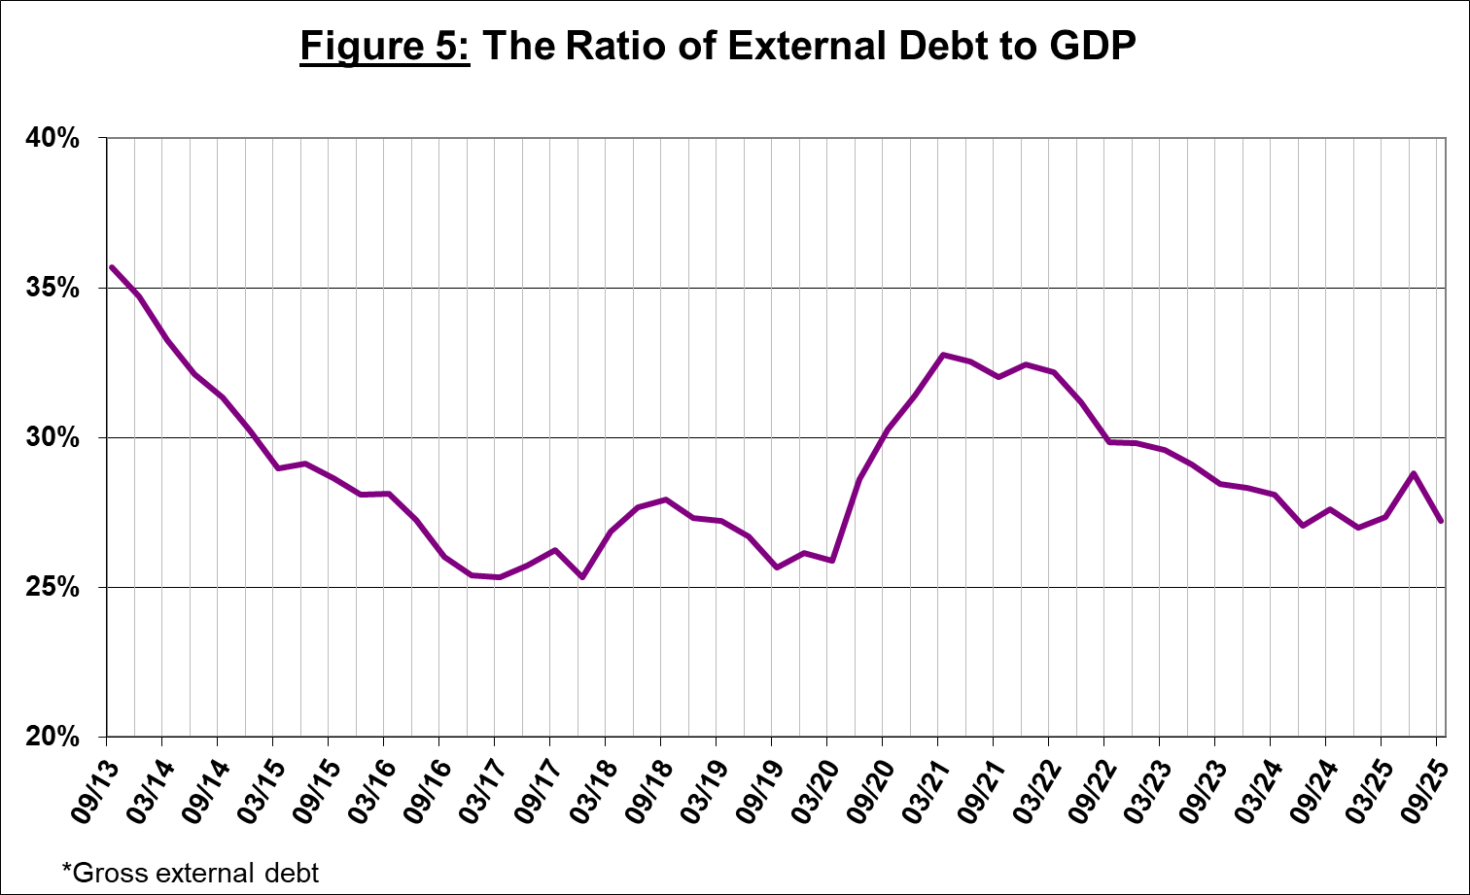

Source: Israel’s Ministry of Finance, Israel’s Central Bureau of Statistics, and Bank of Israel data and processing.¹

- Israel’s surplus assets over liabilities vis-à-vis abroad

The increase in the balance of assets and the lesser increase in the balance of liabilities led to an increase of about $16 billion (7 percent) in the surplus of assets over liabilities vis-à-vis abroad, which totaled about $260 billion at the end of September (Figure 6).

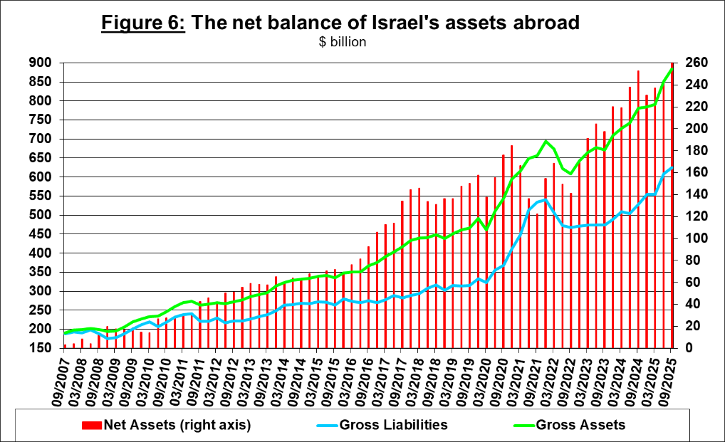

Source: Bank of Israel data and processing¹.

- Net external debt

The surplus of assets over liabilities vis-à-vis abroad in debt instruments alone (negative net external debt) increased by approximately $6.5 billion (about 2.1 percent) in the third quarter, to about $318 billion at the end of September (Figure 7).

The balance of assets in debt instruments increased by about $3.8 billion in the third quarter, to about $478 billion at the end of the quarter, of which about $232 billion is the Bank of Israel's foreign exchange reserves. This balance reflects a coverage ratio of 3 times the gross external debt.

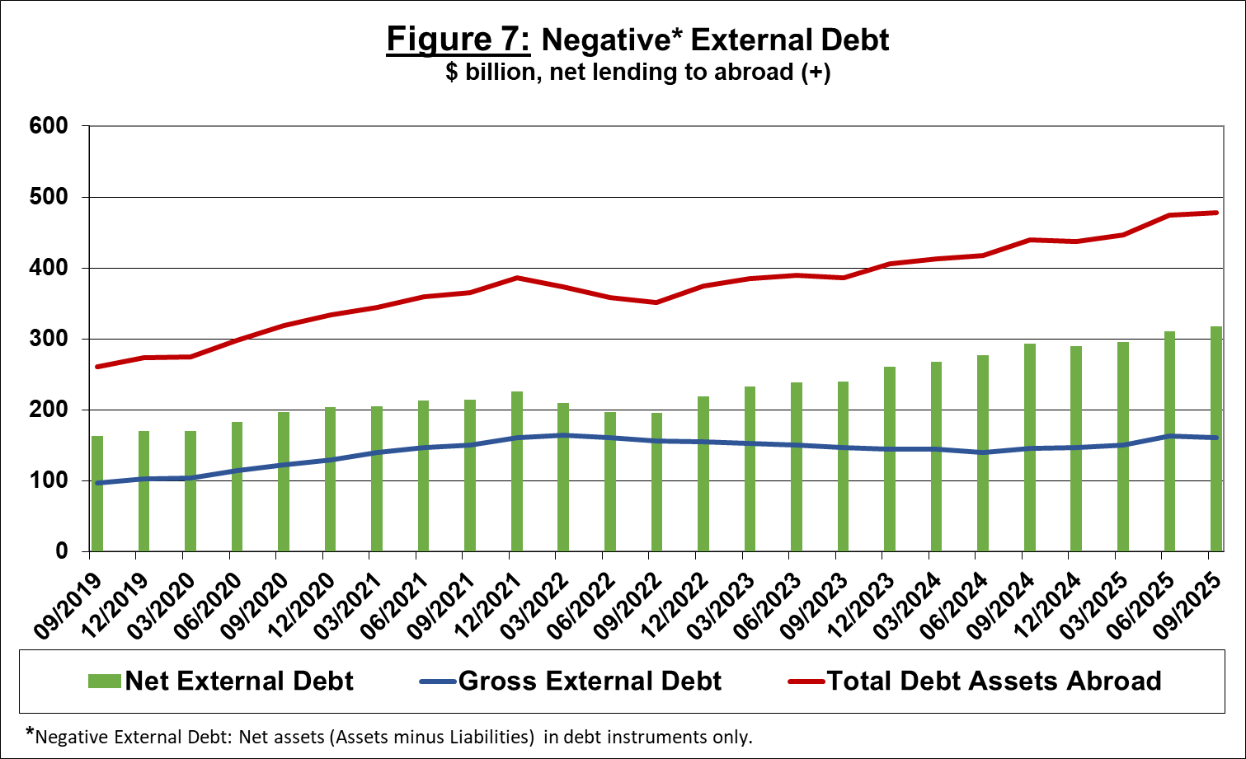

Source: Israel’s Ministry of Finance, and Bank of Israel data and processing.

For the complete data file, click here.

Bank of Israel data and processing: The Bank of Israel’s Information and Statistics Department collects data from numerous varied sources. Most of the data on the economy’s activity vis-à-vis abroad are received by force of a Bank of Israel Order, from direct reports by corporations and individuals to the Bank of Israel. (See: Information Regarding Foreign Exchange Market Developments in Israel, 5770–2010). Additional data used for measuring economic activity vis-à-vis abroad are received by reports from the Bank of Israel’s Accounting Division, the Ministry of Finance, the Central Bureau of Statistics, the Israel Securities Authority, domestic banks and other financial intermediaries, and institutional investors. The Department carries out estimations and processing on data received from the various sources.

