|  |  |  |
| --- | --- | --- |
|  | לוגו בנק ישראל | ‏Spokesperson and Economic  Information |

June 18, 2023

Press Release:

Israel’s International Investment Position (IIP),

first quarter of 2023

* **In the first quarter of 2023, the balance of assets held abroad by Israeli residents increased by approximately $26 billion (4 percent), to about $669 billion at the end of March. The increase was mainly due to a rise in the prices of foreign securities held by Israelis.**
* **Outstanding liabilities to abroad increased by approximately $5 billion (1 percent) in the first quarter, to about $480 billion at the end of the quarter. The increase was primarily due to net direct investments.**
* **Israel’s surplus of assets over liabilities vis-à-vis abroad increased in the first quarter by approximately $21 billion (12 percent), to about $188 billion at the end of the quarter.**
* **The surplus of assets over liabilities vis-à-vis abroad in debt instruments alone (negative net external debt) increased during the first quarter by about $10 billion (5 percent), to approximately $220 billion at the end of March.**
* **The ratio of gross external debt to GDP was essentially unchanged in the first quarter, at about 29.5 percent at the end of March.**

Table 1: Asset and liability balances, and changes in them

A table detailing the balance of Israel’s assets and liabilities vis-à-vis abroad, and the changes in those categories.  The table can be found in the Excel file attached to this notice in the “Table” worksheet.

1. **The balance of Israel’s assets abroad**

In the first quarter of 2023, the value of the assets held abroad by Israeli residents increased by about $26 billion (4 percent) to approximately $669 billion at the end of March. The increase in the balance was seen in all investment channels, particularly an increase in the balance of investments in the tradable securities portfolio and in reserve assets.

* **The value of direct investments** increasedin the first quarter by about $2.5 billion (approximately 2.2 percent), mainly as a result of reinvested earnings.
* **The value of the securities portfolio** increased during the first quarter by about $11 billion (about 5.5 percent) mainly as a result of price increases on foreign securities held by Israeli residents.

During the first quarter, there were net investments in the securities portfolio abroad totaling about $0.7 billion; investments in bonds totaling about $4.5 billion were partly offset by realizations totaling about $3.8 billion in foreign equities.

Most of the realizations in equities were by institutional investors, and most of the investments in foreign bonds were by the banks, institutional investors, and mutual funds (Figure 1).

Source: Bank of Israel data and processing1.

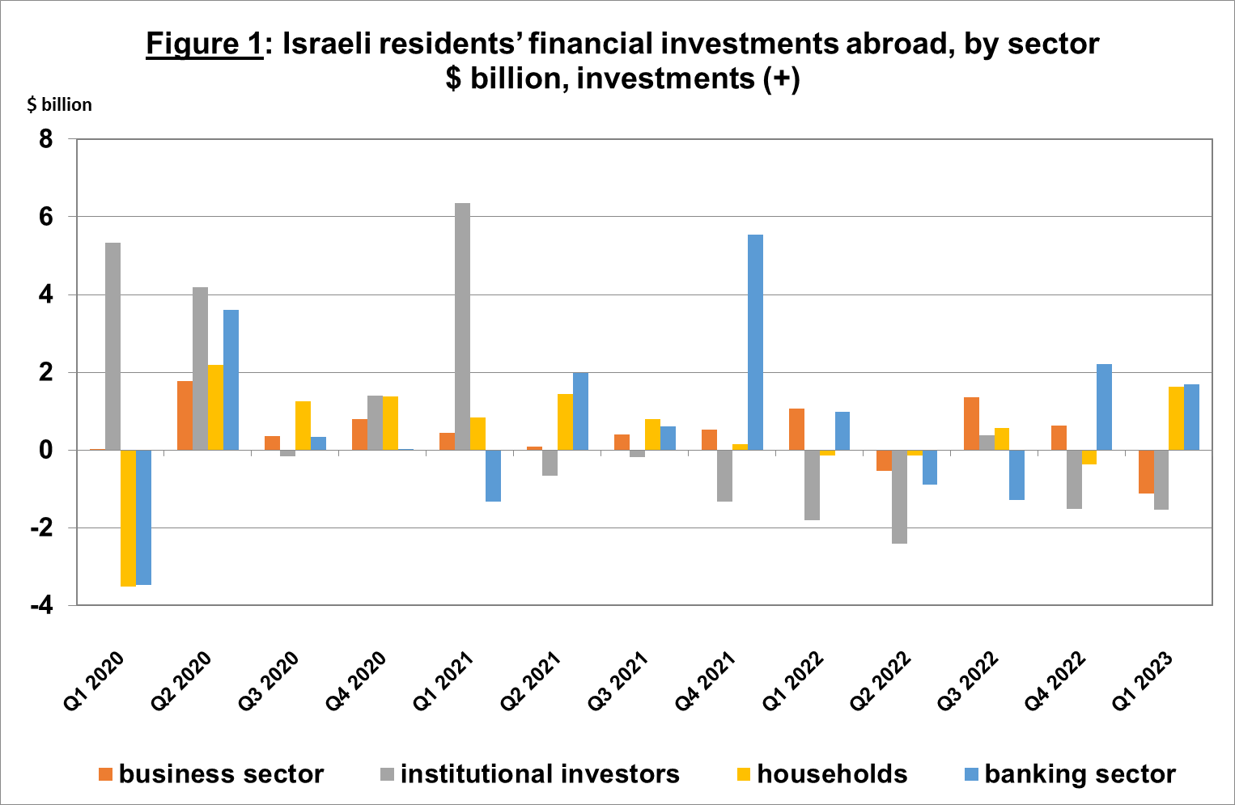

* **The value of other investments** abroad increased by about $1.2 billion (0.9 percent) in the first quarter. The increase derived mainly from net investments by institutional investors in investment funds, at a total of $2.9 billion, and net deposits in Israeli residents’ (including banks’) deposits abroad of $2.4 billion. These investments were partly offset by a decline of $3.6 billion in customers’ credit.
* **The value of reserve assets increased** during the first quarter by about $6.3 billion (about 3.2 percent), to about $200 billion at the end of March. The increase derived mainly from price increases totaling about $4.3 billion. (Figure 2).

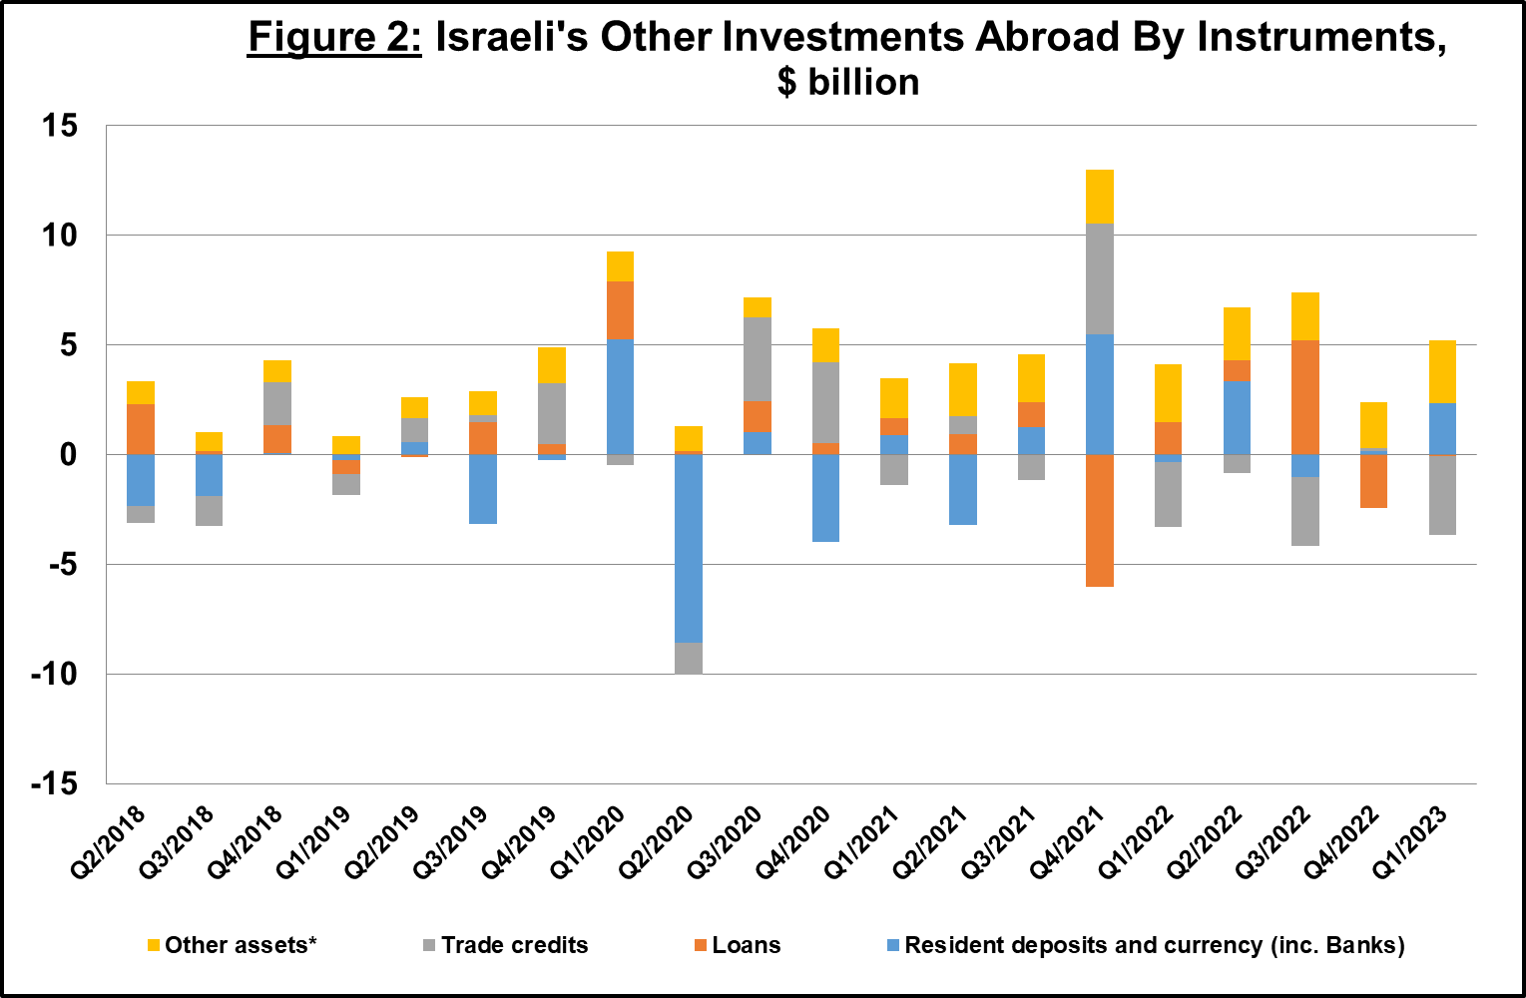

*Investments in non-tradable financial assets, including Investments of less than 10% in non-tradable equity, investments in non-traded Funds, etc.

Source: Israel’s Central Bureau of statistics, Bank of Israel data and processing1.

* **The composition of Israelis’ securities portfolio abroad**: During the course of the first quarter, the share of equity instruments in Israeli residents’ portfolio abroad remained unchanged at 44 percent at the end of March. Accordingly, the share of debt instruments remained at 56 percent at the end of March.

1. **Israel’s liabilities to abroad**

The balance of Israel's liabilities to abroad increased by about $5.4 billion (1.1 percent) during the first quarter, to approximately $480 billion at the end of the quarter. The increase was mainly due to net investments, particularly direct investments.

* **The value of direct investments in the economy** increased during the first quarter by about $1.3 billion (about 0.6 percent), mainly due to net direct investments in share capital totaling about $4.8 billion, of which about $1.3 billion was in respect of reinvested earnings.
* **The value of the securities portfolio** increased by about $3.2 billion (about 1.8 percent) in the first quarter, as a result of an increase in equity prices totaling about $3.8 billion. In contrast, the depreciation of the shekel vis-à-vis the dollar during the quarter reduced the dollar value of the investment portfolio.
* **The value of nonresidents' financial portfolio on the Tel Aviv Stock Exchange,** which makes up a part of nonresidents’ investments in Israel, declined by about $9.7 billion in the first quarter, to about $78 billion at the end of March. The decline in the portfolio value derived mainly from realizations of Makam by nonresidents, a decline in securities prices, and from the depreciation of the shekel vs. the dollar. (Figure 3 and Figure 4).

Source: Israel Securities Authority, and Bank of Israel data and processing1.

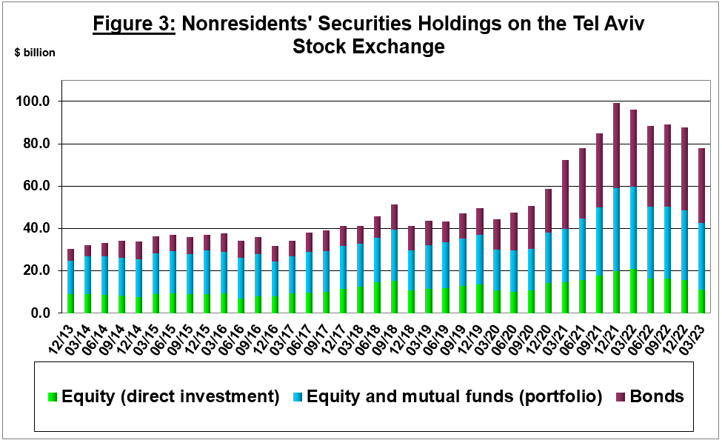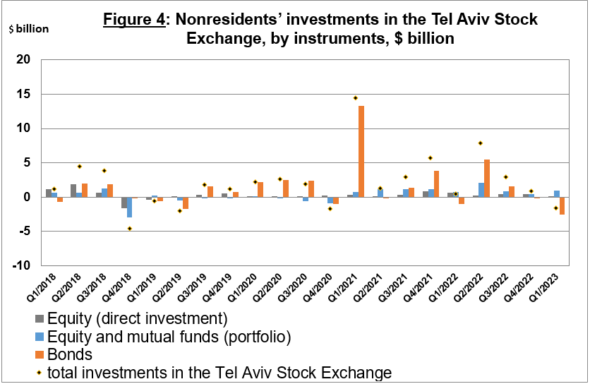

**The value of other investments in the economy** increased by about $0.9 billion (about 1.6 percent) in the first quarter, to about $58 billion. The increase was mainly due to net deposits in nonresidents’ deposits totaling $2.9 billion, which was partly offset by a decline in suppliers’ credit totaling $1.6 billion.

**The balance of liabilities in debt instruments alone,** which makes up Israel's gross external debt, declined by about $0.6 billion (0.1 percent) in the first quarter, to about $152 billion.

**The ratio of gross external debt to GDP** remained unchanged, at about 29.5 percent at the end of March (Figure 5).

Source: Israel’s Ministry of Finance, Israel’s Central Bureau of Statistics, and Bank of Israel data and processing1.

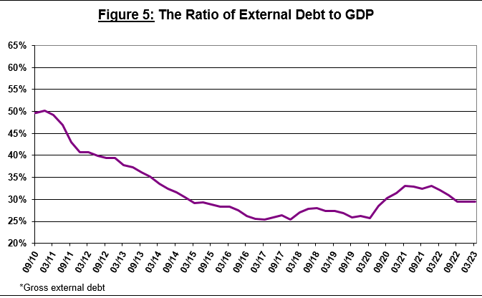

1. **Israel’s surplus assets over liabilities vis-à-vis abroad**

An increase in outstanding assets that was greater than the increase in outstanding liabilities led to an increase of about $21 billion (about 12 percent) in surplus assets over liabilities vis-à-vis abroad, which totaled about $188 billion at the end of March (Figure 6).

Source: Bank of Israel data and processing1.

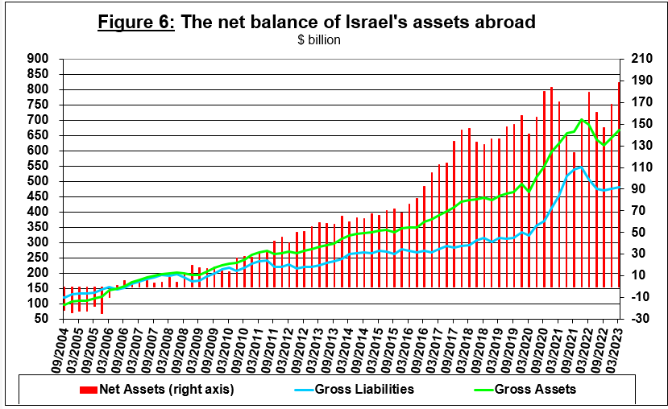

1. **Net external debt**

The surplus of assets over liabilities vis-à-vis abroad in debt instruments alone (negative net external debt) increased by approximately $10.5 billion (about 5 percent) in the first quarter, to $220 billion at the end of March (Figure 7).

**The balance of assets in debt instruments** increased by about $10 billion in the first quarter, to about $372 billion at the end of the quarter, of which about $200 billion is the Bank of Israel's foreign exchange reserves. This balance reflects a coverage ratio of 2.4 times the gross external debt.

Source: Israel’s Ministry of Finance, and Bank of Israel data and processing.

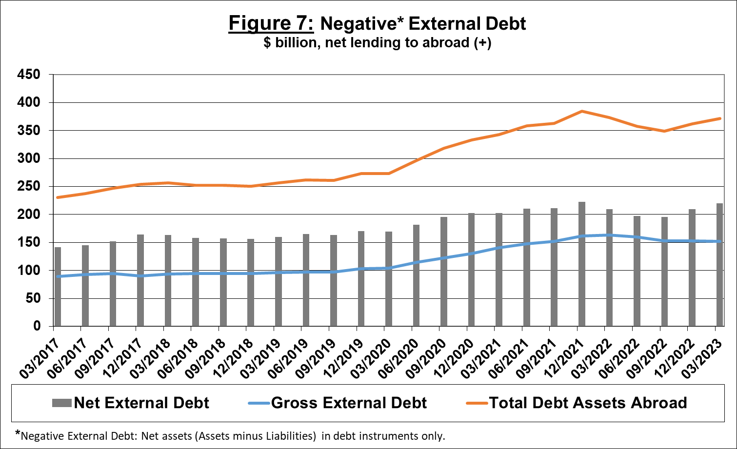

[For the complete data file, click here](http://www.bankisrael.gov.il/deptdata/pik_mth/pikmth_e.htm).