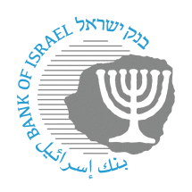
BANK OF ISRAEL
Office of the Spokesperson and Economic Information

Press release

October 14, 2024

Exchange of identification codes allocated to payment service providers

In August 2024, the Bank of Israel published a press release regarding the exchange of identification codes that had been allocated to payment service providers.

The Bank of Israel examined the comments received regarding the proposed changes, and decided to carry out the exchange of the identification codes that had been allocated to the payment service providers as noted in our press release.

The exchange of the codes will go into effect within 2 weeks of the publication of this notice.

Below please find a table that consolidates the changes in the allocation of the identification codes:

Entity name | Identification codes
Entity name | Previous code | New code
Max It Finance Ltd. | 1 | 6
Isracard Ltd. | 5 | 1
Cal (Cartisey Ashrai LeYisrael) Ltd. | 7 | 2
CardCom Clearing Ltd. | 60 | 7
Tranzilla Ltd. | 61 | 5

https://www.boi.org.il/en/communication-and-publications/press-releases/replacement-of-identification-codes-allocated-to-payment-service-providers-and-clearing-of-identification-codes-that-are-not-in-us/

