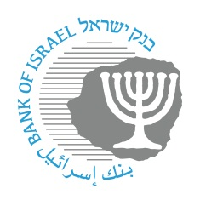

BANK OF ISRAEL
Office of the Spokesperson and Economic Information

Press Release
March 10, 2026

Bank of Israel Governor Prof. Amir Yaron participated online in the BIS meeting of central bank governors

Bank of Israel Governor Prof. Amir Yaron participated in the meeting of central bank governors who are members of the Bank for International Settlements (BIS). Due to the security situation, the Governor remained in Israel in order to lead the economic policy measures under the Bank of Israel’s responsibility. As such, he participated in the meeting online.

During the meeting, the participants discussed recent developments in the global economy, and the implications of the geopolitical tensions with Iran on the financial markets, price stability, and international trade. Issues concerning monetary policy during times of increased uncertainty and the role of central banks in maintaining price stability were also discussed.

