September 30, 2025

Press Release:

# The public's financial assets portfolio in the second quarter of 2025

* **In the second quarter of 2025, the balance of the public’s financial assets portfolio increased by approximately NIS 343 billion (5.5 percent), to about NIS 6.6 trillion.**
* **The increase in the portfolio’s value in the second quarter derived mainly from increases in the balance of equities in Israel (22.3 percent).**
* **The balance of the asset portfolio managed by institutional investors increased in the second quarter by approximately NIS 176 billion (6.1 percent), to approximately NIS 3.06 trillion at the end of the quarter.**
* **The scope of the portfolio managed by mutual funds in Israel increased by approximately NIS 58.7 billion (9.5 percent) in the second quarter, to a level of NIS 675.6 billion. There were net new investments, mainly in shekel money market funds and in funds specializing in domestic equities.**

# 1. The public’s total assets portfolio

**In the second quarter of 2025,** the balance of the public’s financial assets portfolio increased by approximately NIS 343 billion (about 5.5 percent), to about NIS 6.6 trillion (Figure 1). The share of the public’s financial assets portfolio relative to GDP increased by approximately 13.8 percentage points, to about 323.5 percent at the end of the quarter, as a result of an increase in the balance of the asset portfolio that was greater than that of GDP.

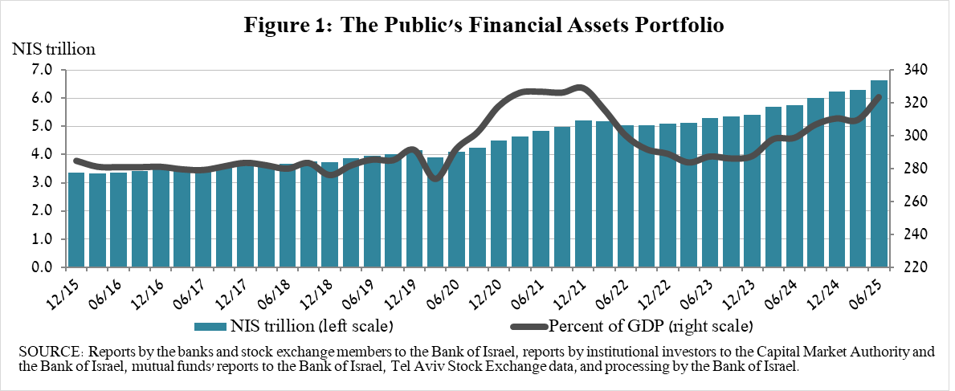

**2. Analysis of the changes in the overall portfolio**

Over the course of the second quarter, there were increases in the balances of the public’s holdings in most components of the portfolio, except for the investments abroad component. The increases in equities in Israel (22.3 percent) were notable.

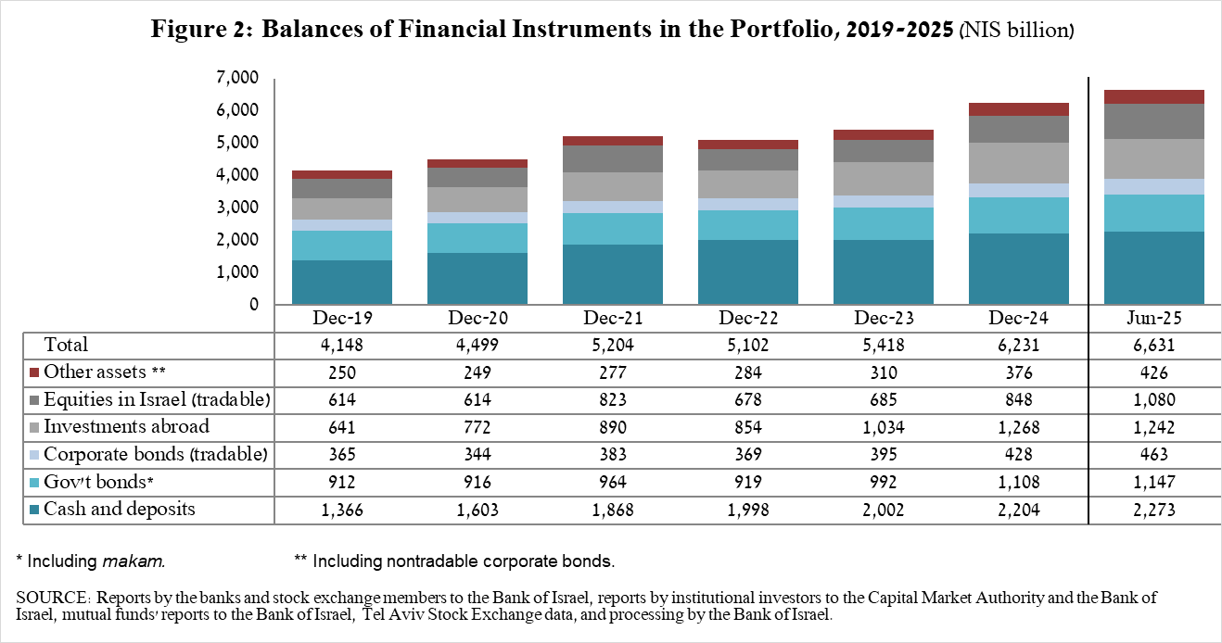

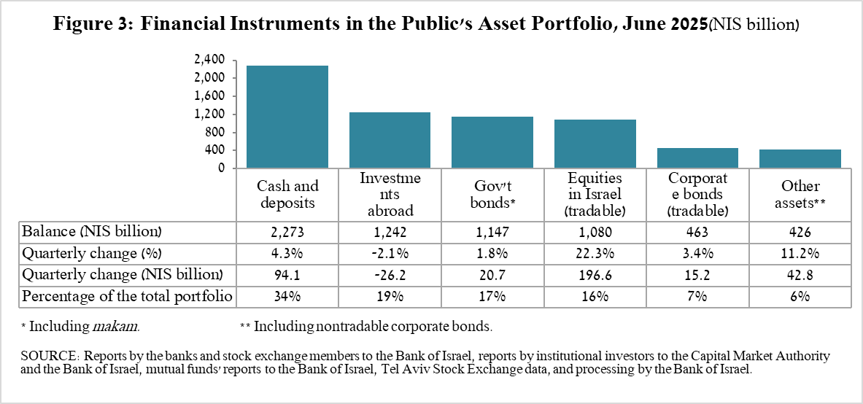

* The balance of **equities in Israel** increased by about NIS 196.6 billion (22.3 percent), mainly in view of price increases that were partly offset by net realizations (estimated at NS 6.4 billion).
* The balance of **cash and deposits** increased during the second quarter by about NIS 94.1 billion (4.3 percent) to about NIS 2.27 trillion, which is about 34 percent of the total portfolio.
* The balance of **tradable corporate bonds in Israel** increased during the quarter by about NIS 15.2 billion to about NIS 463 billion at the end of the quarter, due to a combination of net investments (estimated at NIS 10 billion) and price increases.
* The balance of **tradable** **government bonds** held by the public increased during the quarter by about NIS 21.9 billion to about NIS 472.7 billion at the end of the quarter (Figure 4). In a breakdown by holders of government bonds, the institutional investors are the main holders, increasing the balance of their holdings during the quarter by about NIS 13 billion to a level of NIS 355 billion.
* The **Makam** balance held by the public declined by about NIS 8 billion, to a level of NIS 204.8 billion (Figure 5). During the quarter, the balance of mutual funds’ holdings declined by about NIS 10 billion, to NIS 109 billion, while in contrast institutional investors increased the balance of their holdings by about NIS 3 billion to about NIS 97 billion.

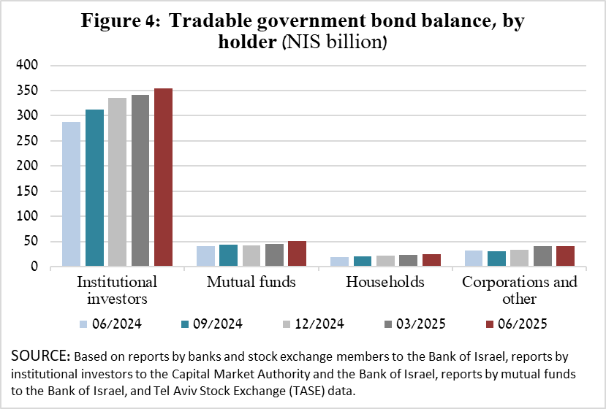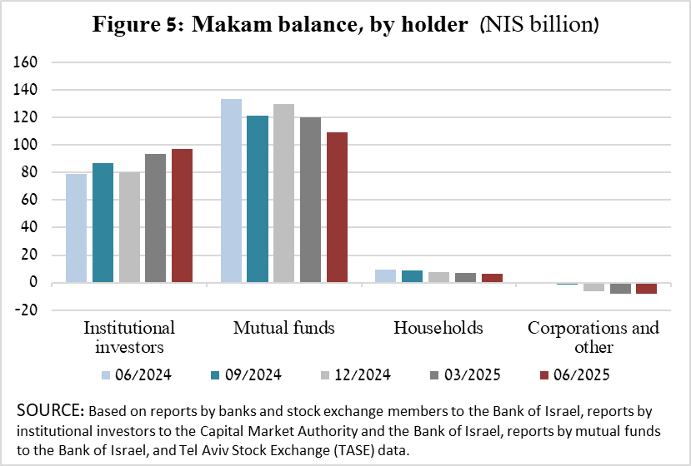

The balance of investments abroad decreased by approximately NIS 26 billion during the quarter, to NIS 1.24 trillion at the end of the quarter, making up approximately 19 percent of the total asset portfolio. The development in the balance of investments abroad was mainly due to the following components:

* The balance of **tradable (corporate and government) bonds abroad** decreased by approximately NIS 16.1 billion (5.6 percent) during the quarter, to about NIS 269.3 billion. This decrease was mainly due to the shekel’s appreciation vis-à-vis the dollar.
* The balance of **investment funds** decreased by about NIS 15.4 billion (5.9 percent) to around NIS 244.2 billion at the end of the quarter.
* The balance of **equities held abroad** increased by approximately NIS 3.3 billion (0.5 percent), about NIS 711.6 billion. This was against the background of increases in prices and net investments that were offset by the appreciation of the shekel against the dollar.

As a result of the developments during the quarter, there was a decline in the share of foreign assets of 1.5 percentage points (from 20.2 percent to 18.7 percent) and of around 1.3 percentage points (from 26.4 percent to 25.1 percent) in foreign currency assets.

# 3. The portfolio managed by institutional investors[1]

* **The balance of assets managed by all institutional investors** increased in the second quarter by about NIS 176 billion (6.1 percent), to about NIS 3.06 trillion (approximately 46 percent of the public’s total financial assets portfolio). The increase in the balance of the managed portfolio during the quarter was mainly due to price increases in capital markets in Israel, and was reflected in the following components: equities in Israel—an increase of NIS 57 billion (20.6 percent) in view of price increases and despite withdrawals; cash and deposits in Israel—an increase of NIS 50.2 billion (18.1 percent); futures contracts abroad—an increase of about NIS 35 billion in the balance-sheet balance, in view of price increases; and government bonds and Makam—an increase of about NIS 30 billion (NIS 3.3 billion).

# 4. The portfolio managed by mutual funds

The value of the portfolio managed by Israeli mutual funds increased in the second quarter by approximately NIS 58.7 billion (9.5 percent), to about NIS 675.6 billion at the end of the quarter, constituting about 10 percent of the public’s asset portfolio.

The increase in the second quarter derived mostly from a combination of price increases and from net new investment totaling NIS 19.1 billion. Most of the new investment was NIS 10.4 billion in shekel money market funds and about NIS 5.5 billion in funds specializing in equities in Israel, totaling about NIS 5.5 billion.

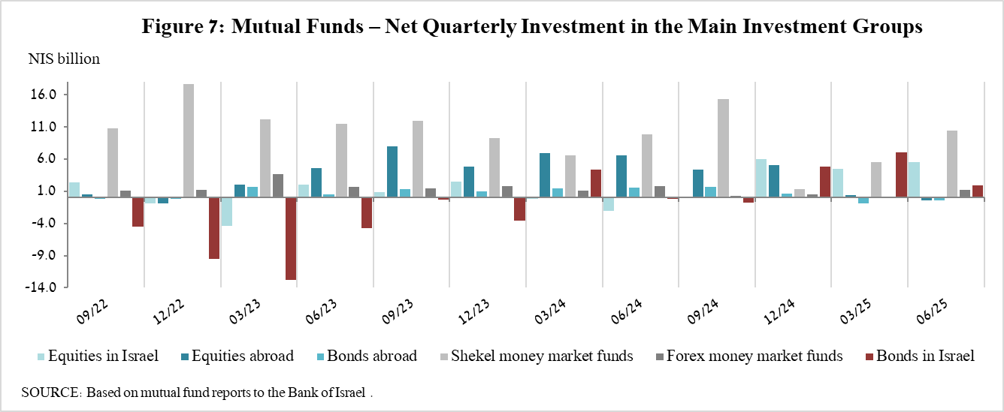

**Further information and details:**

Long-term tables on the asset portfolio are available here.

Long-term tables on institutional investors’ exposure to foreign exchange and to foreign assets are available here.

Long-term tables on mutual funds are available here.

1. Excluding mutual funds.