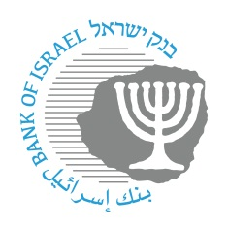

BANK OF ISRAEL
Office of the Spokesperson and Economic Information

December 20, 2022

Press Release:

The new Bank of Israel website goes on air for a trial period

The Bank of Israel’s website (www.boi.org.il) is getting a new look, and a trial run will begin.

The new site will replace the current website that has served the Bank since 2012, and will include new content alongside improved technological and visual abilities and interfaces adjusted for various target groups (click here for a LINK to a page on the website that explains the changes and helps with the processes of searching and navigating the new site).

Within the framework of the trial period, various content and information will gradually be transferred to the new website from the old one, and new content will be added. We thank you in advance for your patience and understanding, and invite you to contact us by email at webmaster@boi.org.il for suggestions, questions, and pointing out any corrections that need to be made.

