

BANK OF ISRAEL
Office of the Spokesperson and Economic Information

Press Release
September 10, 2026

Ms. Tal Harel Matityahu is appointed Deputy Supervisor of Banks and Head of the Bank-Customer Division in the Banking Supervision Department

Following the completion of a selection process at the Bank of Israel, Ms. Tal Harel Matityahu has been appointed Deputy Supervisor of Banks and Head of the Bank-Customer Division.
Tal began her career at the Bank of Israel about 24 years ago and has accumulated extensive experience in a range of senior roles in the Banking Supervision Department. Her previous positions include Deputy Supervisor of Banks and Head of the Technology, Innovation, and Cyber Division, Chief of Staff to the Supervisor of Banks, Head of the Strategy and Special Projects Unit, and Head of the Consumer Regulation Unit.
Over the course of her work, Tal has led many initiatives aimed at benefiting banking customers, including one-click mobility, the “Money Mountain” system for locating dormant bank accounts, assistance programs for banking customers during emergencies, measures to reduce fraud, financial education for senior citizens, and more. She holds a Bachelor’s degree in law and a Master’s degree in business administration, and is also a graduate of two senior executive programs: the Maoz leadership program at Harvard Business School and the “Digital Leaders” program.
The Bank-Customer Division in the Banking Supervision Department focuses on the relationship between the banking system and the public. Its work covers a wide range of issues related to how banks interact with their customers, especially fairness, transparency, service, access to banking products and services, customer rights, and banks’ conduct across retail banking activities.
In her new role, Tal will lead the Division’s work and help shape supervisory policy on matters concerning the relationship between customers and banking corporations. This will include promoting the principle of banking fairness in a consistent and practical way, strengthening consumer-related supervision, and advancing a banking environment that encourages competition and innovation—all with the goal of creating real value for customers.
Supervisor of Banks Daniel Hahiashvili said: “I would like to congratulate Tal on her appointment to this important position. Tal brings extensive professional experience, a deep familiarity with the banking system, and a broad understanding of customers’ needs. The Bank-Customer Division sits at a critically important juncture between supervisory work and the public, and it plays a major role in addressing significant challenges and advancing fairness, service, competition, and innovation. I wish Tal great success in her new role and am confident that she will make a meaningful contribution to the Banking Supervision Department’s work and to strengthening public trust in the banking system.”
Deputy Supervisor of Banks Tal Harel Matityahu said: “Public trust in the banking system is a cornerstone of its existence. To preserve that trust, the banking system must continue strengthening fairness toward its customers, act transparently and responsibly, and give every customer the ability to make informed decisions and exercise their rights. I see this role as a public mission, and I thank the Supervisor of Banks for the opportunity to lead one of the most important divisions in the Department and for placing his trust in me.”
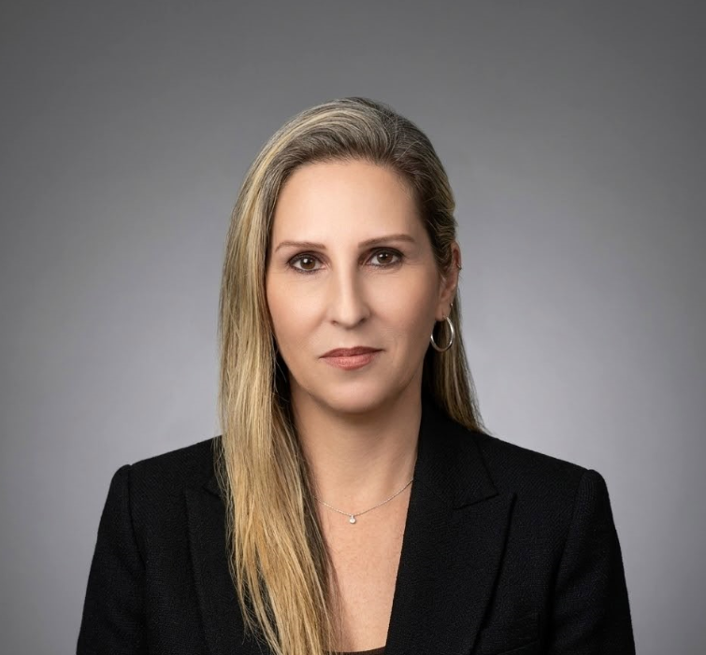

Credit: Bank of Israel Office of the Spokesperson and Economic Information.

