

BANK OF ISRAEL

Office of the Spokesperson and Economic Information

Press release

June 15, 2025

**New Research Department study:**

**The link between working in the public sector and the desire to change jobs— Evidence from Israel**

* Nearly one-fifth of Israel’s employees say their education or training doesn’t match their current workplace. About 14 percent of those employees want to switch jobs, compared to around 8 percent of the overall labor force.
* The proportion of employees reporting a mismatch between their education or training and their workplace is lower in the public sector (around 10 percent) than in the business sector (about 20 percent). The same holds true for employees wanting to change jobs: about 6.1 percent in the public sector versus about 8.5 percent in the business sector.
* Even after accounting for the public sector’s lower mismatch rate and other employee characteristics, public sector employees are about 1.9 percentage points less interesting in changing jobs than their counterparts in the business sector.

The Israeli economy is known for having relatively low labor productivity compared to other countries. One of the main factors shaping productivity is how well employees’ skills and training match their workplace. The more people work in positions that fully utilize their skills, the more overall productivity improves. While most of this matching happens early on—when choosing a field of study, an occupation, and whether to work in the public or private sector—it can also improve later through job changes within or between sectors. Employees typically decide whether to switch jobs based on a comparison of their current job’s conditions to the opportunities available elsewhere.

A new study by Dr. Yuval Mazar of the Bank of Israel’s Research Department looks at whether working in the public sector affects an employee’s inclination to change jobs. The hypothesis is that because public-sector jobs often provide greater job security and, in some areas—like required working hours—offer more comfortable conditions, public-sector employees may be less likely to look for a new job, even if they feel their training doesn’t perfectly match their current position.

The study used data from Labor Force Surveys conducted by Israel’s Central Bureau of Statistics. In 2018, these surveys began including questions about whether employees want to change jobs, as well as how well they feel their skills match their current role. It found that 8 percent of employed individuals want to change jobs, and that in the public sector, this rate is about 2.4 percentage points lower than in the private (business) sector. The study also found that stating a desire to leave a job is positively correlated with actually leaving it within eight months.

About one-third of the gap between the public and private sectors in terms of wanting to leave a job can be explained by differences in employee characteristics (education level, sector, age, etc.) and greater subjective matching in the public sector—a characteristic that itself is linked to a lower inclination to leave. The remaining difference can be ascribed to working in the public sector itself (instead of the business sector), which is what the study delved into more deeply.

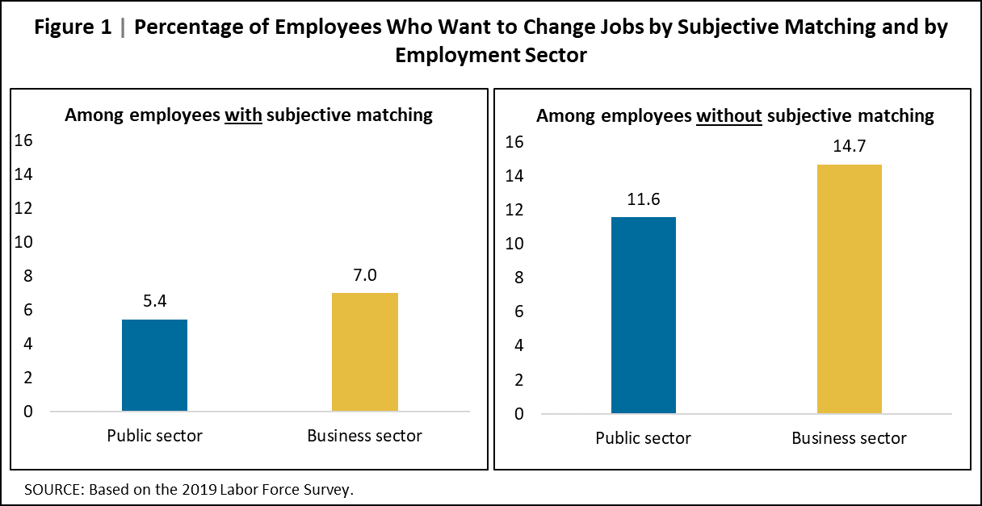

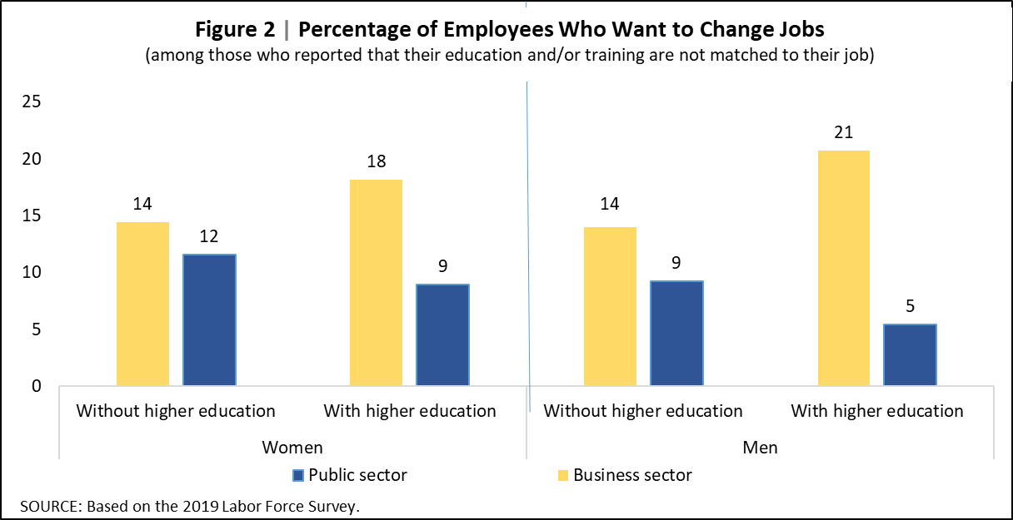The gap between the public and business sectors in the share of employees who say they want to switch jobs is especially noticeable among those who feel their education and/or training doesn’t match their current workplace. The largest gap is found among educated men who say their education isn’t aligned with their job—about 20 percent in the business sector want to leave, compared with only about 5 percent in the public sector (Figure 2). After accounting for employee characteristics, there is still a gap of about 12.2 percentage points between the desire to leave a job in the business sector versus that in the public sector.

Even after using additional common statistical methods, the differences between the public and business sectors remain robust. This finding strengthens the idea that there is a causal relationship—meaning that features of public-sector jobs are what drive the lower desire to leave—rather than a simple statistical correlation stemming from unobserved personal traits that led workers to choose the public sector in the first place.

Based on this, the study concludes that working in the public sector reduces the tendency to look for a new job (compared to the business sector), especially if employees feel they are not a good fit for their current position. The study suggests that this is mainly due to the distinct employment conditions in the public sector, which include greater job security and fewer working hours. Since the research also shows that the public sector’s influence on dampening the desire to switch jobs is especially strong among employees with higher education than their peers in similar roles, one can infer that job stability and shorter hours help the public sector retain workers with higher human capital—despite the economic inefficiency of employing people whose education isn’t the best match for their role.

An analysis in the study indicates that this mismatch has a relatively small macroeconomic impact on labor productivity, mainly because only a small share of workers in the economy want to change jobs in the first place. The estimated effect is up to 0.12 percent of the average productivity level per employee. In terms of 2024 GDP, that translates into an annual loss of up to NIS 2.3 billion shekels.