
BANK OF ISRAEL
Office of the Spokesperson and Economic Information

December 30, 2020

Press Release

Debt Developments in the Nonfinancial Private Sector,
Third Quarter of 2020

The following is a summary of developments in nonfinancial private sector debt in the third quarter of the year:

- In the third quarter of 2020, there was an increase of about NIS 9 billion (1 percent) in the balance of business sector debt, due to the increase in outstanding nonbank debt, mostly raised abroad.
- The spread between the yields on corporate bonds included in the Tel Bond 60 index and the yields on indexed government bonds continued to narrow, to about 1.4 percentage points, following the significant widening in the first quarter, mainly in March, in view of the COVID-19 crisis.
- The balance of households’ housing debt continued to increase in the third quarter, growing by about NIS 8 billion (1.9 percent).
- The balance of nonhousing debt declined by about NIS 1 billion (0.4 percent) in the third quarter. Since the beginning of the year, nonhousing debt declined by about 4 percent, mainly in the first quarter of the year, in view of the COVID-19 crisis.

The nonfinancial business sector’s outstanding debt
- In the third quarter of 2020, the balance of business sector debt increased by approximately NIS 9 billion (1 percent), to about NIS 963 billion. The increase was due to net debt raised through the tradable bonds channel in Israel and abroad, which was partly offset by a decline in bank loans and in direct loans from institutional investors, and by the appreciation of the shekel by 2.8 percent against the dollar, which lowered the value of debt denominated in or indexed to foreign exchange.
- In the third quarter, the business sector issued about NIS 9 billion in bonds, lower than the average quarterly amount raised in the previous four quarters (about NIS 11.5 billion). About two-thirds of bond issuances in the third quarter were by companies in the construction and real estate industry. In October 2020, the business sector issued bonds worth about NIS 4 billion, mostly in tradable bonds (Figure 3).
- In the third quarter, the spread between yields on corporate bonds that are included in the Tel Bond 60 index, and the yields on CPI-indexed government bonds continued to narrow, to about 1.4 percentage points. This followed the significant widening in the first quarter, mostly in March, in view of the COVID-19 crisis. In October–November, the spread continued to narrow, to about 1.3 percentage points (Figure 4).

Table 1: The Composition of Business Sector Debt

Figure 1: Estimated Net Quarterly Quantitative Change in Business Sector Debt
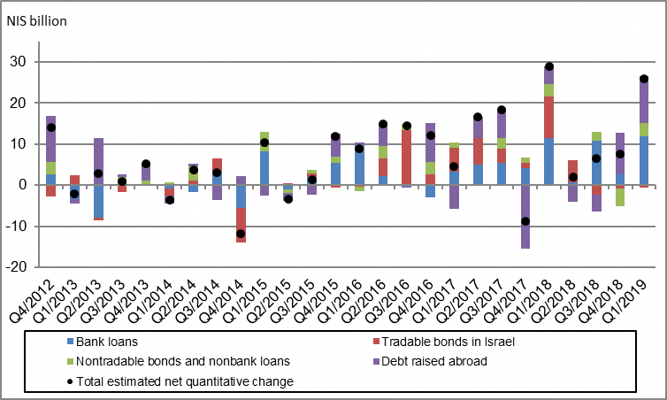

Figure 2: Rate of Change (Year on Year) in the Business Sector's Bank and Nonbank Debt
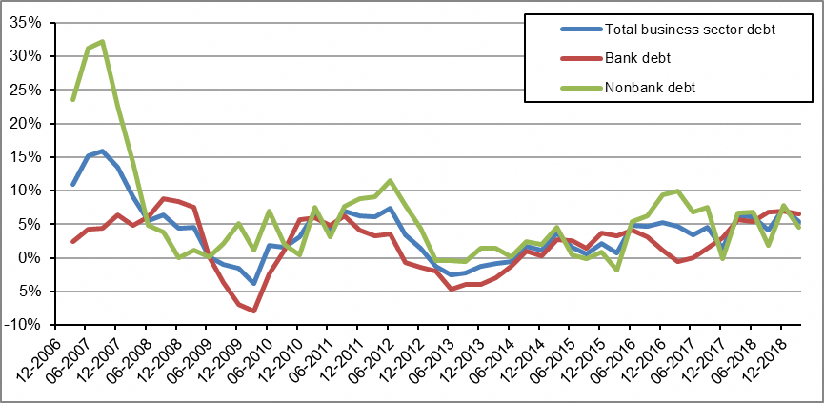

Figure 3: Nonfinancial Business Sector Bond Issuance during the quarter, by Industry
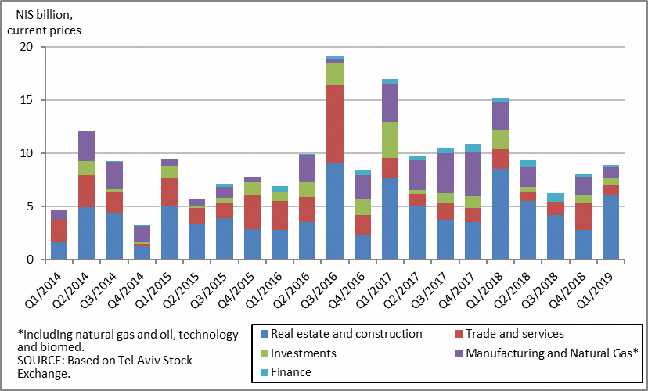

Figure 4 : Spread between Indexed Corporate Bonds (Tel-Bond 60) and Indexed Government Bonds (monthly average)
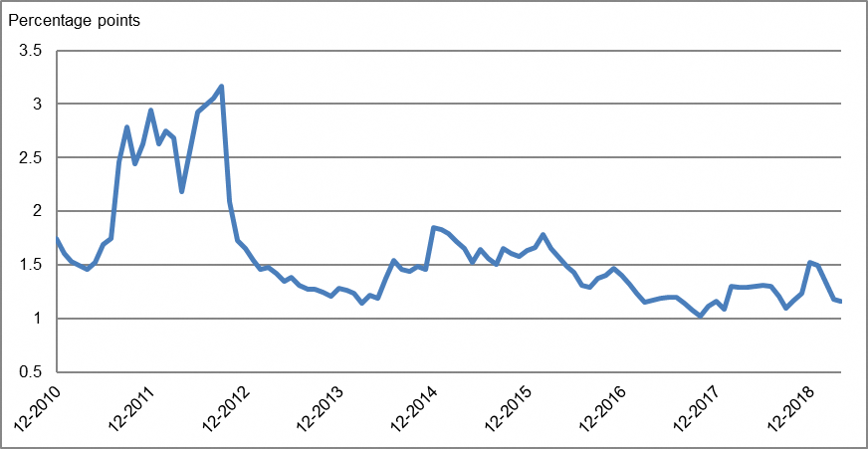

Household debt
- Households’ outstanding debt increased by about NIS 7 billion (1.2 percent) in the third quarter of 2020, to about NIS 602 billion. Outstanding housing debt increased by about NIS 8 billion (1.9 percent) to about NIS 408 billion, and nonhousing debt continued to decline, by about NIS 1 billion (0.4 percent), to about NIS 194 billion. Since the beginning of the year, the balance of nonhousing debt declined by about 4 percent. The decline intensified mainly in the first quarter, in view of the COVID-19 crisis (Figure 5).
- In the third quarter of 2020, there was a total of about NIS 19.5 billion in new mortgages taken out, higher than the same period last year (about NIS 18.3 billion). However, there was a decline in October that was mostly seasonal, to about NIS 6.2 billion. Net of seasonal effects, new mortgages taken out in October totaled about NIS 7.4 billion. (Figure 6).

Table 2: Outstanding Debt Balances of Households¹

Figure 5: Rates of Change in Households’ Housing and Nonhousing Debt, Current Quarter vs. Corresponding Quarter of Previous Year
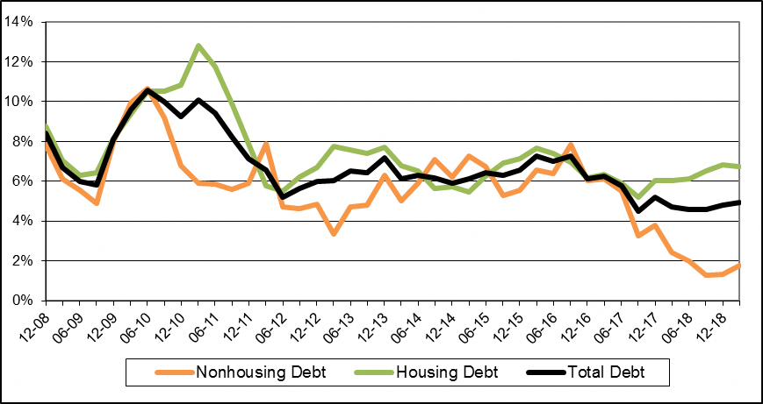
Figure 6 : Amount of New Mortgages Provided by Banks to the Public
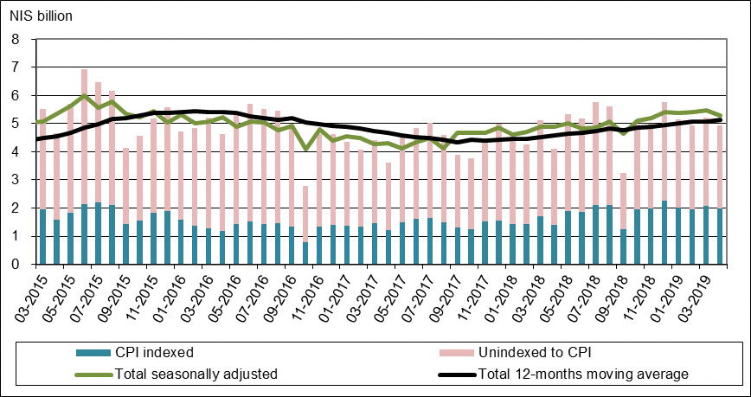
Links to Data and Statistics on the Bank of Israel website:
http://www.boi.org.il/en/dataandstatistics/pages/default.aspx
http://www.boi.org.il/en/bankingsupervision/data/pages/tables.aspx?chapterid=13
http://www.boi.org.il/en/BankingSupervision/Data/Pages/Tables.aspx?ChapterId=19
http://www.boi.org.il/en/DataAndStatistics/Pages/MainPage.aspx?Level=3&Sid=74&SubjectType=2

Israeli firms, excluding banks, credit card companies, and insurance companies.
The change in the spread from one quarter to the next is calculated as the difference between the average spread in the final month of the reviewed quarter and the average spread in the final month of the previous quarter.

