BANK OF ISRAEL
Office of the Spokesperson and Economic Information

October 6, 2025

Press Release:

Foreign Exchange Reserves at the Bank of Israel, September 2025

Israel’s foreign exchange reserves at the end of September 2025 stood at $231,880 million, an increase of $1,560 million from their level at the end of the previous month. The level of the reserves relative to GDP was 41.3 percent (Figure 1).

The increase was mainly explained by a revaluation of the reserves totaling approximately $2,353 million, which was partly offset by foreign exchange activity by the government totaling about $774 million.

Israel's Foreign Exchange Reserves ($ million)

Date | Reserves excluding IMF (including reserves bought under the natural gas purchase program) | Reserves at the IMF | Total Foreign Exchange Reserves
September 2025 | 227,246 | 4,634 | 231,880
August 2025 | 225,694^{c} | 4,626 | 230,320^{c}
July 2025 | 222,157 | 4,611 | 226,768
June 2025 | 223,651 | 4,599 | 228,250
May 2025 | 219,086^{c} | 4,553 | 223,639^{c}
April 2025 | 217,489 | 4,546 | 222,035
March 2025 | 214,394^{c} | 4,416 | 218,810^{c}
February 2025 | 215,898^{c} | 4,356 | 220,254^{c}
January 2025 | 211,710^{c} | 4,358 | 216,068^{c}
December 2024 | 210,170^{c} | 4,400^{c} | 214,570^{c}
November 2024 | 212,684 | 4,416 | 217,100
October 2024 | 211,638 | 4,436 | 216,074
September 2024 | 215,807 | 4,570 | 220,377

Figure 1
Level of foreign exchange reserves, and their ratio to GDP, 2008–2025

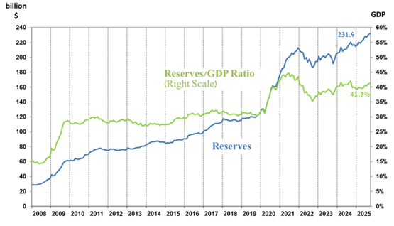

Including Bank of Israel payments and receipts in foreign currency.
^{b} This column includes Special Drawing Rights (SDRs), the balance of NAB loans, and the balance of Israel's reserve tranche at the IMF. c Updated after the original date of publication.

