
BANK OF ISRAEL
Office of the Spokesperson and Economic Information

March 22, 2026

Press Release:

Debt Developments in the Nonfinancial Private Sector,
Fourth Quarter of 2025

For the annual survey of debt developments for 2025, see “The debt of the nonfinancial private sector” in Part 1 of the “Statistical Bulletin for 2025” (translation forthcoming).

The following is a summary of developments in nonfinancial private sector debt in the fourth quarter of 2025:

- The increase in the balance of nonfinancial private sector debt (both business and household) continued, and in the fourth quarter of 2025, it increased by approximately 2.8 percent to a level of NIS 2.5 trillion.
- The balance of business sector debt increased by about 3.6 percent during the fourth quarter, to about NIS 1.5 trillion. This was mainly due to net debt raised, which was concentrated in bank credit and debt raised abroad.
- The balance of household debt also continued to increase during the quarter, to about NIS 903 billion, mainly due to a combination of an increase in the balance of housing debt (by about NIS 9 billion, 1.4 percent), which was due to an increase in new mortgage volume from banks, and an increase in the balance of nonhousing debt (about NIS 4 billion, 1.6 percent) to about NIS 250 billion.

The nonfinancial business sector’s debt
- In the fourth quarter of 2025, the balance of business sector debt continued to increase, by about NIS 53 billion (3.6 percent) to NIS 1.5 trillion. The increase in the balance derived from considerable net debt raised, totaling NIS 65 billion, made up of mostly of bank credit and by debt raised abroad via bonds and loans. It was partly offset by the appreciation of about 3.5 percent in the shekel vis-à-vis the dollar and by a decline of 0.6 percent in the CPI, which decreased the value of the debt denominated in and indexed to foreign currency and indexed to the CPI.
- Due to these impacts, the annual growth rate of the balance of business sector debt continued to expand in the quarter, to 11 percent, a trend that began in the second half of 2024, after a slowdown in the two preceding years. This development was reflected in bank debt in which the growth rate from the second half of 2024 accelerated to a high rate of 18 percent. The annual growth rate in the nonbank debt balance was about 1 percent at the end of 2025, lower than the rate of growth in the previous year, of 6 percent (Figures 1, 2).
- In the fourth quarter of the year, the business sector issued about NIS 19 billion in bonds, with more than half of it raised in December. This is lower than the average quarterly funds raised in the past four quarters (about NIS 22 billion on quarterly average.). About 48 percent of the issues in the quarter were by companies in the real estate and construction industry, the industry that continues to lead in funds raised, as in previous years (Figure 3).
- In the fourth quarter of 2025, the spread between yields on corporate bonds that are included in the Tel Bond 60 Index and the yields on CPI-indexed government bonds contracted slightly, to about 0.86 percentage points. This contraction continued in January as well to 0.82 percentage points However, in February 2026 this spread widened to about 0.94 percentage points (Figure 4)

Table 1

Table 1: The Composition of Business Sector Debt
Figure 1: Estimated Net Quarterly Quantitative Change in Business Sector Debt

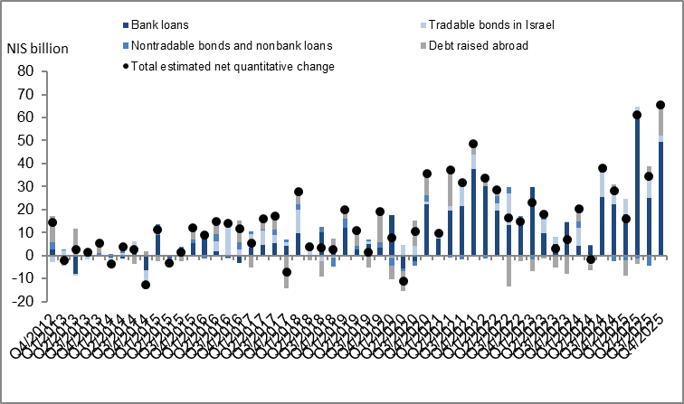

Figure 2: Rate of Change (Year on Year) in the Business Sector's Bank and Nonbank Debt
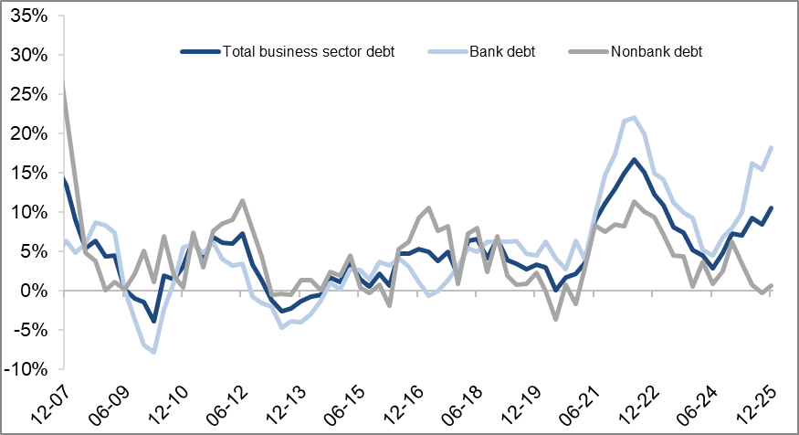

Figure 3: Nonfinancial Business Sector Bond Issuance during the quarter, by Industry

Figure 4: Spread between Indexed Corporate Bonds (Tel-Bond 60) and Indexed Government Bonds (monthly average)
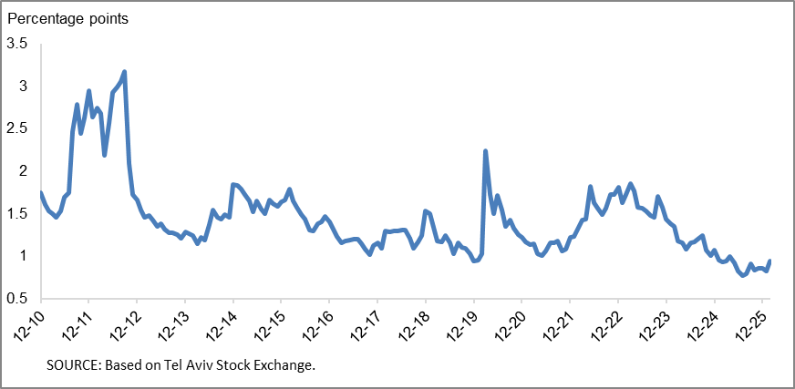

Household debt
- In the fourth quarter of 2025, the balance of households’ outstanding debt continued to increase, to a level of NIS 903 billion –an increase of NIS 13 billion (1.5 percent). The balance of housing debt continued to increase, by about 1.4 percent (about NIS 9 billion), to about of NIS 653 billion, mostly to banks.
- The balance of nonhousing debt also increased in the quarter, by about 1.6 percent (about NIS 4 billion), to about NIS 250 billion.
- Due to these effects, the annual growth rate of housing debt remained high during the quarter, with some stabilization during the year, and it ended at 7 percent. The annual growth rate of the nonhousing debt balance expanded to 6 percent after reaching a negative record at the end of 2023 in view of the outbreak of the war (Figure 5).
- The increase in housing debt is the result of continued new mortgage borrowing from the banks, ending the fourth quarter of the year, after seasonal adjustment, at NIS 26 billion, similar to the quarterly average of new mortgage volume in 2025 on quarterly average
- In January-February 2026, new mortgage volume taken from the banks totaled, after seasonal adjustment, at NIS 10 billion on monthly average, slightly above the monthly average taken out during 2025 (about NIS 8.8 billion) (Figure 6).

Table 2: Outstanding Debt Balances of Households¹
Figure 5: Rates of Change in Households’ Housing and Nonhousing Debt, Current Quarter vs. Corresponding Quarter of Previous Year
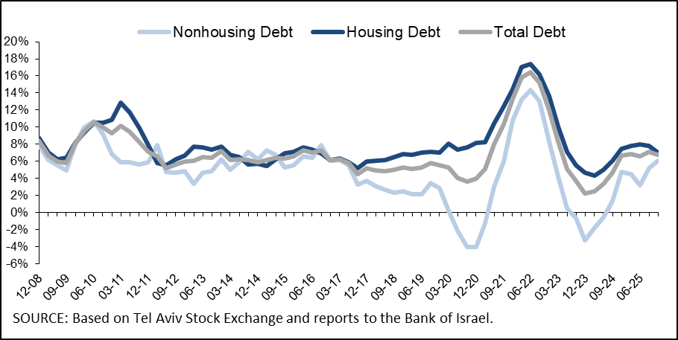

Figure 6 :Amount of New Home Purchase Loans Provided by Banks to the Public (Mortgages)
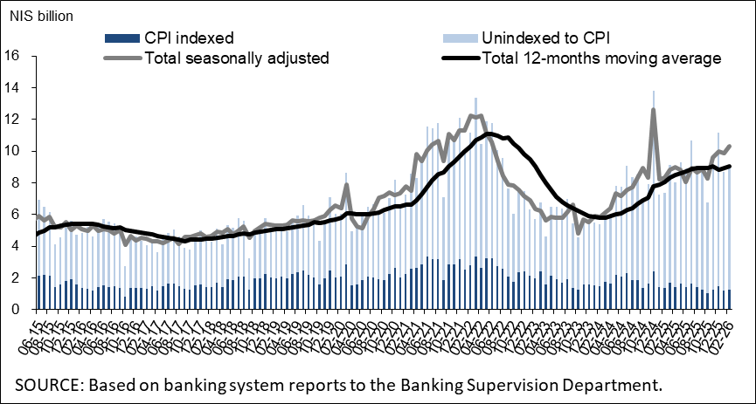
Links to Data and Statistics on the Bank of Israel website:
https://www.boi.org.il/en/economic-roles/data-and-statistics/money-and-debt-aggregates/debt-and-credit/

Data on debt to banks are based on monthly balances sheet data, not on data from annual financial statements. As of the writing of this notice, the financial statements for 2025 have not yet been published.
Israeli corporations, excluding banks, credit card companies, and insurance companies.
The change in the spread from one quarter to the next is calculated as the difference between the average spread in the final month of the reviewed quarter and the average spread in the final month of the previous quarter.

