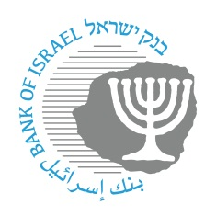

BANK OF ISRAEL
Office of the Spokesperson and Economic Information

January 25, 2026

Press Release:
IMF Mission Begins Its Discussions on the Israeli Economy
The annual mission of the International Monetary Fund (IMF) today began its routine discussions on developments in the Israeli economy.

At the conclusion of the meetings, the mission will publish its concluding statement. Afterward, a detailed annual report will be prepared and submitted to the IMF’s Executive Board for its consideration, as is standard practice for every member country.

The mission is headed by Mr. Kotaro Ishi.

As with every such visit, the mission will hold consultations with economic decision-makers, in both the public and private sectors. For example, the mission will meet with senior officials from the Bank of Israel and the Ministry of Finance, as well as with senior officials from various government ministries, commercial banks, and private sector representatives.

