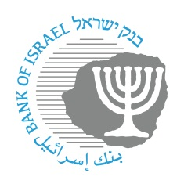

BANK OF ISRAEL
Office of the Spokesperson and Economic Information

Press Release
January 8, 2026

The Bank of Israel Monetary Committee met with private forecasters

Bank of Israel Governor Prof. Amir Yaron and the members of the Monetary Committee held their quarterly meeting today with the group of forecasters who regularly provide the Bank of Israel with projections for inflation, the interest rate, and the exchange rate. The meeting serves as a platform for exchanging views and assessments between the Bank of Israel and key financial institutions in the economy.
Governor Yaron opened the meeting with remarks on recent economic developments in view of the war. Following his remarks, Nimrod Cohen, an economist in the Research Department, presented and explained the Department’s assessment as prepared and published on January 5, 2026 alongside the most recent interest rate announcement. The presentation shown at the meeting is attached (in Hebrew).
The forecasters responded to the presentations and shared their own economic assessments regarding the various developments.

