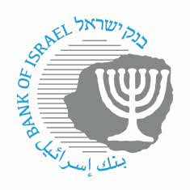

**BANK OF ISRAEL**

Office of the Spokesperson and Economic Information

December 11, 2022

Press Release:

**The Bank of Israel is streamlining the connection to the payment systems for fintech firms and other entities**

From the end of the year onward, the Bank of Israel, MASAV and SHVA will publish times at which new entities, including fintech firms, bigtech firms, credit and savings unions[1], and other relevant banking entities will be able to connect to their infrastructures. Until now, these infrastructures have been the domain of traditional banks only. Access to the payment systems will enable the new entities to offer payment services to the public. Those entities are expected to use the infrastructures to offer additional financial services.

Today, the Bank of Israel instructed the operators of the following controlled payment systems to publish the dates of the entry windows[2] for the coming two years:

|  |  |
| --- | --- |
| System Operator | System |
| Bank of Israel | ZAHAV – Real-time gross settlement |
| MASAV | Credit, debit and transfer of payments system |
| Faster payments |
| SHVA | Ashrait – Payment card services (switch) |
| ATM - Automated Teller Machine |

Oded Salomy, Director of the Bank of Israel’s Payment and Settlement Systems Department, said: “Following the Bank of Israel’s instruction, new participants will be able to arrange in advance when they will enter the payment systems, from among the potential dates set out. Once such a date is chosen, a launch program will be set that will include all the stages in the process and the schedule for implementation, so that the new participant will be able to prepare in advance for the start of its operations, and streamline its activity with the payments market.”

1. Referring to “Deposit and Credit Unions”, which are known to the general public as “Credit and Savings Unions”.
2. “Entry windows” are the dates on which new entities can connect to the payment systems.