September 23, 2026

Press Release:

The public's financial assets portfolio in the second quarter of 2026

- In the second quarter of 2026, the balance of the public’s financial assets portfolio increased by approximately NIS 332 billion (4.6 percent), to about NIS 7.62 trillion.
- The increase in the portfolio’s value in the second quarter was mainly due to increases in the balance of equities abroad (8.3 percent), in the balance of cash and deposits (4.2 percent), and in the balance of corporate bonds (3.8 percent).
- The balance of the assets portfolio managed by institutional investors increased in the second quarter by approximately NIS 198 billion (6.1 percent), to approximately NIS 3.5 trillion at the end of the quarter.
- The scope of the portfolio managed by mutual funds in Israel increased by approximately NIS 46 billion (6 percent) in the second quarter, to a level of NIS 826 billion. There were net new investments, mainly in shekel money market funds and in funds specializing in domestic bonds.

1. The public’s total assets portfolio

In the second quarter of 2026, the balance of the public’s financial assets portfolio increased by approximately NIS 332 billion (about 4.6 percent), to about NIS 7.62 trillion (Figure 1). The share of the public’s financial assets portfolio relative to GDP increased by approximately 8.4 percentage points, to about 348 percent at the end of the quarter, as a result of an increase in the balance of the asset portfolio that was larger than the increase in GDP.
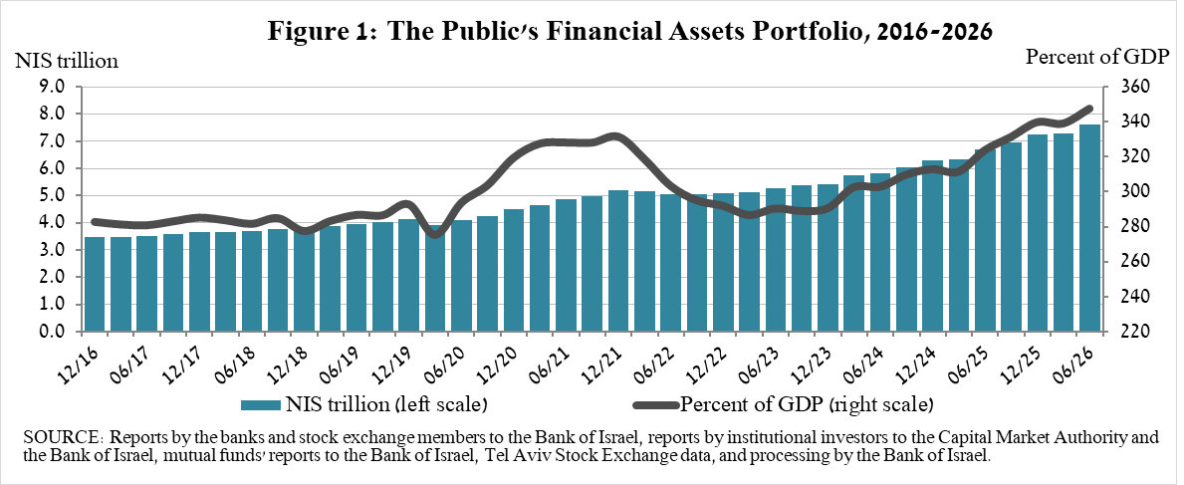
2. Analysis of the changes in the overall portfolio

Over the course of the second quarter, there were increases in the balances of the public’s holdings in all of the portfolio’s components. The increases in the balances of investments abroad (8.3 percent), cash and deposits (4.2 percent), and corporate bonds (3.8 percent) were particularly prominent.
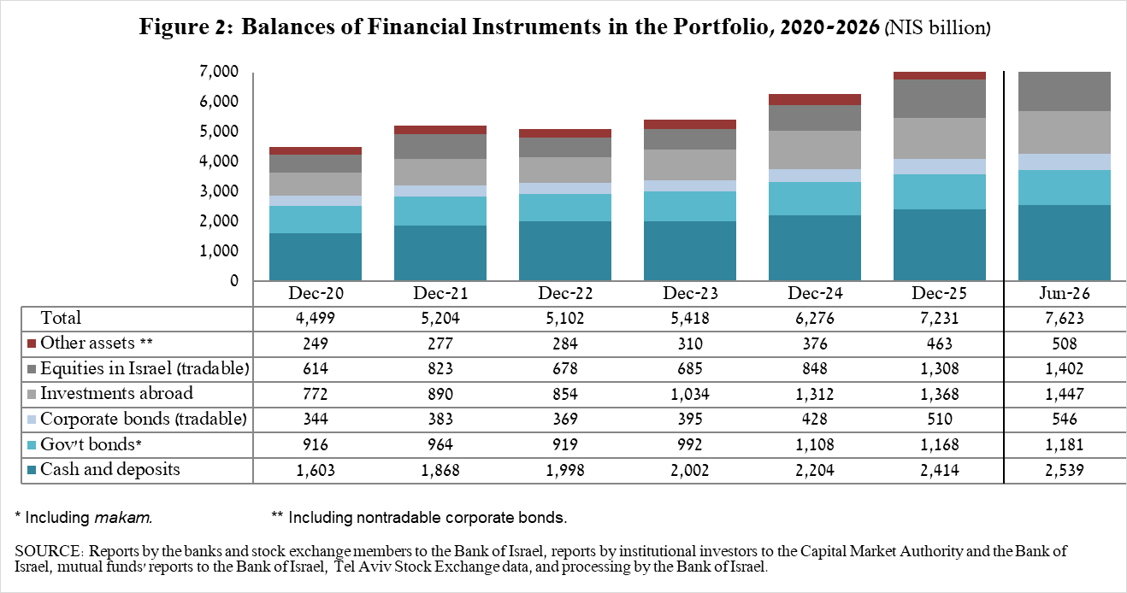

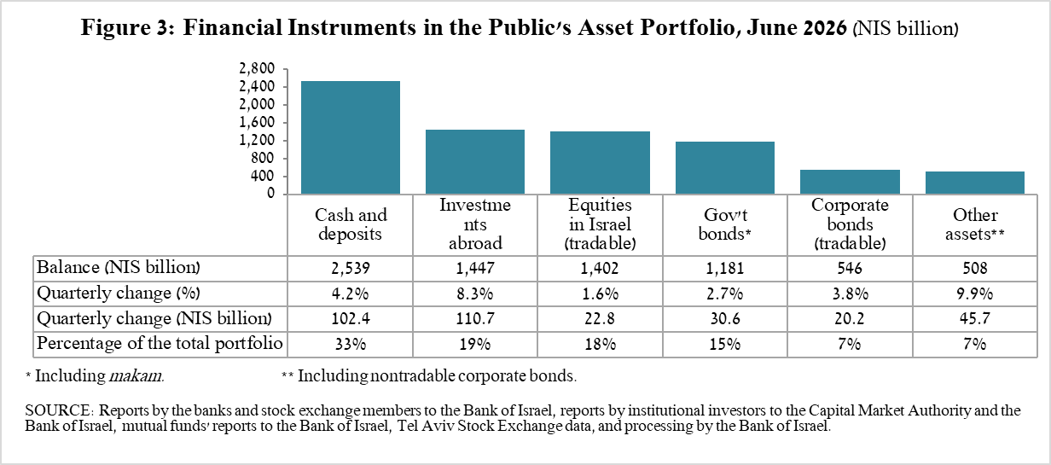

- The balance of cash and deposits increased during the second quarter by about NIS 102.4 billion (4.2 percent) to about NIS 2.54 trillion, which is about 33 percent of the total portfolio.
- The balance of tradable corporate bonds in Israel increased during the quarter by about NIS 20.2 billion to about NIS 546 billion at the end of the quarter, due to both net investments and price increases.
- The balance of equities in Israel increased by about NIS 22.8 billion (1.6 percent), mainly in view of price increases.
- The balance of Makam (central bank bills) held by the public increased by about NIS 8 billion, to about NIS 196 billion.
- The balance of tradable government bonds held by the public increased by about NIS 16 billion, to about NIS 519 billion at the end of the quarter (Figure 4). In a breakdown by holders of government bonds, the balance of institutional investors’ holdings increased by about NIS 13.4 billion, to about NIS 370 billion.

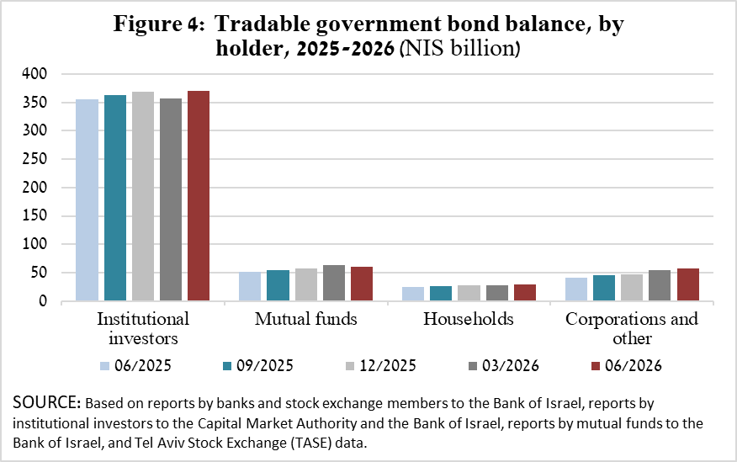

The balance of investments abroad increased by approximately NIS 111 billion, to about NIS 1.45 trillion at the end of the quarter, accounting for approximately 19 percent of the total asset portfolio. The development in the balance of investments abroad was mainly due to the following components:

- The balance of equities held abroad increased by approximately NIS 129.5 billion (16.8 percent), to about NIS 901 billion at the end of the quarter, the result of a combination of price increases and net new investments.
- The balance of investment funds abroad declined by about NIS 9 billion (3.7 percent) to about NIS 238 billion at the end of the quarter.
- The balance of tradable (corporate and government) bonds abroad declined by approximately NIS 6.4 billion (2.8 percent) to about NIS 221 billion at the end of the quarter.

As a result of the developments during the quarter, there was an increase of about 0.8 percentage points (from 24.1 percent to 24.9 percent) in foreign currency assets, and an increase of about 0.7 percentage points (from 18.3 percent to 19 percent) in the share of foreign assets.

3. The portfolio managed by institutional investors
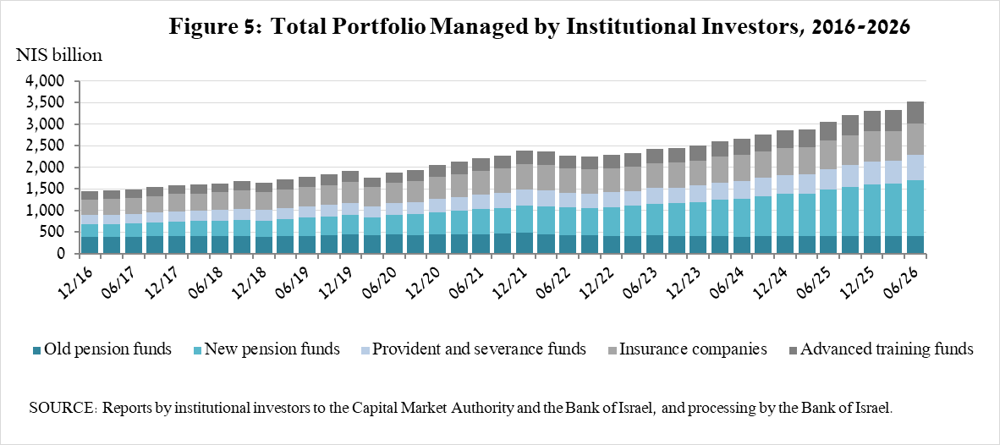
- The balance of assets managed by all institutional investors increased in the second quarter by about NIS 198 billion (6.1 percent), to NIS 3.5 trillion (approximately 46 percent of the public’s total financial assets portfolio). The increase in the balance of the managed portfolio during the quarter was reflected in the following components: investments abroad—an increase of about NIS 109 billion (13 percent), which was mainly due to price increases; cash and deposits in Israel—an increase of about NIS 33 billion (9.5 percent); and tradable and nontradable government bonds in Israel—an increase of about NIS 19 billion (2.2 percent).

4. The portfolio managed by mutual funds

The value of the portfolio managed by Israeli mutual funds increased in the second quarter by approximately NIS 46 billion (6 percent), to about NIS 826 billion at the end of the quarter, comprising about 11 percent of the public’s asset portfolio.

The increase in the second quarter was mostly due to net new investments totaling NIS 22.6 billion, and to price increases. Most of the new investment was in shekel money market funds (about NIS 11.5 billion) and in funds specializing in bonds in Israel (about NIS 9.1 billion). In contrast, there was negative net new investment in funds specializing in equities in Israel (about NIS 4.8 billion).
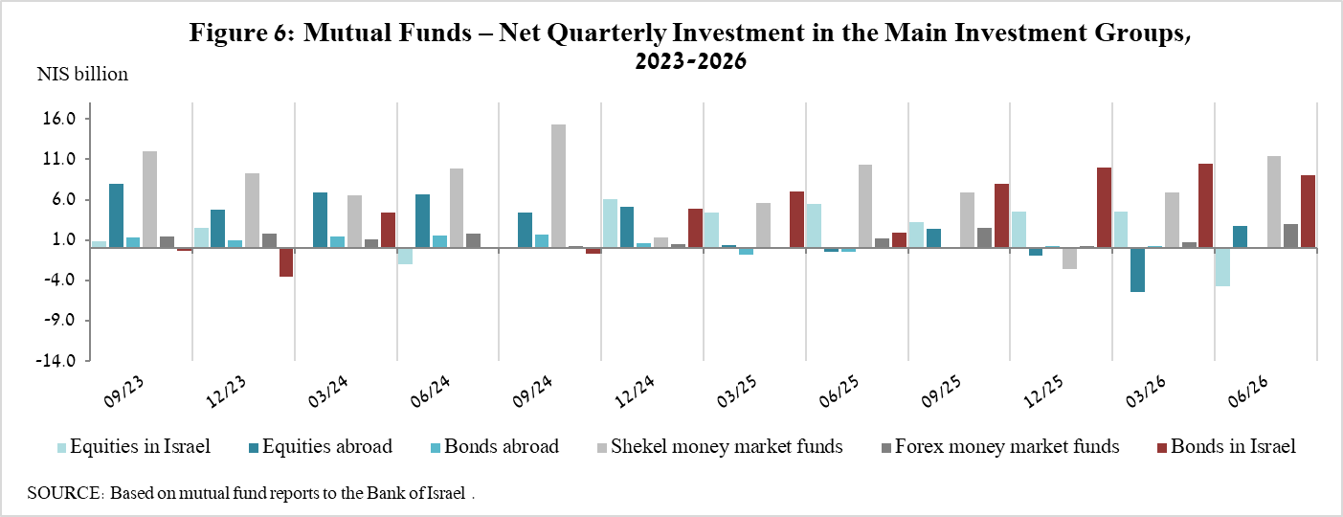

Further information and details:

Long-term tables on the asset portfolio are available here.

Long-term tables on institutional investors’ exposure to foreign exchange and to foreign assets are available here.

Long-term tables on mutual funds are available here.

Excluding mutual funds.

