

BANK OF ISRAEL
Office of the Spokesperson and Economic Information

Press release

October 21, 2026

The monthly Index of Economic Activity increased by 0.3 percent in September

The monthly Index of Economic Activity increased by 0.3 percent in September. The Index this month reflects the average monthly growth estimate for the three months from July to September. The Index was positively affected by credit card purchase data (mainly in August), goods exports—particularly manufacturing exports, and the NASDAQ 100 and Tel Aviv Stock Exchange General Shares indices in August and September, as well as the retail trade index and receipts in respect of other services in August. In contrast, actual employee and job vacancy figures in August and indirect tax receipts in September moderated the increase in the Index (Tables 1 and 2).
The pace of increase of the index is similar to the long-term growth trend (about 0.3 percent).
The Indices for recent months were revised downward following the publication of final data for previous months.
Figure 1 presents the Index data over the past two years. Table 1 presents the contributions of the Index’s components to the overall estimate and the revisions to the Index, and Table 2 presents the monthly rate of change in the Index’s components.

FIGURE 1: The Monthly Index of Economic Activity
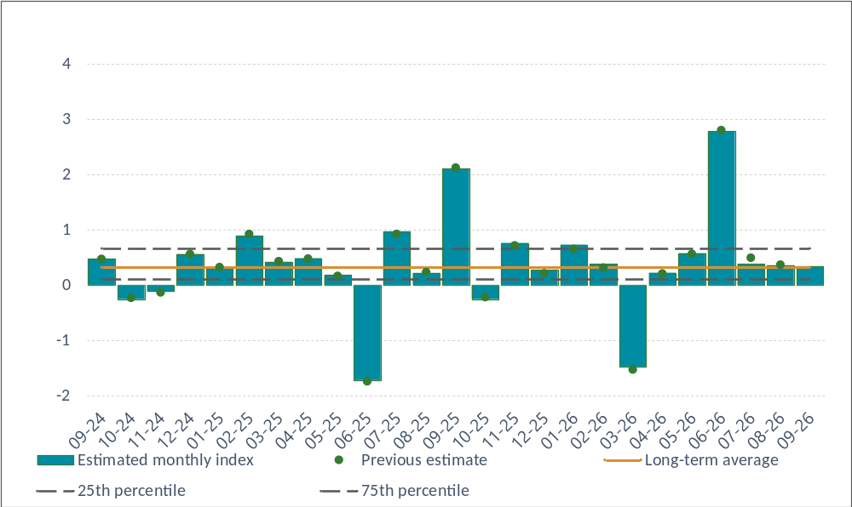

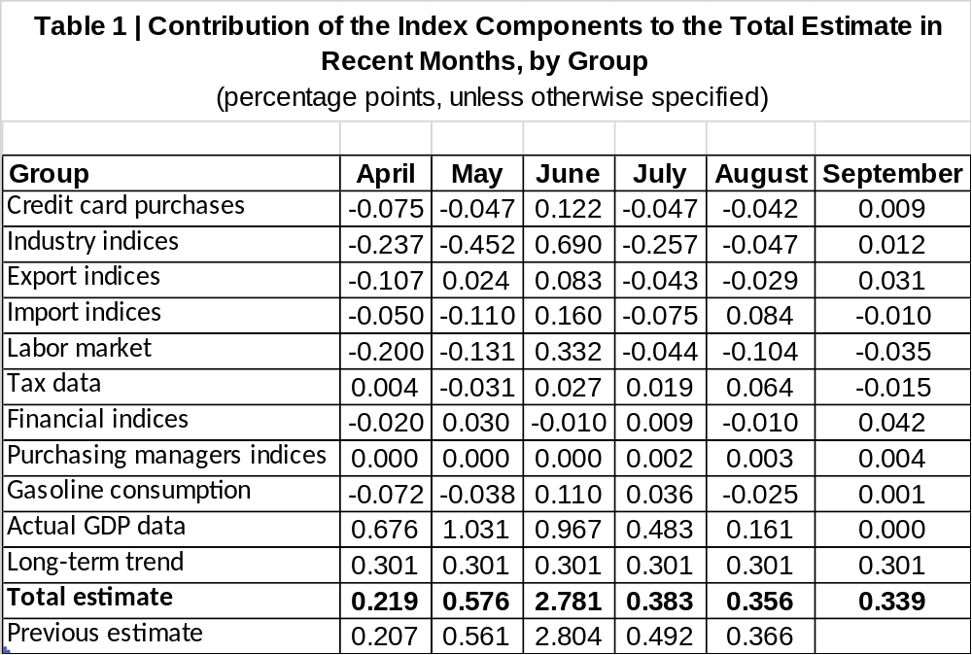
a
* The table presents the contribution of each group of components in the monthly index, such that the monthly estimate constitutes the sum of the contributions of each of the components detailed in the table. Some of the raw data influence the monthly estimate with a lag or influence the estimates of several months.

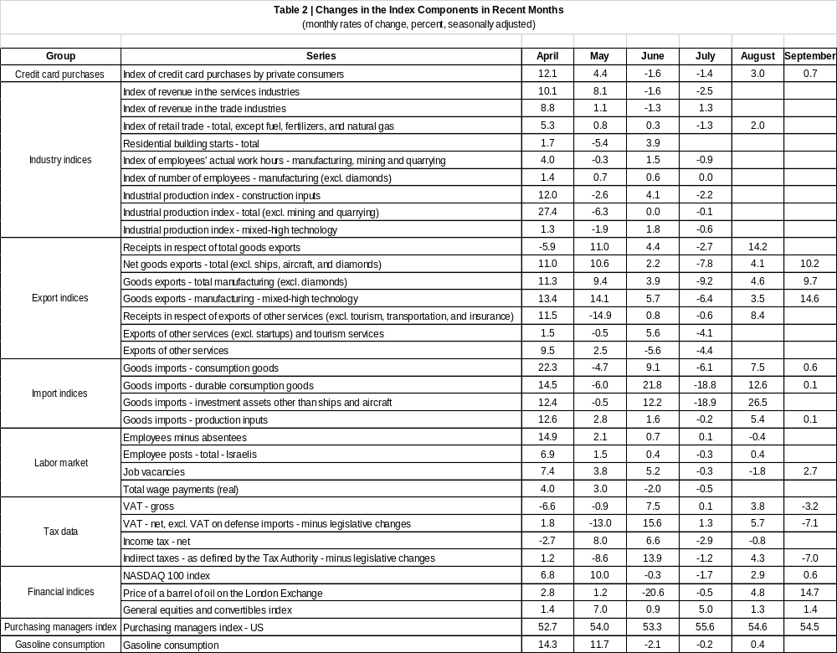

The monthly Index of Economic Activity reflects the three-month average of the estimated monthly growth of GDP. The estimate is based on a model developed at the Bank of Israel (Ginker and Suhoy, 2021).

