September 16, 2025

Press Release:

Israel’s International Investment Position (IIP),
Second quarter of 2025

- The economy’s outstanding liabilities to abroad increased by approximately $54.6 billion (about 10 percent) in the second quarter, to about $609 billion at the end of the quarter. Nonresidents continued to make net investments in Israel, mainly in direct investments (primarily in undistributed profits) and other investments. At the same time, the prices of Israeli securities held by nonresidents increased.
- In the second quarter of 2025, the balance of assets held abroad by Israeli residents increased by approximately $61.5 billion (about 7.8 percent), to about $852 billion at the end of June. The increase was mainly due to net investments abroad by Israeli residents and an increase in the prices of foreign securities held by Israeli residents.
- The surplus of assets over liabilities vis-à-vis abroad increased during the second quarter of 2025 by $7 billion (2.9 percent), to about $244 billion at its end.
- The surplus of assets over liabilities vis-à-vis abroad in debt instruments alone (negative net external debt) increased by about $16 billion (5.3 percent) during the second quarter, to approximately $312 billion at the end of second quarter.
- The ratio of gross external debt to GDP (in dollar terms) increased by about 1.4 percentage points in the second quarter, to about 28.7 percent at the end of June.

Table 1: Asset and liability balances, and changes in them

- The balance of Israelis’ assets abroad
In the second quarter of 2025, the value of the assets held abroad by Israeli residents increased by about $61.5 billion (about 7.8 percent), to approximately $852 billion at the end of June.
- The value of direct investments increased by about $3.1 billion (approximately 2.7 percent) in the second quarter, mainly as a result of net investments by Israeli residents.
- The value of the securities portfolio increased during the second quarter by about $30.5 billion (about 11 percent), mainly as a result of an increase in prices of foreign securities held by Israeli residents totaling about $16 billion, and of net investments by Israeli residents in foreign securities totaling approximately $13 billion. Most of the investments in the securities portfolio were made by the banking sector. (Figure 1).

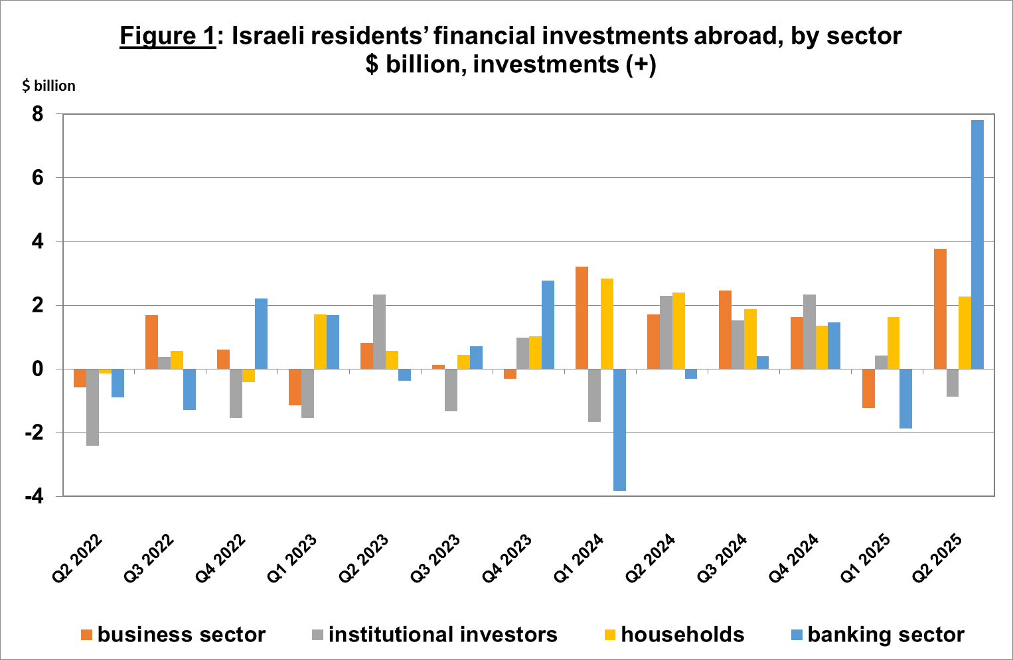
Source: Bank of Israel data and processing¹.

- The value of other investments abroad increased during the second quarter by about $8.2 billion (about 4.5 percent), mainly as a result of net investments totaling about $3.6 billion. Israeli residents (including banks) deposited about $4.2 billion, net, in deposits abroad. Most of the deposits were made by the banking sector. In contrast, there was a decline in customer credit to nonresidents, totaling about $1.5 billion.
- The value of the reserve assets increased by about $9.4 billion (about 4.3 percent) during the second quarter, to about $228 billion at the end of June. The increase in the balance was mainly due to an increase in the price of foreign securities totaling about $6.5 billion, and to a weakening of the US dollar against other currencies, which contributed an increase of about $4.2 billion to the value of reserve assets. In contrast, government activities led to a decline of $1 billion.
- The composition of Israelis’ securities portfolio abroad: During the second quarter, the share of equity instruments in Israeli residents’ portfolio abroad remained unchanged, and at the end of June it was 46 percent. Accordingly, the share of debt instruments was 54 percent at the end of the quarter.

- Israel’s liabilities to abroad

The balance of Israel's liabilities to abroad increased by about $54.6 billion (about 10 percent) during the second quarter, to approximately $608 billion at the end of the quarter. The increase was mainly due to an increase in prices of Israeli securities held by nonresidents. Nonresidents increased their volume of investments in Israel relative to the previous quarter.
- The value of direct investments in the economy increased by about $10 billion (about 3.8 percent) during the second quarter, due to net investments (mainly undistributed profits) by nonresidents totaling about 5.4 billion, and an increase in the prices of Israeli equities held by nonresident parties at interest. Direct investment in Israeli share capital was fully offset by realizations of equities of Israeli companies traded abroad (Figure 2). Some of these realizations were due to the transition from direct investment to investment in the tradable portfolio.
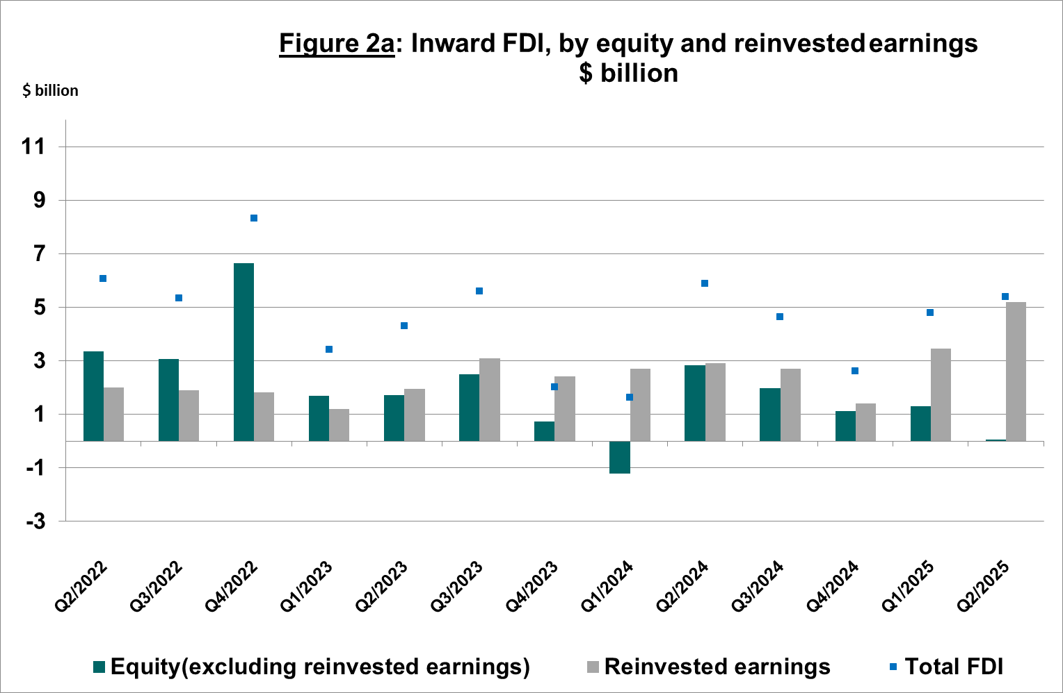
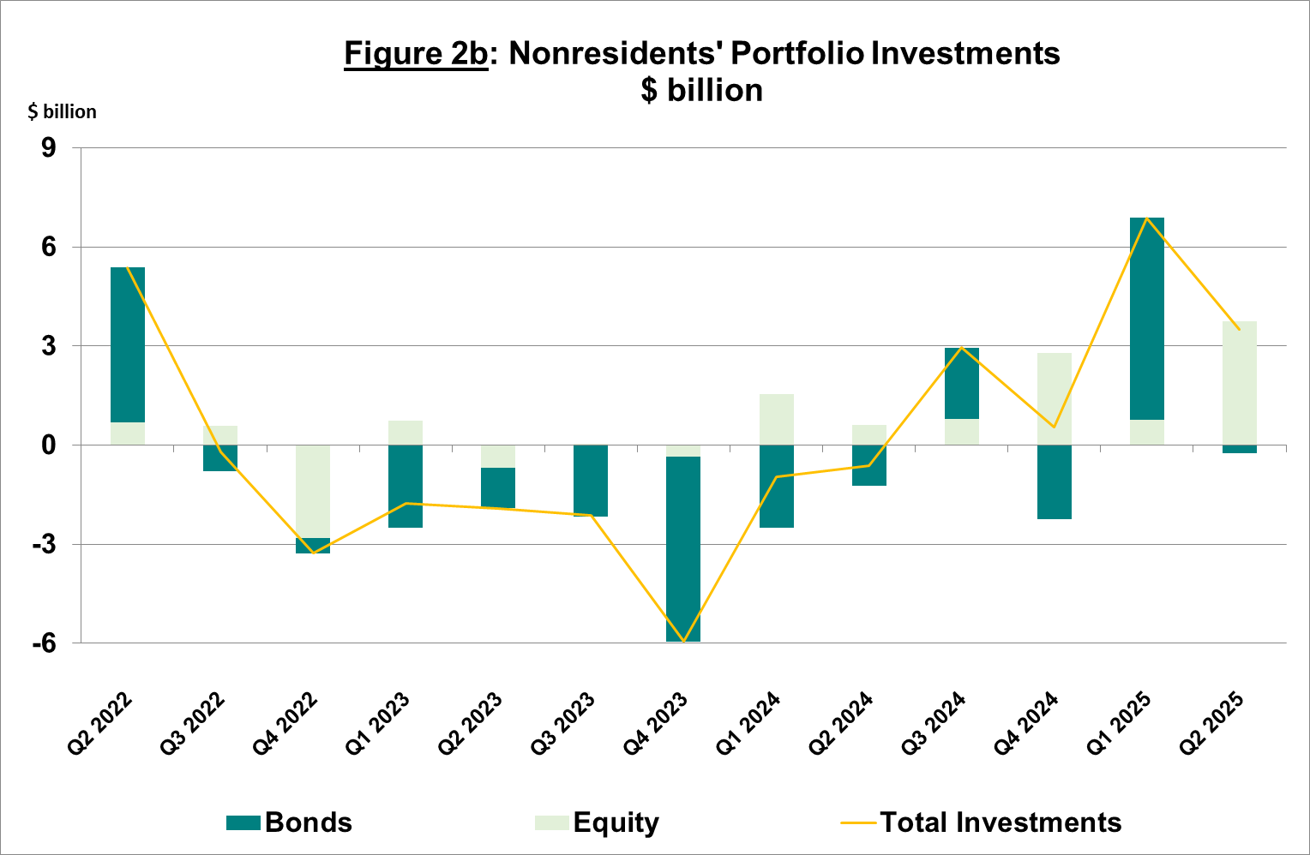

- The value of the securities portfolio increased by about $37.8 billion (about 17.3 percent) in the second quarter. Nonresidents made net investments of about $3.7 billion in Israeli equities, and made net realizations of about $0.2 billion in Israeli bonds. The rest of the change in the balance was due to an increase in the prices of Israeli equities held by nonresidents.
- The value of nonresidents' financial portfolio on the Tel Aviv Stock Exchange, (which makes up a part of nonresidents’ investments in Israel) increased by about $28.4 billion in the second quarter of 2025, to about $107 billion at the end of June. (Figure 3 and Figure 4).

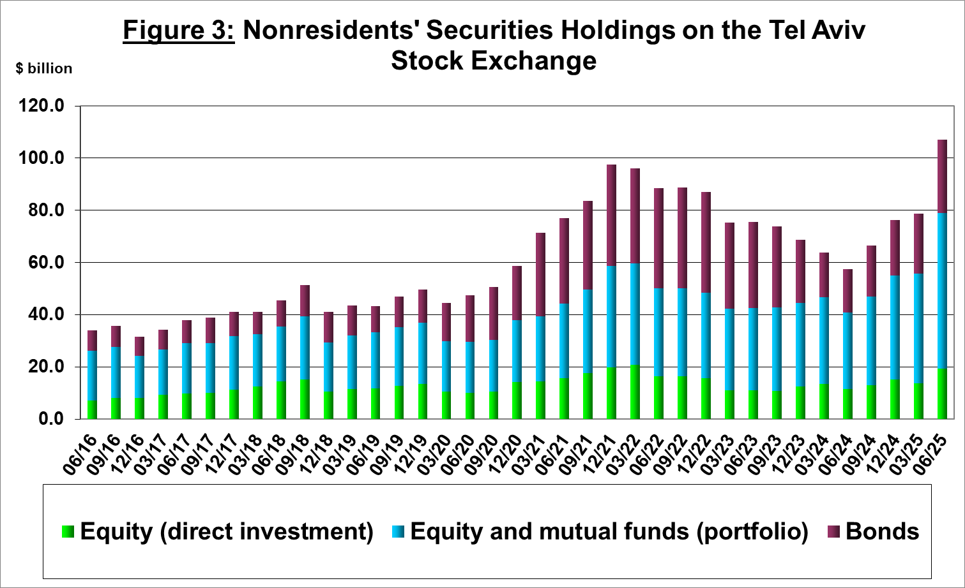
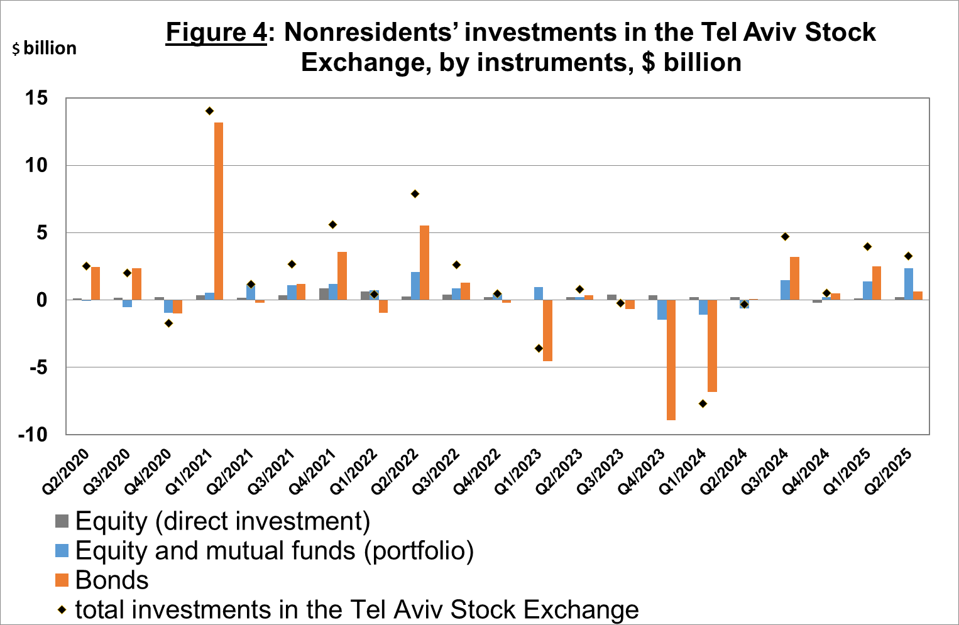

Source: Israel Securities Authority, and Bank of Israel data and processing¹.

The value of other investments in the economy increased by about $6.7 billion (about 9.7 percent) in the second quarter, to about $75 billion. The increase was mainly due to net investments by nonresidents (including banks) in deposits with Israeli banks totaling about $6.3 billion. In contrast, there was a decline in suppliers’ credit totaling about $1.2 billion.

The balance of liabilities in debt instruments alone, which makes up Israel's gross external debt, increased by about $11.8 billion (7.8 percent) in the second quarter, to about $163 billion.

The ratio of gross external debt to GDP declined by about 0.4 percentage points in the second quarter, to about 27 percent at the end of June. The decrease in the external debt to GDP ratio reflected an increase in the balance of gross external debt at a lower pace than the increase in GDP in dollar terms (Figure 5).

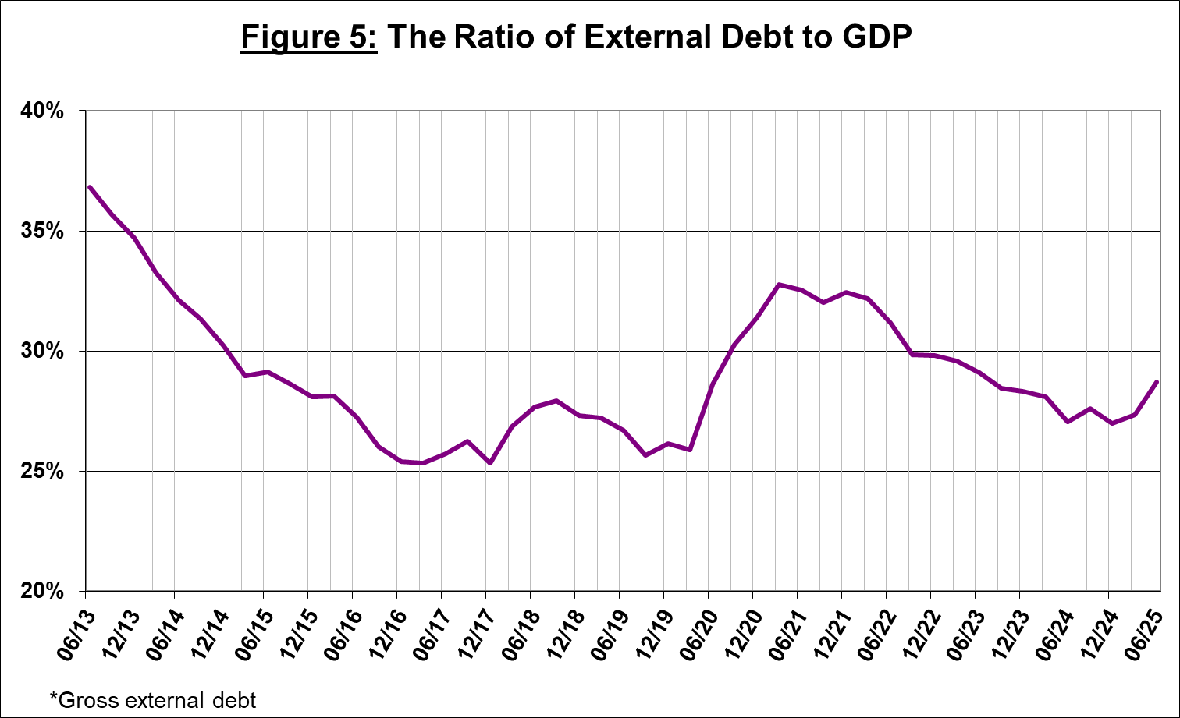

Source: Israel’s Ministry of Finance, Israel’s Central Bureau of Statistics, and Bank of Israel data and processing.¹

- Israel’s surplus assets over liabilities vis-à-vis abroad
The increase in the balance of assets and the lesser increase in the balance of liabilities led to an increase of about $7 billion (2.9 percent) in the surplus of assets over liabilities vis-à-vis abroad, which totaled about $244 billion at the end of June (Figure 6).

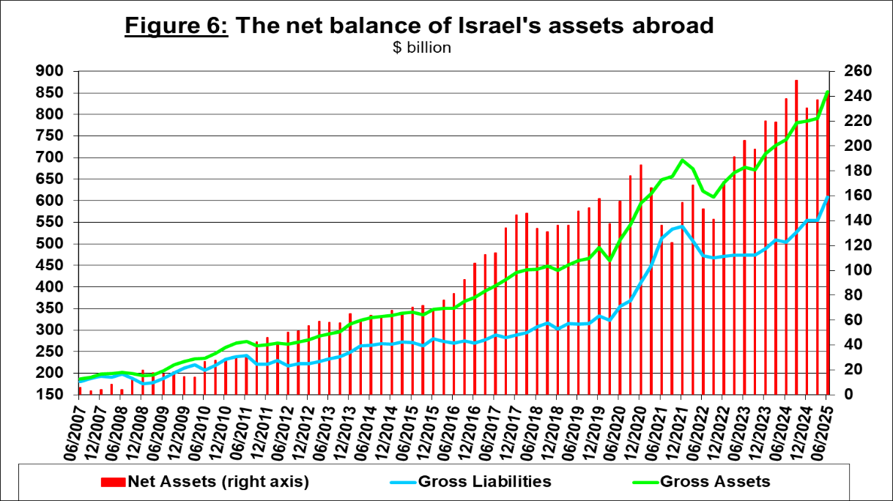

Source: Bank of Israel data and processing¹.

- Net external debt

The surplus of assets over liabilities vis-à-vis abroad in debt instruments alone (negative net external debt) increased by approximately $16 billion (about 5.3 percent) in the second quarter, to about $312 billion at the end of June (Figure 7).

The balance of assets in debt instruments increased by about $27.5 billion in the second quarter, to about $475 billion at the end of the quarter, of which about $228 billion is the Bank of Israel's foreign exchange reserves. This balance reflects a coverage ratio of 2.9 times the gross external debt.
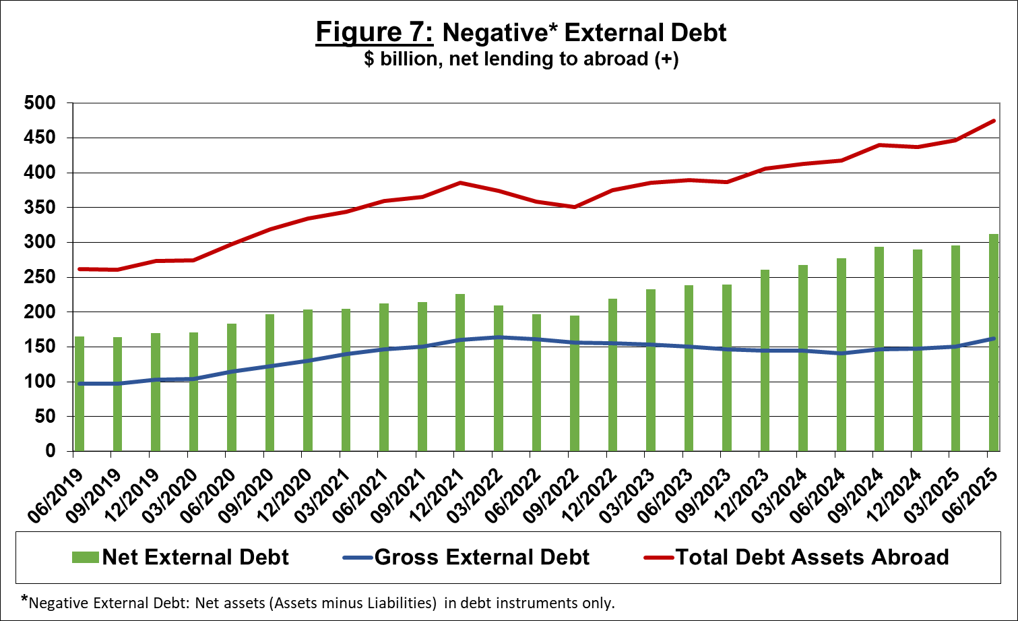

Source: Israel’s Ministry of Finance, and Bank of Israel data and processing.

For the complete data file, click here.

Bank of Israel data and processing: The Bank of Israel’s Information and Statistics Department collects data from numerous varied sources. Most of the data on the economy’s activity vis-à-vis abroad are received by force of a Bank of Israel Order, from direct reports by corporations and individuals to the Bank of Israel. (See: Information Regarding Foreign Exchange Market Developments in Israel, 5770–2010). Additional data used for measuring economic activity vis-à-vis abroad are received by reports from the Bank of Israel’s Accounting Division, the Ministry of Finance, the Central Bureau of Statistics, the Israel Securities Authority, domestic banks and other financial intermediaries, and institutional investors. The Department carries out estimations and processing on data received from the various sources.

