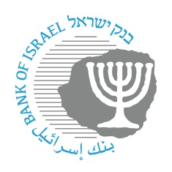

**BANK OF ISRAEL**

Office of the Spokesperson and Economic Information

June 21, 2023

Press Release:

**The Bank of Israel leads an additional process to open the financial sector to nonbank entities**

The Bank of Israel today is publishing its “Payment Systems Access Guide”. It details for nonbank entities, including domestic and international fintech companies, how to join the core systems of the financial sector in Israel, alongside the banks, and to provide services to the public.

The document is being published due to steps taken by the Bank of Israel, among others, to open the payment systems to new entities. It contains details on the various payment systems and possible types of participation in the systems. In addition, the document publishes, for the first time, an “access diagram[1]” formulated by the Bank of Israel. The access diagram details the process of new entities joining the controlled payment systems, and includes the stages and requirements vis-à-vis all the relevant entities leading up to activity in the system.

New entities that are interested in beginning the process of joining the payment systems, in accordance with the diagram below, are welcome to contact the payment systems oversight function at the Bank of Israel in order to receive information on the various options for new entities.[2]

The Access Guide will probably be updated periodically. Interested parties can find the most up to date version at the Bank’s website at [www.boi.org.il](http://www.boi.org.il).

**Payment and Settlement Systems Department Director Mr. Oded Salomy** said, “Publication of the guide is intended to clarify to the various entities, including fintech companies in Israel and abroad, the various requirements and alternatives for activity in the payment systems in Israel, in order to enable them to choose the model that is appropriate for them, and to ease the participation process for them. We expect that those companies will consider access to the payment systems as an initial step to providing a broad range of financial services to the Israeli public.”

**Payment Systems Oversight Division Head Ms. Noa Sheshinski-Lavi** said, “Publication of the Access Guide joins a series of steps taken by Payment Systems Oversight in order that the payment market in Israel will be more competitive, fair, and efficient. It is important for us to clarify to the various entities the range of requirements and alternatives for participation in Israel’s payment systems, in order to ease the participation process for them, to enable them to offer advanced and innovative payment solutions, and to be significant participants in the payments area, while reducing the dependence on the banking system.”

**The Process for a Payment Service Provider to Join the Controlled Payment Systems**

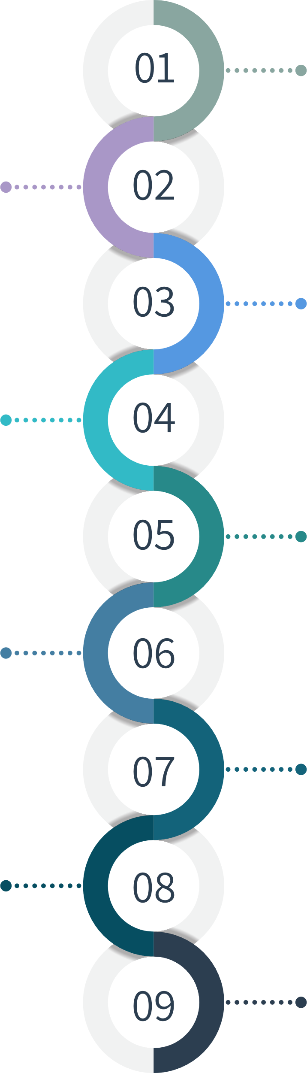

Clarification regarding access to the payment systems

Determination of the types of participation for the 3 pillars

Receipt of recommendation on providing access

Approval of allocation of an ID code

Receipt of system rules that are not sensitive

Documentation of exemption from license

Receipt of system rules that are sensitive

Certification of successful completion of the examinations

Completion of system access process



Entities in process of receiving a license

Entities that have a license

Entities acting as a payment institution that is exempt from a license, except CLP



1. The access diagram, which describes the high-level stages is attached below. The breakdown of substages appears in the Access Guide.
2. You can contact Payment Systems Oversight via, among other ways, email to: [payments-oversight@boi.org.il](mailto:payments-oversight@boi.org.il)