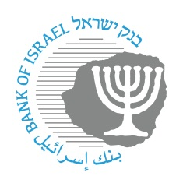

BANK OF ISRAEL
Office of the Spokesperson and Economic Information

Press Release
January 13, 2026

The Bank of Israel announces an expansion of the identification code used by nonbank corporations to connect to the payment systems to three digits, as a further step in opening access to the payment systems

The Bank of Israel has decided to expand the identification codes used by banking corporations and nonbank entities to connect to the payment systems. The code, which was previously known as a “bank code”, is currently composed of two digits. It will be expanded to three digits.
Connecting to the payment systems is conditioned on the connecting entity’s identification using an identification code. Expanding the format of the code will make it possible to increase the number of participants that can connect to the payment systems. This step will enable nonbank entities, including domestic and international fintech firms, to operate as direct participants in the payment systems, alongside the banks, and will enable them to offer the Israeli public a wide variety of financial services. This decision is a further step by the Bank of Israel in its efforts to increase efficiency and competition in the payment systems.

The decision on the format for expanding the identification code is expected to have a systemic effect on the entire economy, and was therefore made following a prolonged examination process. During this process, possible solutions were examined and the significance of each alternative was analyzed, in consultation with financial system participants, regulators, and a broad sample of entities, international institutions, technology solution providers, corporate businesses, and more.

The Bank of Israel will publish schedules during 2026 for implementation of the expanded identification code.

Payment and Settlement Systems Department Head Ofer Golan said: “The decision to expand the identification code reflects the Bank of Israel’s long-term systemic view. It supports the entry of nonbank participants and fintech firms directly into the payment systems, alongside the banks, and will enable the development of advanced, competitive, and innovative financial services for the benefit of consumers and businesses in Israel.”

For more information and public enquiries, please contact: bank.kod@boi.org.il

