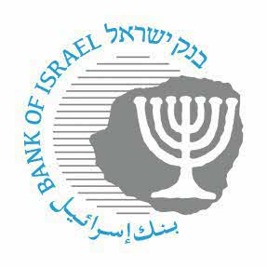

BANK OF ISRAEL
Office of the Spokesperson and Economic Information

December 7, 2022

Press Release:

Foreign Exchange Reserves at the Bank of Israel, November 2022

Israel’s foreign exchange reserves at the end of November 2022 stood at $194,414 million, an increase of $5,572 million from their level at the end of the previous month. The level of the reserves relative to GDP was 37.5 percent (Figure 1).

The increase was the result of a revaluation that increased the reserves by approximately $6,754 million.

In contrast, the increase was partly offset by:
- Government transfers to abroad totaling approximately $1,134 million.
- Private sector transfers totaling approximately $48 million.

Israel's Foreign Exchange Reserves ($ million)

Date | Reserves excluding IMF (including reserves bought under the natural gas purchase program) | Reserves at the IMF | Total Foreign Exchange Reserves
November 2022 | 189,997 | 4,417 | 194,414
October 2022 | 184,531 | 4,311 | 188,842
September 2022 | 181,720^{c} | 4,274 | 185,994^{c}
August 2022 | 187,804 | 4,347 | 192,151
July 2022 | 193,011^{c} | 4,458 | 197,469^{c}
June 2022 | 189,384 | 4,426 | 193,810
May 2022 | 195,361 | 4,447 | 199,808
April 2022 | 193,213 | 4,417 | 197,630
March 2022 | 201,619^{c} | 4,544 | 206,163^{c}
February 2022 | 202,461^{c} | 4,587 | 207,048^{c}
January 2022 | 204,149^{c} | 4,588 | 208,737^{c}
December 2021 | 208,320^{c} | 4,673 | 212,993^{c}
November 2021 | 204,152 | 4,618^{c} | 208,770^{c}

Figure 1
Level of foreign exchange reserves, and their ratio to GDP, 2007–22

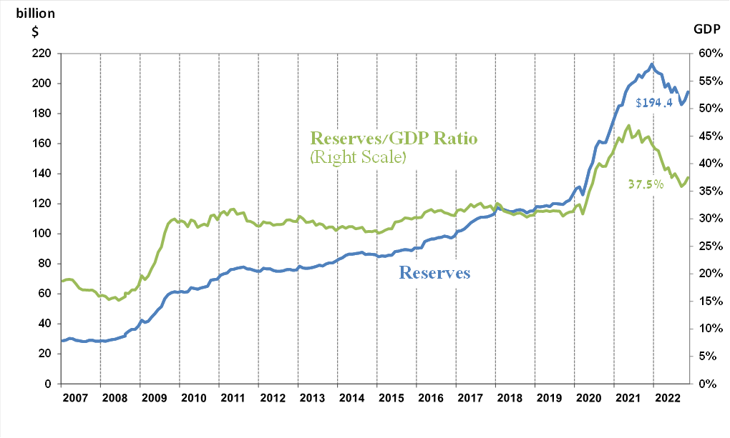

ª Includes Bank of Israel payments and receipts in foreign currency.
b This column includes Special Drawing Rights (SDRs), the balance of NAB loans, and the balance of Israel's reserve tranche at the IMF. c Updated after the original date of publication.

