

BANK OF ISRAEL
Office of the Spokesperson and Economic Information

May 12, 2020

Press Release:

Special analysis by the Bank of Israel Research Department: Initial economic insights from indices of changes in mobility patterns in Israel

- Recently, Google and Apple began publishing “Mobility reports” that present changes in mobility patterns among the population. In particular, Google’s mobility reports include indices for mobility to workplaces and to retail and recreation areas that can serve as real-time indicators of the state of the labor market and of private consumption.

- Government measures to deal with the coronavirus crisis in Israel, including the marked decline in economic activity, are reflected well in these indices, and particularly in the sharp decline in mobility to work places (by about 70 percent at the low points relative to the level of the month prior to the crisis) and to retail and recreation areas (about 80 percent).

- In the second half of April, against the background of a series of easings announced by the government, there was a marked improvement in mobility to workplaces and to a lesser degree in mobility to retail and recreation areas as well—the gap relative to the baseline level of the month before the crisis decreased to 50 percent to workplaces and 70 percent to retail and recreation areas.

- At its peak, the decline in mobility to places of work, retail and recreation during the coronavirus crisis in Israel was greater than the decline in most OECD countries. Nonetheless, beginning from the middle of April 2020, the gap between Israel and the OECD median began to contract, a finding that may indicate that the economic recovery in Israel is more rapid compared to other countries.

The data in this analysis are as of May 2, 2020. Additional data on economic activity in recent days will become available and will be analyzed subsequently.

Mobility reports
The outbreak of the coronavirus and the ramifications of the steps taken to deal with the virus led to an economic crisis, and to higher than usual uncertainty. The Bank of Israel is following the various economic developments on an ongoing basis, and thus compiled a set of rapid indices in various areas that help with making policy decisions and with fulfilling the Bank’s role as economic advisor to the government.

In order to obtain a picture of the state of recent developments in economic activity, we shall present real-time indicators, at a daily frequency, of the public’s mobility patterns, broken down to places such as work, retail and recreation, public transportation hubs, and more, that are published with a short lag of several days. These indices join a series of real-time indicators compiled by the Bank of Israel, such as credit card data, that can indicate a change in economic trends in real-time and contribute to the compilation of the Bank of Israel Research Department’s macroeconomic forecast for the second quarter of 2020.

As part of that, several weeks ago, against the background of the spread of the coronavirus pandemic, Google began to publish its “Community Mobility Report”, based on Google Maps, to measure changes in the public’s mobility to 6 categories of places: workplaces, retail and recreation, grocery and pharmacy, public transit stations, parks, and residential. In parallel, Apple began to publish the “Mobility Trend Report” based on Apple’s navigation app and describing changes in the number of routing queries of Apple users divided among 3 categories: driving, walking, and transit. Google’s and Apple’s data include data on most countries worldwide, and for some of the countries, including Israel, they include information at the district and large-city levels.

Changes in mobility patterns in Israel
The breakdown of Google’s mobility data into 6 categories of places provides an advantage in that it allows the examination in real time of specific indices of economic activity. In particular, mobility indices for workplaces make it possible to examine the effect of the crisis and of the measures in response on the labor market, and in parallel, data on mobility to retail and recreation places makes it possible to partially examine the state of private consumption.

Figure 1 presents Google’s mobility indices for Israel, broken down into Google’s 6 categories of places. Each point on the graph represents a 7-day moving average of the change relative to the baseline period, before the closure steps, between January 3 and February 6, 2020. The shaded area of the graph presents the lockdown period. As can be seen in the figure, Google’s mobility data well illustrate the public response in Israel to the spread of the coronavirus and the government’s steps that followed it. At the low point (around the middle of April), there was a decline of approximately 70 percent in mobility to workplaces relative to the baseline. There was a sharper decline of roughly 80 percent in mobility to retail and recreation places such as restaurants, cafes, shopping centers, and movie theaters. There were also declines in visits to public parks and public transportation hubs. After the easing of limitations, a recovery can be seen in mobility to workplaces, retail and recreation, public transportation, and even to public parks, though their level at the beginning of May remains markedly lower than the baseline level.

Apple’s mobility indices (not represented in this paper) indicate a similar decline in routing instruction search volume in the 2 categories available for Israel (walking and driving) that began even before the closure and reached a low point of approximately 70 percent, relative to the baseline point defined as the search volume on January 13, 2020. At the end of the sample, a recovery can be seen in the quantity of searches which points to the return to routine activities.

It is interesting to note that the decline in mobility in Israel preceded the imposing of limitations on traffic, and apparently reflected the public’s response to the spread of the pandemic, which took voluntary social distancing steps and this reduced their going out to retail and recreation places. However, in contrast, even before the imposition of the lockdown there was an increase in mobility to residential places, as well as to groceries and pharmacies in order to stock up prior to the lockdown. There was a renewed increase in mobility to grocery and pharmacy places toward the middle of April (the Passover holiday) and at the end of the sample the level was 25 percent lower than the baseline level. This partially reflects changes in the public’s consumption habits—the switch to purchases via deliveries, going out to buy things with fewer family members, help with purchases for at-risk populations, etc.

Israel vis-à-vis the OECD countries
The declines seen in the previous part are consistent, as noted, with what would have been expected against the background of the policy measures taken. In addition, the indices can be analyzed and conclusion may be drawn regarding the relative magnitude of the health crisis and the steps taken in Israel compared with those taken in other countries—is the economy in Israel more negatively impacted than other countries’? Is the Israeli public more “disciplined” than the public in other countries? Are the government measures taken in Israel stricter or more lenient compared to other countries? To that end, an international comparison of the indices of mobility to workplaces and to retail and recreation places was conducted.

Figure 2 presents the mobility index for workplaces and retail and recreation places for Israel compared with the median and the distribution of parallel values in OECD countries, where the distribution of values is presented via the green shaded areas—the darker area represents the 10th through 90th percentiles, and the lighter area shows the maximum and minimum values at each time. The figure indicates that the decline in mobility in Israel during the crisis, both to workplaces and to retail and recreation places, is high relative to the OECD countries, and is at its lowest point around the 10th percentile of the distribution. Nonetheless, a recovery can be seen in the mobility indices in the second half of April, particularly in mobility to workplaces, against the background of the easing in the limitations in Israel, which led to a contraction of the gap between Israel and the OECD median. This finding may indicate that the economic recovery in Israel is more rapid than in other countries.

What does the future hold?
Several countries, including Israel, are currently at the end of the first stage of “flattening the curve” and switching to the “coronavirus routine” stage, which includes a gradual return to activity under restrictions that are intended to prevent to the extent possible a second wave of the pandemic. In order to attempt to assess how the next stage appears from the perspective of economic activity, this section compares Israel with several East Asian countries that are deep into the second stage, with countries that are at this time beginning to implement an exit strategy, and with Sweden that did not adopt official social distancing measures.

Figure 3 presents the indices of mobility to workplaces and retail and recreation areas in several selected countries. The color of the line in each of the figures represents the daily change in the number of confirmed cases (7-day moving average). The lighter the color of the line, the larger the number of infected people. One conclusion that arises from the figure is that even at the end of the sample, except for South Korea and Taiwan, none of the countries returned to the baseline level of mobility to workplaces. However, it is important to remember that the baseline period for South Korea and Taiwan does not necessarily represent “normal” times because those countries were among the first to adopt social distancing measures and the imposing of limitations. In this regard, Singapore is notable as it excelled in dealing with the pandemic, but is currently experiencing a renewed increase in the number of infected people accompanied by a marked decline in mobility.

A similar, and even stronger, phenomenon is occurring in mobility to retail and recreation places—all the countries in the sample, including South Korea and Taiwan, are below the baseline level, though there is heterogeneity in the size of the gap. In Taiwan, the gap is relatively small, although a rising trend can be seen in it (that is, the negative gap relative to the baseline level increased). In South Korea, the gap in mobility to retail and recreation places has not yet closed (lower than the baseline by about 10 percent), and even gets smaller over the course of the sample.

The figure indicates that Israel is similar in its mobility characteristics to the advanced economies that adopted lockdown and social distancing steps, such as Italy, Germany, Austria, the UK, and the US, which as such suffered a marked adverse impact to the economy. It is interesting to note in this regard that in Sweden there is a decline of about 20 percent in mobility to workplaces and to retail and recreation places, even though it did not adopt a strict closure policy like most other countries did. This is essentially evidence of the voluntary social distancing by the Swedish public due to the concern over the pandemic that markedly negatively impacted the economy, even without the imposition of formal limitations.

Figure 1
Google mobility indices for Israel

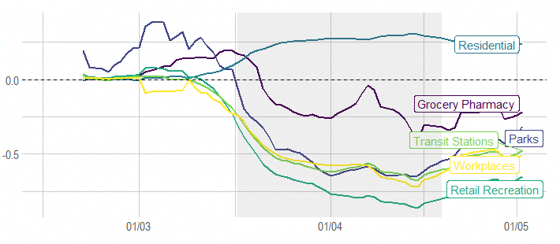
Notes: This figure depicts the ratio between mobility to various places in Israel at all points in time and the mobility level during the baseline period (7-day moving average). The shaded area represents the lockdown period. The level during the baseline period was established based on the median value of the volume of visits for each day of the week during the period January 3–February 6, 2020.

SOURCE: Based on Google Community Mobility Report.

Figure 2
Google mobility indices, Israel vs. OECD

A. Workplace
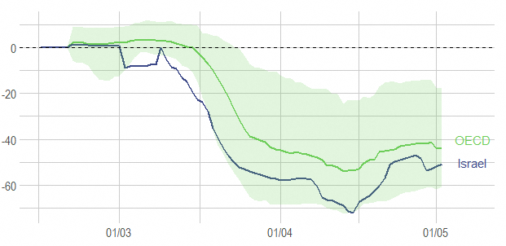
B. Retail and Recreation
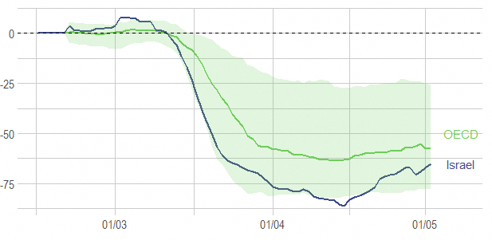

Notes: This figure depicts the ratio between mobility to workplaces (above) and to retail and recreation (below) at all points in time and the level during the baseline period (7-day moving average). The blue line represents the value for Israel, and the green line represents the median value for OECD countries for each day. The green shaded areas represent the range between the 90th percentile and the 10th percentile and the range between the minimum and maximum each day, respectively. The level during the baseline period was established based on the median value of the volume of visits for each day of the week during the period January 3–February 6, 2020.

SOURCE: Based on Google Community Mobility Report.
Figure 3
Google mobility indices, selected countries

- Workplace

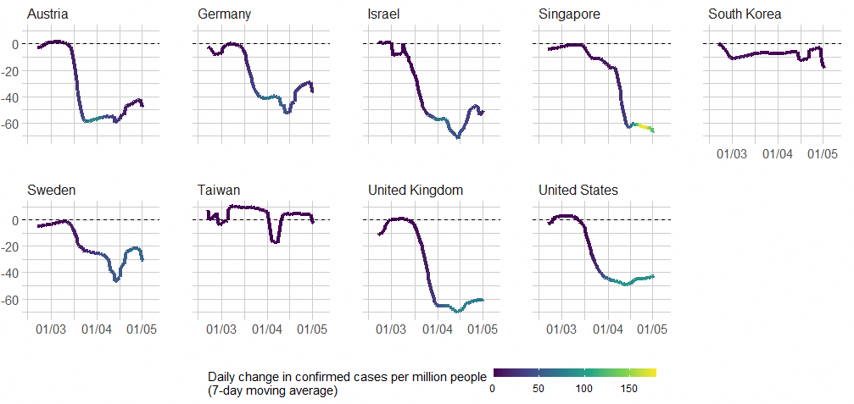
- Retail and recreation

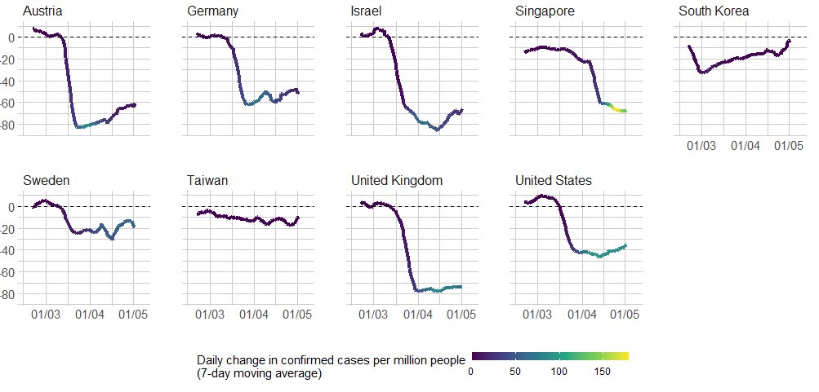

Notes: This figure depicts the ratio between mobility to workplaces (above) and to retail and recreation (below) at all points in time and the mobility level during the baseline period (7-day moving average). The line represents the mobility index for each country. The color of the line represents the daily change in the number of infected people (7-day moving average). The level during the baseline period was established based on the median value of the volume of visits for each day of the week during the period January 3–February 6, 2020.

SOURCE: Based on Google Community Mobility Report and Johns Hopkins University CSSE.

The code for recreating the analysis that appears in this paper is at https://github.com/itamarcaspi/mobility-reports-boi.
For expanded discussion on Google’s mobility index, see https://www.google.com/covid19/mobility/.
For expanded discussion on Apple’s mobility index, seehttps://www.apple.com/covid19/mobility.
Google data on which the analysis in this note is based include data up to May 2, Apple data are up to May 5.
In contrast, Apple data are more limited and include only data on the volume of routing queries by Apple users, segmented into 3 categories: driving, walking, and transit. The latter is not available for Israel.
It is reasonable to assume that part of the decline that we see in mobility to workplaces and to retail and recreation was offset by phenomena that cannot be seen in the graphs, such as work from home and online purchases and deliveries.
Data regarding Apple’s 3rd category, “transit” are not available for Israel.
As will be seen below, this phenomenon is not unique to Israel.
According to Google, accuracy of measuring location and the categorization of places into work, retail, and recreation, public transit, etc. varies among countries, so some caution is required when comparing data among countries with different features (such as countries characterized more by rural areas compared to countries with large and dense urban areas).
The OECD median that appears in the figure is defined as the 7-day moving average of the median value of the mobility indices for the OECD for each day.
The decline in the data in Israel at the end of the sample reflects the effect of the lockdown during the Memorial Day-Independence Day period.

