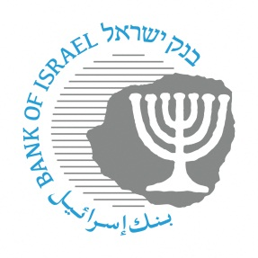

BANK OF ISRAEL
Office of the Spokesperson and Economic Information

May 13, 2019
Press Release

Israel’s foreign currency market in the first quarter of 2019

Beginning with this notice, a section that presents the activity of the main activity sectors in the foreign currency market will also be included.

1. The Exchange Rate
Strengthening of the shekel against the dollar, in parallel with a mixed trend of the dollar worldwide.
During the course of the first quarter, the shekel strengthened by approximately 3.1 percent against the dollar, and by 5 percent against the euro.
Against the currencies of Israel's main trading partners, in terms of the nominal effective exchange rate of the shekel (i.e., the trade-weighted average shekel exchange rate against those currencies), the shekel strengthened by about 3.5 percent.

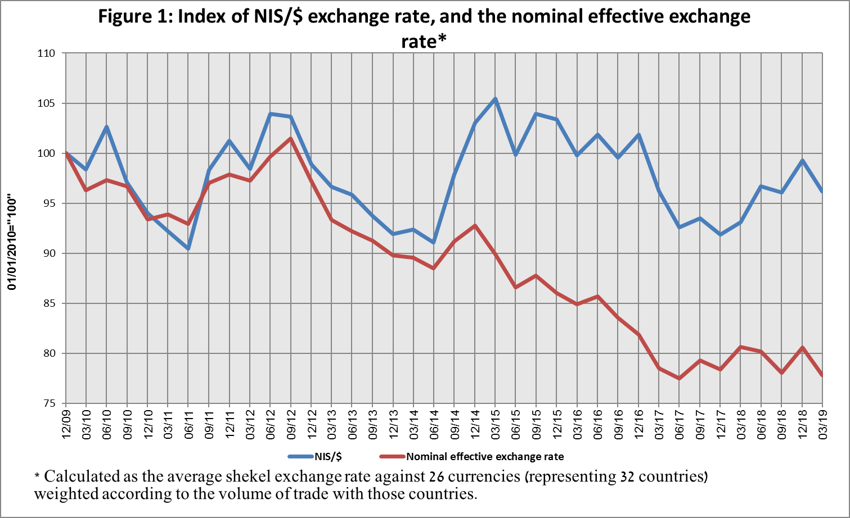
Worldwide, the US dollar traded mixed against most major currencies in the first quarter. The dollar strengthened by approximately 2 percent against the euro, by 0.9 percent against the Japanese yen, and by 1.1 percent against the Swiss franc. In contrast, the dollar weakened by 1.9 percent against the British pound.

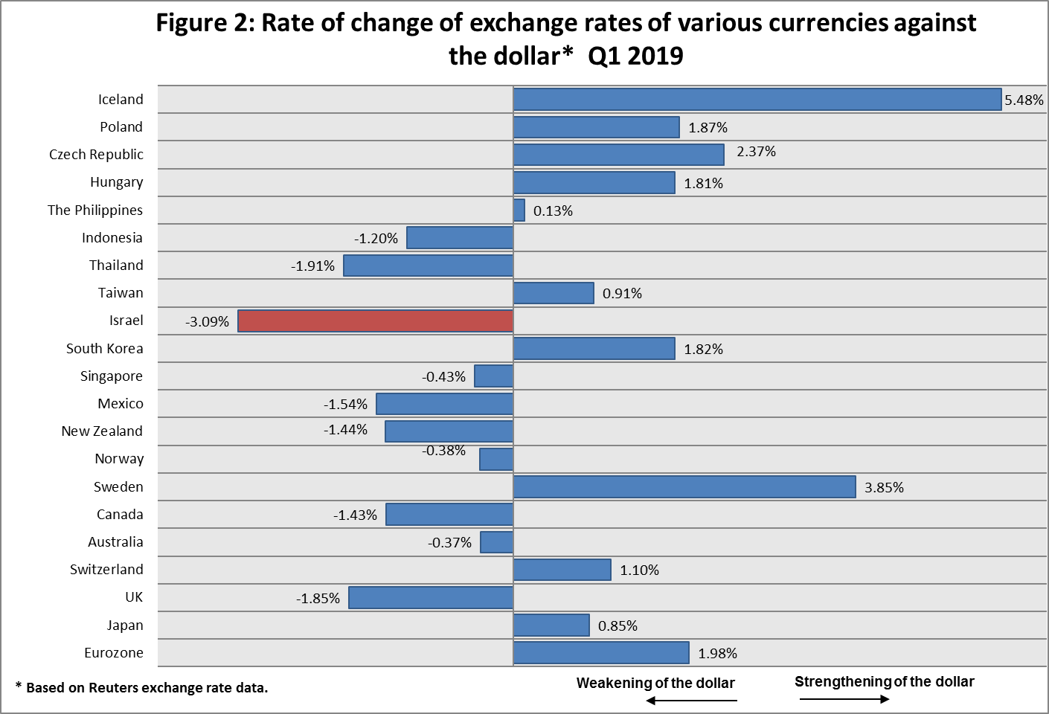

2. Exchange Rate Volatility
A decline in actual volatility of the exchange rate, and stability in implied volatility.
The standard deviation of changes in the shekel/dollar exchange rate, which represents its actual volatility, declined by about 0.3 percentage points in the first quarter, to 5.1 percent at the end of March.

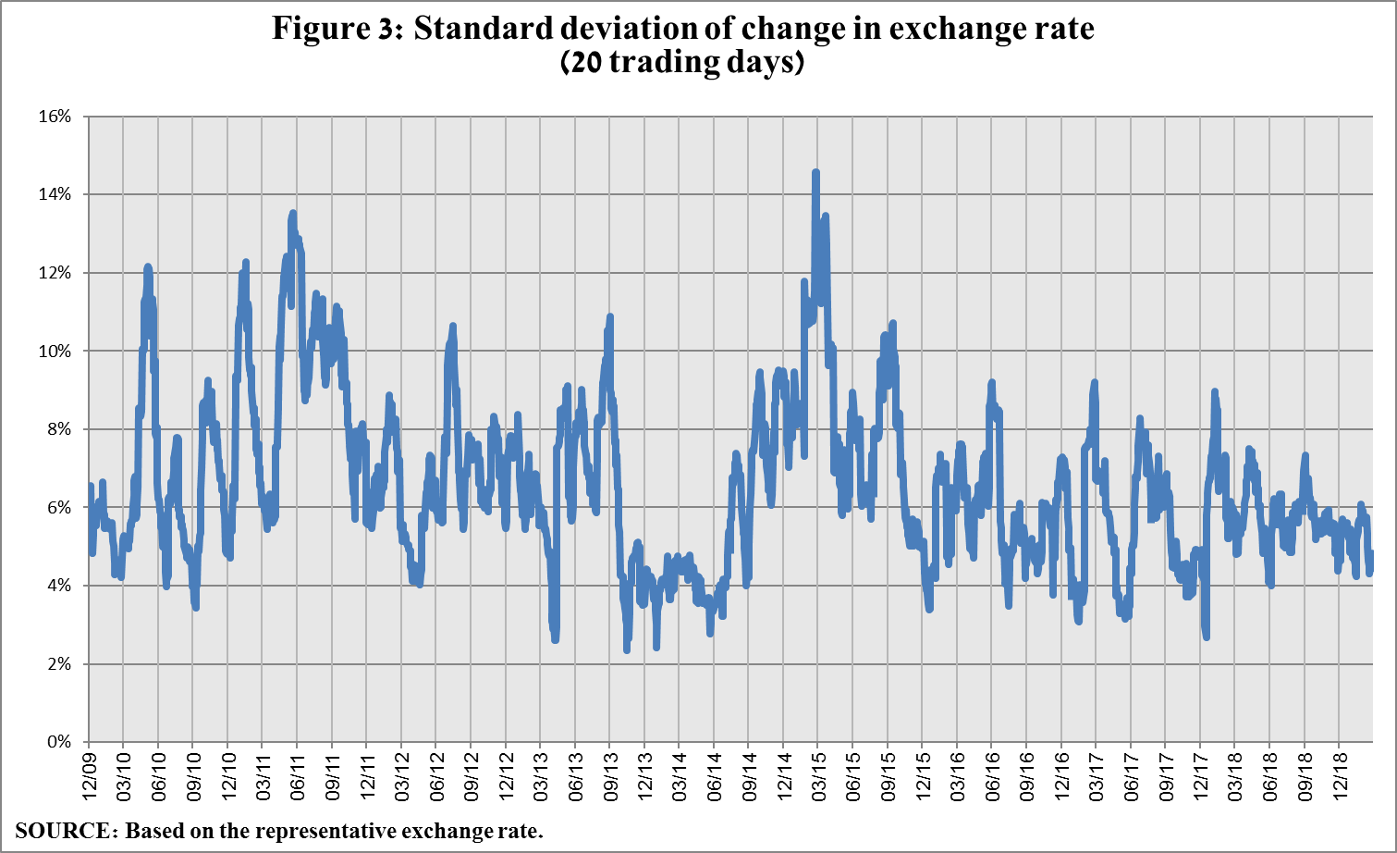
The average level of implied volatility in over the counter shekel/dollar options remained stable in the first quarter, and was 7.4 percent at the end of March.
The implied volatility in foreign exchange options in emerging markets declined in the first quarter to 9.5 percent, compared with 10.8 percent at the end of the previous quarter. The implied volatility in foreign exchange options in developed markets decreased to 7.5 percent at the end of the first quarter, compared with 8.1 percent at the end of the previous quarter (Figure 4).
The implied volatility in foreign exchange options trading is an indication of expected exchange rate volatility.

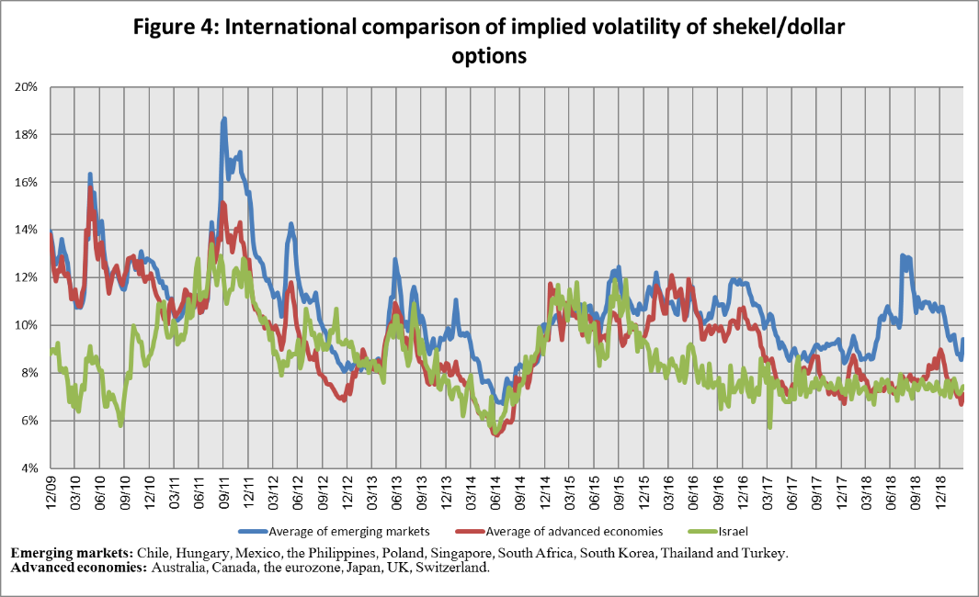

3. The Activity of the Main Sectors in the Foreign Currency Market
An estimate of the activity of the main sectors in the foreign currency market in the first quarter of 2019 indicates that during the course of the quarter, institutional investors shifted to net sales of foreign currency, totaling $3.4 billion, compared with net purchases of foreign currency of approximately $4.7 billion in the preceding quarter.
Foreign currency sales by nonresidents totaled approximately $2.4 billion in the first quarter, similar to their conduct in the previous quarter.
In contrast, during the quarter, the real sector purchased foreign currency at a net $5.6 billion, as opposed to net foreign currency sales of $0.8 billion in the previous quarter.
The Bank of Israel has not intervened in foreign currency trading since January 2019.

4. The Volume of Trade in the Foreign Currency Market—tables and figures
Nonresidents' share of total trading (spot and forward transactions, options and swaps) increased by about 2.7 percentage points to about 39.4 percent at the end of the first quarter. The increase was a result of higher volume of activity by nonresidents in options transactions.

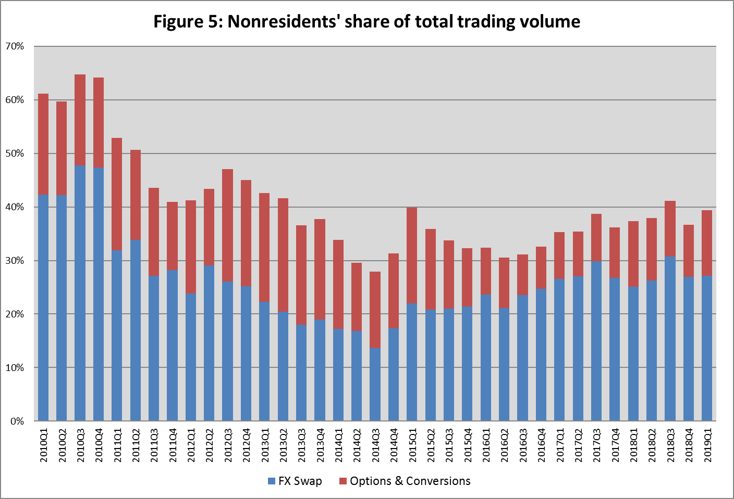

The main sectors presented do not make up the entire market—for additional information, see the section on “The data system on activity of the shekel/foreign currency market” in Statistical Bulletin, 2018 (in Hebrew): https://www.boi.org.il/he/NewsAndPublications/RegularPublications/Documents/MabatStat2018/full.pdf
Volumes of trade only vis-à-vis the domestic banking system.

