

BANK OF ISRAEL

Office of the Spokesperson and Economic Information

September 21, 2025

Press Release:

Debt Developments in the Nonfinancial Private Sector,

Second Quarter of 2025

The following is a summary of developments in nonfinancial private sector debt in the second quarter of 2025:

* In the second quarter of 2025, the balance of **nonfinancial private sector debt (both** **business and household)** increased by approximately 2.1 percent to a level of NIS 2.3 trillion. The annual growth rate of outstanding debt increased to about 8.2 percent.
* The balance of **business sector debt** increased by about 2.6 percent (about NIS 36 billion) during the second quarter, to about NIS 1.5 trillion. This was mainly due to net debt raised via bank loans.
* The balance of **household debt** also continued to increase during the quarter, to about NIS 866 billion, mainly due to a combination of an increase in the balance of **housing debt** (by about NIS 12 billion, 2 percent), which was due to new mortgage volume from banks, and a decline in the balance of **nonhousing debt** (about NIS 1.4 billion, 0.6 percent) for the first time since the last quarter of 2023, to NIS 236 billion, as a result of a decline in the balance of debt to banks and to credit card companies.

**The nonfinancial business sector’s[1] debt**

* In the second quarter of 2025, the **balance of business sector debt** increased, by about 2.6 percent (about NIS 36 billion) to NIS 1.5 trillion.
* The increase in the balance derived from considerable net debt raised totaling NIS 58 billion, mainly the result of bank credit taken out, given mostly to the financial services sector, including credit for collaterals for derivative and securities lending transactions. In addition, funds raised via tradable bonds in Israel contributed to the increase, as did an increase of about 1.3 percent in the Consumer Price Index[2] which increased the value of the CPI-indexed debt; these increase were partly offset by an appreciation of about 9.3 percent in the shekel vis-à-vis the dollar, which reduced the value of the debt denominated in and indexed to foreign currency, as well as from net redemptions in debt raised abroad and in nontradable bonds in Israel.
* These effects led to a continued increase in the annual growth rate of the balance of bank debt—to about 16 percent—a trend that began in the second half of 2024, while the annual growth rate of debt to nonbank lenders continued to decline, for the second consecutive quarter, though it remained positive—at about 0.5 percent compared to 3.5 percent in the previous quarter (Figures 1, 2).
* In the second quarter of the year, the **business sector** **issued** about NIS 28 billion in bonds, notably higher than the quarterly average of funds raised in the previous four quarters (about NIS 16 billion per quarter. Approximately 43 percent of the issuances in the second quarter were carried out by companies in the real estate and construction industry, which continues to lead in bond issuances, similar to previous years (Figure 3).

In July 2025, the business sector issued bonds worth NIS 14 billion, of which about 56 percent were issued by companies in the real estate and construction industry.

* In the second quarter of 2025, **the spread[3] between yields on corporate bonds that are included in the Tel Bond 60 Index and the yields on CPI-indexed government bonds** continued to narrow, to about 0.83 percentage points, and it continued to decline in July 2025, to about 0.77 percentage points. In August, 2025, there was a slight increase in this spread, to about 0.79 percentage points, which is still low relative to the past three years (Figure 4).

**Table 1: The Composition of Business Sector Debt**



**Figure 1: Estimated Net Quarterly Quantitative Change in Business Sector Debt**



**Figure 2: Rate of Change (Year on Year) in the Business Sector's Bank and Nonbank Debt**



**Figure 3: Nonfinancial Business Sector Bond Issuance during the quarter, by Industry**

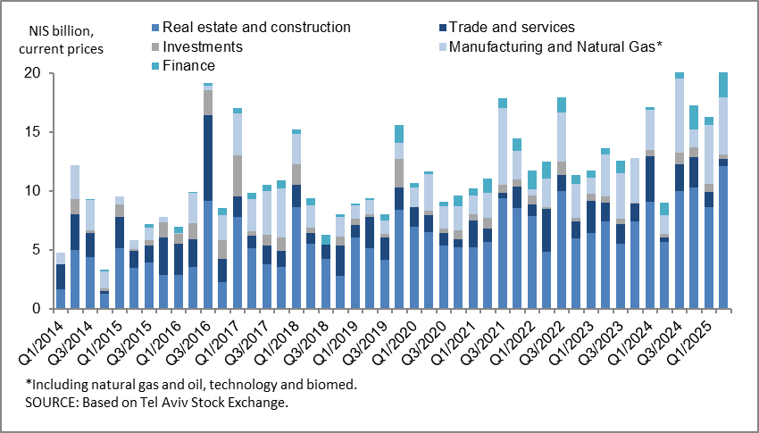

**Figure 4: Spread between Indexed Corporate Bonds (Tel-Bond 60) and Indexed Government Bonds (monthly average)**

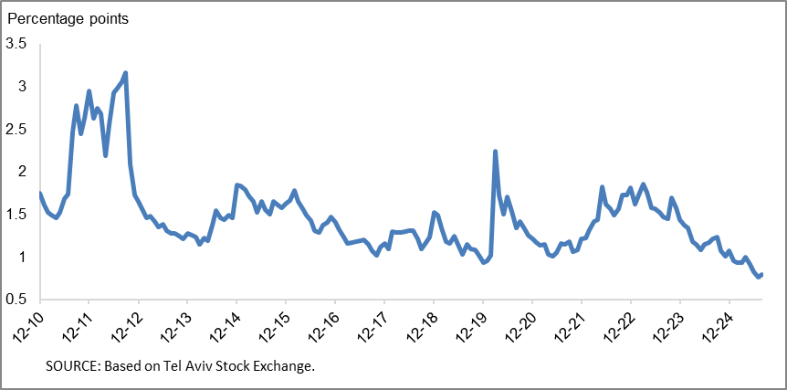

**Household debt**

* In the second quarter of 2025, the **balance of households’ outstanding debt** continued to increase, by approximately 1.3 percent (about NIS 11 billion), to NIS 866 billion. The increase was due to the combination of an increase in the **housing debt balance** (about NIS 12 billion, 2 percent) to a level of NIS 630 billion, mostly to banks; and a decline in **nonhousing debt** (about NIS 1.4 billion, -0.6 percent), for the first time since het last quarter of 2023, to a level of NIS 236 billion. This derived from a decline in the balance of debt to banks and to credit card companies.
* Due to these effects, the annual growth rate of housing debt continued to increase in the quarter, to about 8 percent, a trend that began in the second half of 2024, while the annual growth rate of nonhousing debt continued to decline, for the second consecutive quarter, but remained positive, at 3.2 percent (Figure 5).
* The increase in housing debt is the result of continued new mortgage borrowing from the banks, which began at the end of 2023, and they totaled in the second quarter of the year, after seasonal adjustment, about NIS 26 billion, slightly higher than the corresponding period of the previous year (about NIS 21 billion).
* In July and August 2025 as well, new mortgage borrowing from banks totaled, after seasonal adjustment, about NIS 9 billion per month on average (Figure 6).

**Table 2: Outstanding Debt Balances of Households1**



**Figure 5: Rates of Change in Households’ Housing and Nonhousing Debt, Current Quarter vs. Corresponding Quarter of Previous Year**



**Figure 6 :Amount of New Home Purchase Loans Provided by Banks to the Public (Mortgages)**



Links to Data and Statistics on the Bank of Israel website:

<https://www.boi.org.il/en/economic-roles/data-and-statistics/money-and-debt-aggregates/debt-and-credit/>

1. Israeli corporations, excluding banks, credit card companies, and insurance companies.
2. CPI-indexed balances are calculated according to the known CPI on the date the financial statements are published, so that a change in the CPI refers to the change between the known CPI and the CPI of the preceding month.
3. The cha1nge in the spread from one quarter to the next is calculated as the difference between the average spread in the final month of the reviewed quarter and the average spread in the final month of the previous quarter.