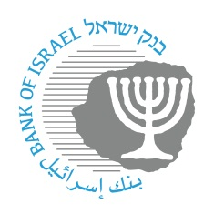

BANK OF ISRAEL
Office of the Spokesperson and Economic Information

December 15, 2022

Press Release:

The Governor participated in the meeting of the Israel Hotels Association

Governor of the Bank of Israel Prof. Amir Yaron spoke today at a meeting with senior executives in the hotels industry in Israel. The meeting was held in the Dan Tel Aviv Hotel.

In his remarks, the Governor surveyed the tourism and hospitality industry from the perspectives of employment, the scope and volume of activity, and the recovery from the COVID-19 crisis. He presented domestic and international indices that reflect the picture of the industry’s economic situation.

In addition, the Governor presented to the conference participants major developments regarding the global economy, real activity in Israel in the areas of growth and employment, inflation, and fiscal policy.

